Value of Dynamic Subtraction MRI in Assessing HCC Response to Image-guided loco-regional Therapy
Rasha Abdelhafiz Aly¹, Dina Hamdy Hashem¹, Rania A.M. Abouyoussef², Heba Said Ellaban¹
¹Radiology Department, National Liver Institute, Menoufia University
²internal medicine department, Alexandria University.
Corresponding author: Rasha Abdelhafiz Aly
Email: rasha_radiology@yahoo.com.
Tel.: +2010006299905.
DOI: 10.21608/AJGH.2023.216003.1033
Submission date:06 June 2023
Revision date: 28 July 2023
Acceptance date(final): 06 August 2023.
First online: 08 August 2023.

ABSTRACT
Background: Hepatocellular carcinoma (HCC) is considered one of the foremost cancers worldwide. Although the hepatic resection of HCC has a high existence in the clinical scenarios, locoregional management is preferred owing to the preservation of hepatic parenchyma with lower morbidity and mortality. Dynamic contrast-enhanced MR with subtraction imaging improves the evaluation of managed HCC with easy detection of residual or recurrent viable lesions.
Patients and methods: This study was designed in a retrospective pattern from December 2020 to December 2022. Forty patients were referred to our radiology department with solitary HCC, underwent therapeutic intervention, then underwent follow-up by dynamic MRI study.
Results: Forty patients with solitary HCC were conducted during our study; all underwent locoregional therapy with follow-up by dynamic MRI with subtraction technique one month later. The subtraction image has a sensitivity of 100%, specificity of 100%, PPV of 100%, NPV of 100%, and 100% accuracy, compared to 90.91%, 77.78%, 83.33%, 87.5%, and 85% for conventional dynamic images, 45.45%, 100%, 100%, 60% and 70% for diffusion-weighted images. Analysis of those results exhibited a considerable additive value of the subtraction technique to the dynamic MRI to detect the response of HCC after management.
Conclusions: Subtraction MRI is a pivotal tool to assess the interventional treatment of HCC, particularly in lesions having pre-contrast high signal intensity with distinguished radiologists’ confidence.

Keywords: Dynamic MRI, Hepatocellular carcinoma, Locoregional therapy, Subtraction MRI, DWI, HCC response, T1 signal, HCC management, sensitivity, specificity.

Introduction
Hepatocellular carcinoma (HCC) is one of the most prominent malignancies worldwide, with an awful prognosis in untreated patients [1]. HCC treatment is tricky as multidisciplinary tumor management is available depending on tumor stage, liver function, and patient status. However, the prime curative therapy for HCC is surgical resection; only 10% of patients with HCC are fitted for this option [2-4].
Image-guided locoregional therapy is used as alternative minimally invasive approaches for those patients, including ablation and trans-arterial chemoembolization (TACE). Ablative therapy involves chemical ablation (ethanol ablation) and thermal ablation by using heat (radiofrequency ablation; RFA or microwave ablation; MWA) or cold (cryoablation). The previous techniques result in coagulative tumor necrosis producing similar imaging features during follow-up surveys [5].
Transcatheter arterial chemoembolization (TACE) is one of the usual treatments for HCC patients. It consists of delivering lipiodol along the feeding artery of the tumor with a chemotherapeutic agent, such as doxorubicin, to obtain tumor necrosis [6, 7]. Some complications may occur following TACE, such as arterio-portal fistula, portal vein occlusion, bile duct injury, or parenchymal infarction [8]. Recently, Transarterial Yttrium-90 radioembolization (TARE) has progressively increased in HCC treatment with subsequent tumor necrosis [9].
Therefore, accurate imaging is vital in tumor assessment after management to detect active lesions and any post-treatment complications. Contrast-enhanced computed tomography (CT) and magnetic resonance imaging (MRI) are the most frequent imaging modalities for assessing treatment response [5]. Several studies have suggested that MRI is more accurate in detecting residual or recurrent viable HCC after management [10-12].
Subtraction MR imaging is a postprocessing technique on the MR software where non-enhanced T1-weighted images are subtracted from identical postcontrast T1-weighted images. Thus, the subtraction provides supplementary information about HCC after management since the persisting signal in the subtracted images will be only because of the enhancement demonstrating active tumor [13].
METHODS
Study design: Retrospective cohort study employing descriptive and analytical statistics.
Patient’s data
From December 2020 to December 2022, a retrospective analysis of forty patients with solitary HCC who underwent therapeutic intervention was referred to the Radiology Department at National Liver Institute, Menoufia University, to undergo follow-up by dynamic MRI study. The Research Ethics Committee of the National Liver Institute approved this study with IRB number 00464/2023.
All patients had been subjected to full clinical assessment and laboratory investigations, including liver enzymes (SGPT and SGOT), serum bilirubin, and renal function tests (urea and creatinine).
Follow-up protocol for treated HCC: All patients were scheduled to perform dynamic MRI one month after image-guided loco-regional therapy for HCC lesion (27 patients undergone TACE, 11 patients undergoing radiofrequency ablation, and only two patients undergone microwave ablation) with post-processing to obtain subtraction images. If there is no active tumor, another follow-up study is performed three months later, in the first two years, every 3–6 months following treatment, and after two years of surveillance every six months later.
Exclusion criteria
We exclude tumors other than HCC, cases with excessive hepatic tumor infiltration, and HCC mass adjacent to vital structures such as the diaphragm or central bile duct. MRI contraindications, e.g., metallic implants, cardiac pacemakers, and claustrophobic patients. Contraindications to contrast media administration. History of prior allergic-type reaction to gadolinium chelates or severe renal insufficiency.
MRI acquisition
Imaging the whole liver was performed using a 1.5 T MRI system (GE, Optima 450W, and 32 channels), using a body phased-array coil. Before the examination, patients were asked to fast for 8 hours. In most cases, a venous catheter was placed in a peripheral vein (ante-cubital vein), passing through a long connecting tube to an automatic injector to allow easy injection. The patient was instructed on breathing-hold techniques.
Precontrast imaging was obtained, followed by the dynamic postcontrast (DCE-MRI) study. The pre-contrast study included coronal survey BFFE, Axial T1 weighted (T1WI) images (FRFSE/PROP). In-phase and out-phase gradient echo sequence (dual-FFE-BHSENSE) axial images. Axial T2 weighted (ax T2 RTr prop), Coronal T2W-(FRFSE/PROSP), Axial T2 fat suppression sequence, Axial heavy T2 weighted images. Diffusion study (DW): Respiratory-triggered fat-suppressed single-shot echo-planar DW imaging was performed in the transverse plane with tri-directional diffusion gradients using b values 0,500&1200 sec/mm².
DCE-MRI was performed after a bolus injection of 0.1 mmol/kg body weight of Gd-DTPA, followed by 20 ml saline at a 2.0 ml/sec rate to flush the injector tube—dynamic imaging using 3D fat-suppressed T1-weighted gradient echo sequence. Firstly, pre-contrast images were obtained, followed by four post-contrast images (early and late arterial, portal, and a 5-min delayed phase). All patients were imaged in end-expiration to decrease image misregistration.
Subtraction dynamic imaging, an automated post-processing technique, was accomplished on the MRI workstation as the unenhanced T1-weighted sequence was subtracted from the identical postcontrast (late arterial phase) dynamic sequence. So, any native T1 signal is deleted with the remaining signal only regarding enhancement within the hepatic lesion, followed by an assessment of the enhancement pattern in the subtraction imaging.
Data acquisition
All images were depicted by two experienced radiologists with experience of 5 and 10 years in abdominal MRI imaging. Each one had access to the patient’s clinical data and assessed the MRI images separately, reaching final decisions by consensus. The morphological features of the hepatic lesions were estimated involving the following items: site, size, margins, and signal intensity at T1 and T2 WIs. Our 40 patients were presented with a solitary hepatic lesion. Most lesions (33/40, 82.5%) are seen in the right hepatic lobe, with lesion size ranging from 2.3 cm to 6 cm in average dimension.
We studied the signal intensity of the entire managed area in the pre-contrast T1 and T2 images by verifying signals as low, high, intermediate, and heterogeneous signals. Facilitated or restricted lesions regarding the diffusion-weighted images were also recorded.
Analysis of the conventional dynamic study was first done as tumor enhancement in the arterial phase with delayed wash-out represented tumor viability. The absence of arterial enhancement suggested a well-managed tumor. So, subtraction images were used to prove/adjust the noted enhancement findings, demonstrating that the high signal in the arterial phase refers to tumor viability rather than coagulative necrosis, showing pre-contrast high T1 signal intensity within the managed tumor.
During image analysis, a perilesional hepatic parenchymal enhancement could be assessed carefully: • post-managed reactive changes are stated as early enhancement beyond the managed hepatic lesion with delayed persistence. • Perfusion abnormalities, known as transient hepatic intensity difference (THID), are an ill-defined, usually wedge-shaped parenchymal arterial enhancement with delayed isointense signal intensity, likely due to traumatic arterio-portal shunting. Finally, marginal well-defined enhancement represented the rim of granulation tissue (Marginal persistent or delayed phase enhancement) or tumor recurrence (Nodular enhancement).
The studied patients were then differentiated into two groups: A well-managed group with no MRI signs of viable tumor, disregarding the newly developed lesions, representing complete response. The residual group with MRI evidence of viable tumor (residual or recurrence) represents an incomplete response.
Statistical Analysis
Data was fed to the computer and analyzed using IBM SPSS software package version 20.0. (Armonk, NY: IBM Corp). Categorical data were represented as numbers and percentages. Quantitative data were expressed as a range (minimum and maximum), mean, standard deviation, and median. The chi-square or Fisher’s exact test compared well-managed and residual groups based on subtraction MRI. Diagnostic indices, including sensitivity, specificity, PPV, and NPV, were calculated for conventional MRI, diffusion MRI, and the subtraction image.
Results
This study was done on 40 patients with managed solitary HCC lesions, including 32 males (80%) and eight females (20%). Their ages ranged from 48 to 72 years with a mean age ± SD 60.7 years ± 9.7.
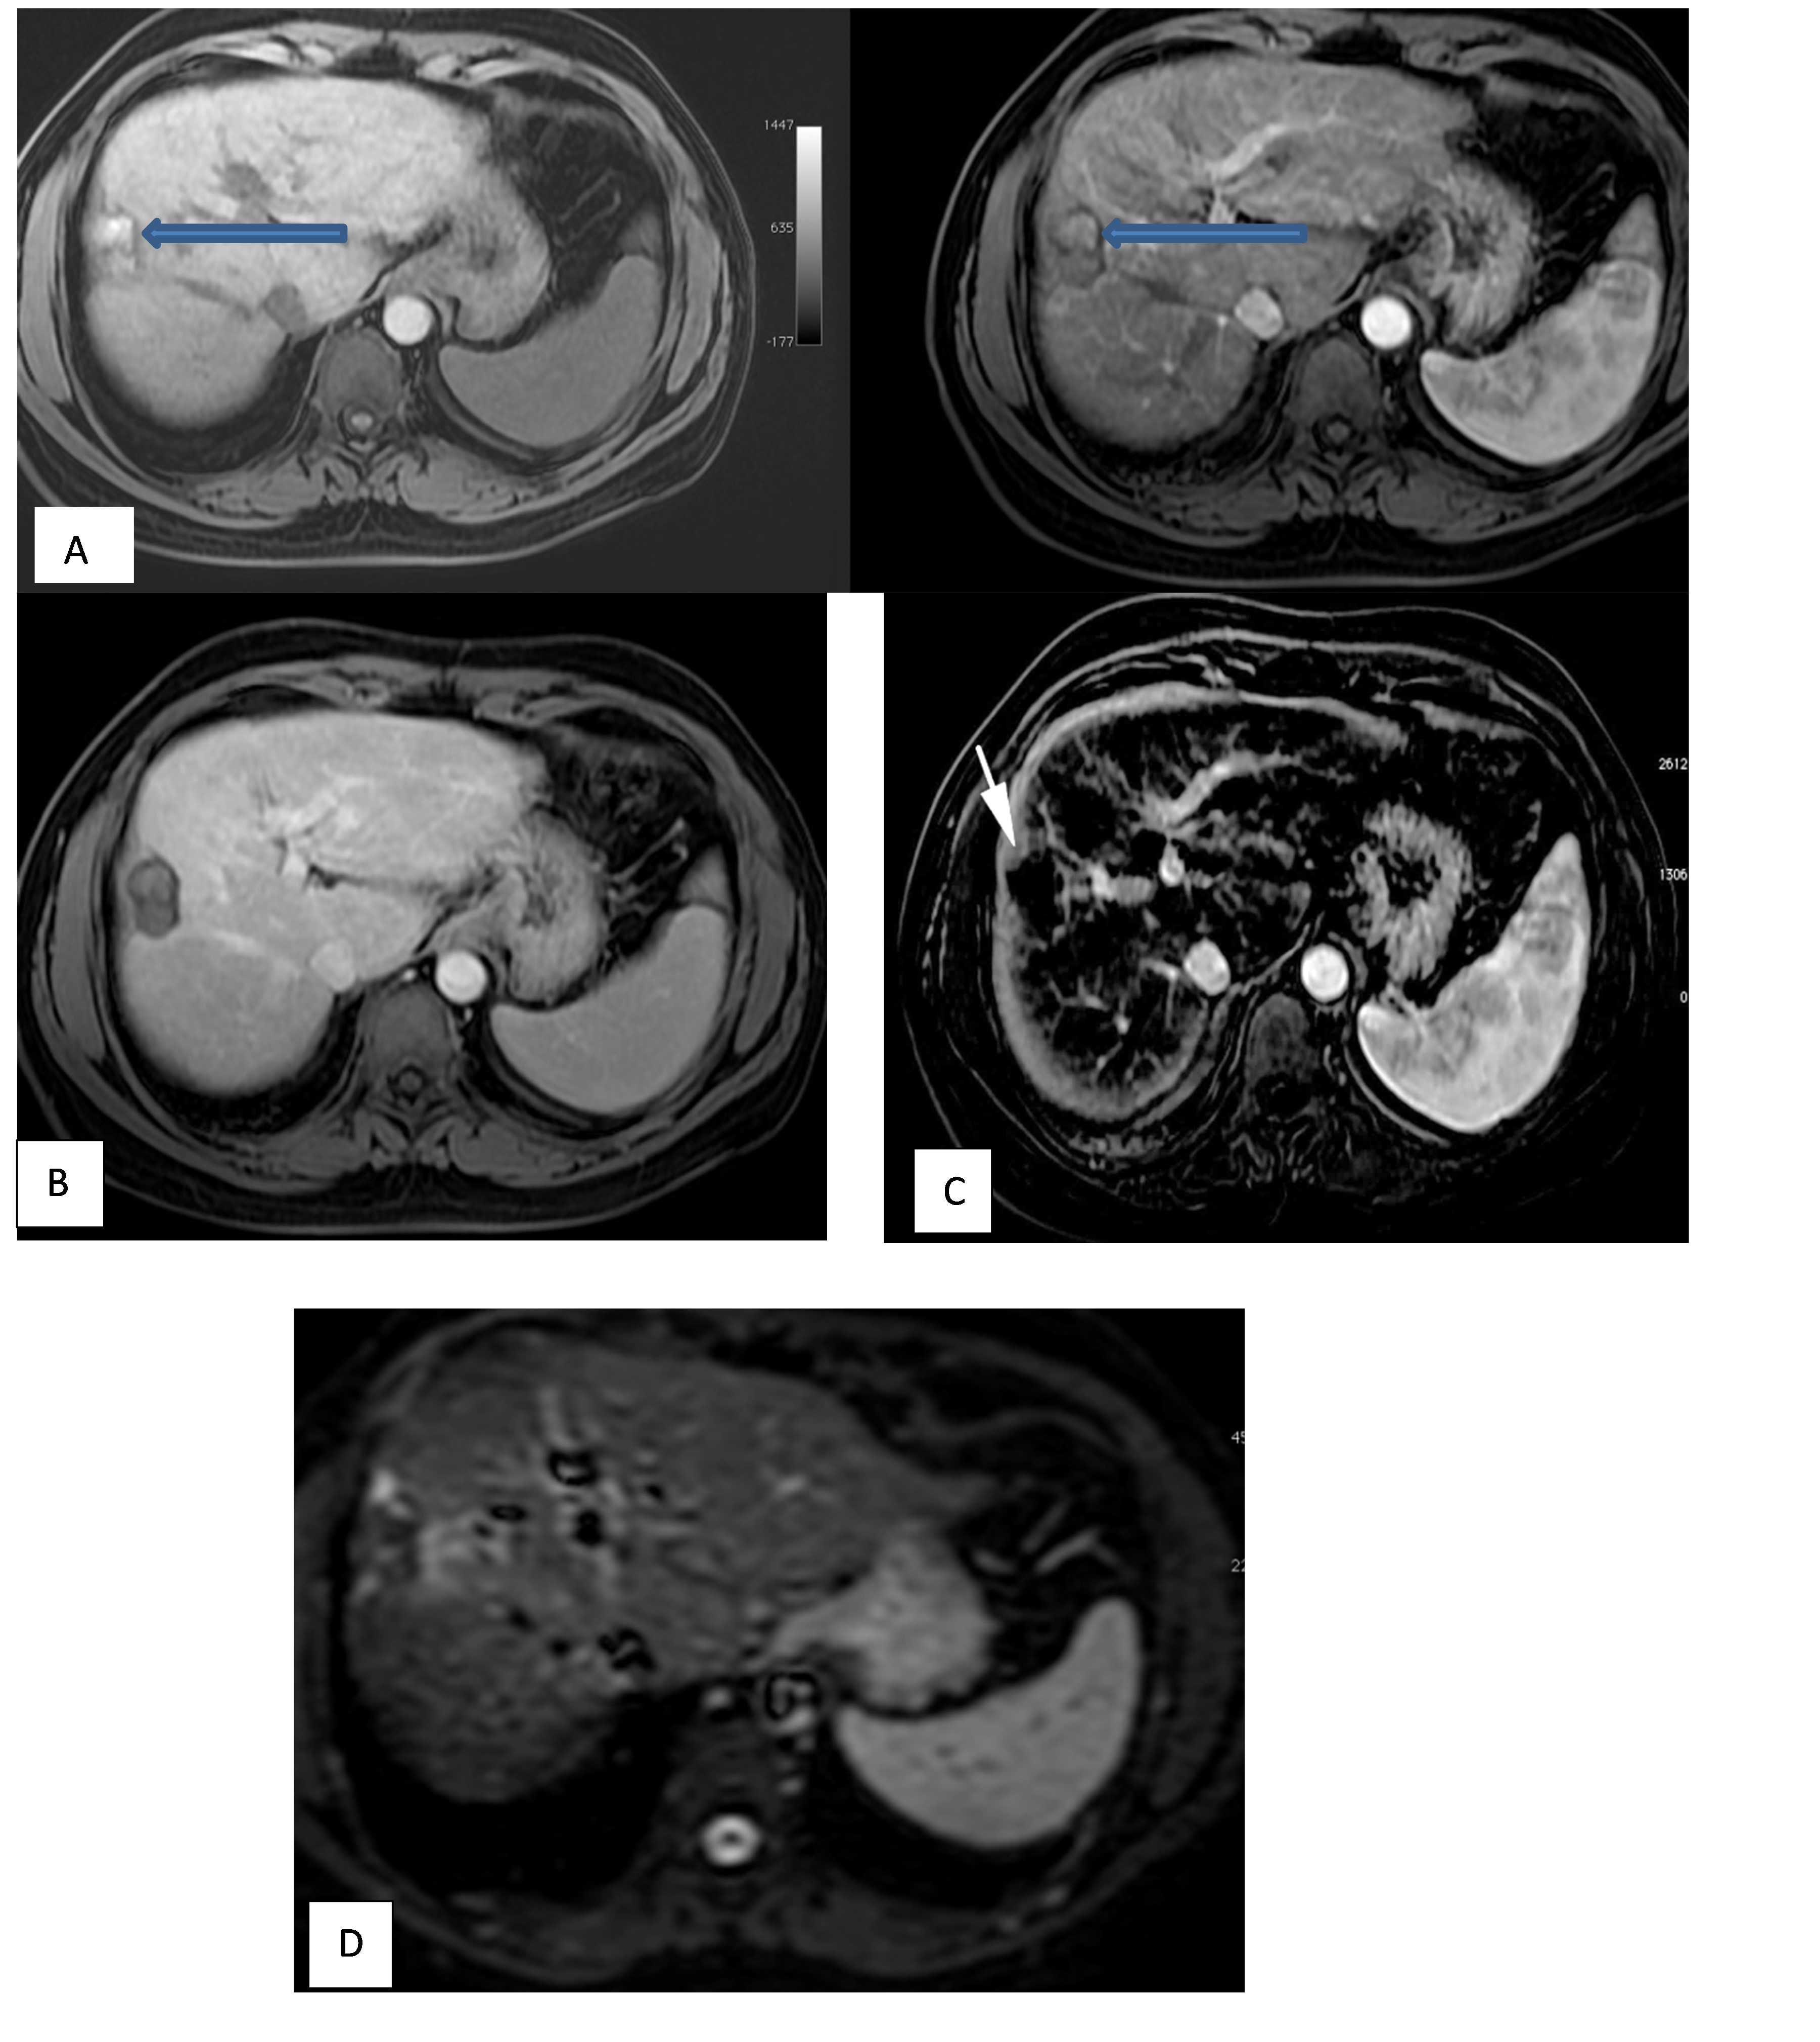
Fig 1. A 50-year-old male patient with liver cirrhosis had undergone a TACE session for a right hepatic lobe focal lesion with a follow-up one month later. Dynamic MRI was done with subtraction technique: A. Axial T1WI pre- and post-contrast: High signal of the managed Lesion in the pre-contrast image (blue arrow) and slightly hyperintense in the post-contrast arterial phase (blue arrow). B. Axial post-contrast delayed phase: Low signal intensity lesion. C. Axial arterial subtraction image: Non-enhancement of the Lesion denoting well-managed lesion (white arrow). D. DWI image: No diffusion restriction of the lesion.

We analyzed the entire managed hepatic area on T1 WI, as in the treated 40 HCC lesions imaged one month after management; we found that 15 lesions (37.5%) displayed high signal, ten lesions (25%) showed low signal, nine lesions (22.5%) with heterogenous signal.

Finally, six lesions (15%) displayed an intermediate signal. Interpretation of the lesion's pre-contrast high or heterogenous T1 signal intensity should be considered, as discrimination from postcontrast arterial enhancement is difficult with the inability to evaluate tumor response.

On diffusion-weighted imaging (DWI), we found that 30 lesions out of 40 (75%) displayed no restriction, and only 10/40 lesions (25%) displayed restriction with a low ADC signal. All restricted lesions were found to be viable on subtraction MRI.
We found that 24 lesions out of 40 (60%) with conventional dynamic MRI imaging have arterial enhancement, while 16 (40%) displayed no enhancement. On subtraction dynamic MRI imaging, 22/40 managed lesions (55%) showed enhancement with proven tumor activity, while the remaining 18 (45%) lesions showed no activity.
Our study defines two groups depending on subtraction dynamic MRI: A well-managed group with good response included about 18/40 patients (45%). The residual group included about 22/40 patients (55%) with detectable viable tumors. The detailed qualitative MR imaging features of our cases are listed in Table 1.
Table 1. Distribution of the studied cases according to different parameters (n = 40).
 | No. (%)
Sex
Male | 32 (80%)
Female | 8 (20%)
Age
Mean ± SD. | 60.7 ± 9.7
Median (Min. – Max.) | 58.5 (43 – 77)
Response
Good response | 18 (45%)
Residue | 22 (55%)
Diffusion
Facilitated | 30 (75%)
Restricted | 10 (25%)
Subtraction
Non-enhanced | 18 (45%)
Enhanced | 22 (55%)
Dynamic
Non-enhanced | 16 (40%)
Enhanced | 24 (60%)
T2
Low signal | 9 (22.5%)
High signal | 4 (10%)
Isointense | 17 (42.5%)
Heterogenous signal | 10 (25%)
T1
Low signal | 10 (25%)
High signal | 15 (37.5%)
Isointense | 6 (15%)
Heterogenous signal | 9 (22.5%)

Subtraction dynamic MRI is more valuable than conventional dynamic MRI and diffusion-weighted imaging (DWI) in follow-up of HCC lesions after locoregional therapy (Table 2, Fig. 2), where traditional dynamic MRI showed a sensitivity of 90.91%, specificity of 77.78%, PPV of 83.33% and NPV of 87.50%, where DWI showed a sensitivity of 45.45%, specificity 100%, PPV 100% and NPV 60% compared to added subtraction MRI with a sensitivity of 100%, specificity of 100%, PPV of 100% and NPV of 100% (Table 3). So, a notable additive value of dynamic subtraction imaging to conventional dynamic MRI and DWI was identified with a P-value <0.001.
Table 2. Relationship of Subtraction MRI with Conventional dynamic and diffusion findings
 | Subtraction MRI |  | Total  (n=40) | P value
 | Non-enhancing (n = 18) | Enhancing(n = 22) | Total  (n=40) | P value
Diffusion
Facilitated | 18 (100%) | 12 (54.5%) | 30(75%)  10(25%) | ^{FE}p=0.001*
Restricted | 0 (0%) | 10 (45.5%) | 30(75%)  10(25%) | ^{FE}p=0.001*
Dynamic MRI
Non-enhanced | 16 (88.9%) | 2 (9.1%) | 18 (45%)  22 (55%) | <0.001*
Enhanced | 2 (11.1%) | 20 (90.9%) | 18 (45%)  22 (55%) | <0.001*
FE: Fisher's Exact
p: p-value for comparing non-enhanced and enhanced.
*: Statistically significant at p ≤ 0.05.

Tab 3. Agreement (sensitivity, specificity, and accuracy) for diffusion, subtraction, and dynamic MRI.
 | Activity |  | Sensitivity | Specificity | PPV | NPV | Accuracy
 | No residue(n = 18) | Residue (n = 22)
Diffusion
Facilitated | 18 (100%) | 12 (54.5%) | 45.45 | 100 | 100 | 60 | 70
Restricted | 0 (0%) | 10 (45.5%)
Subtraction
Non-enhanced | 18 (100%) | 0 (0%) | 100 | 100 | 100 | 100 | 100
Enhanced | 0 (0%) | 22 (100%)
Dynamic
Non-enhanced | 14 (77.8%) | 2 (9.1%) | 90.91 | 77.78 | 83.33 | 87.50 | 85.0
Enhanced | 4 (22.2%) | 20 (90.9%)
PPV: Positive predictive value.
NPV: Negative predictive value.
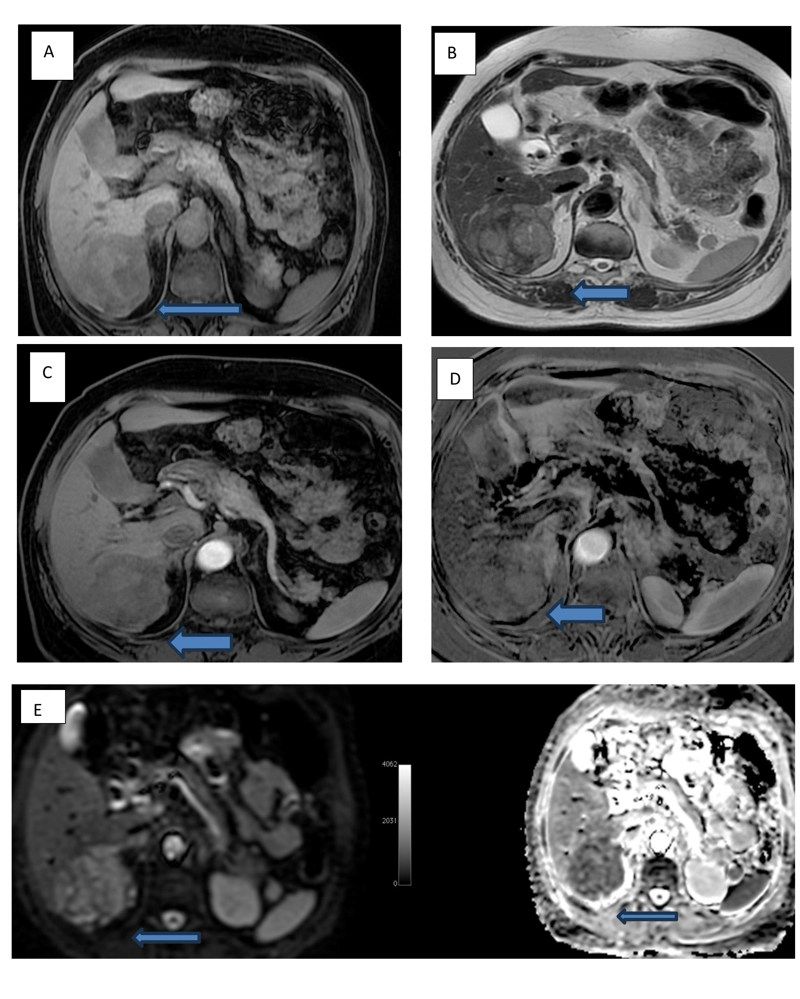
Fig 2. A 72-year-old male patient with liver cirrhosis had undergone a TACE session for a right lobe segment V/VI focal lesion with a follow-up one month later. Dynamic MRI was done with subtraction technique: A. Axial non-contrast T1WI: Heterogeneous signal intensity of partially exophytic lesion (white arrow). B. Axial T2WI: Heterogeneous signal intensity lesion (white arrow). C. Post-contrast arterial phase: No noticeable enhancement compared to the pre-contrast T1WI image. D. Arterial subtracted image: Evidence of lesion enhancement denoting residual activity (white arrow). E: Axial DWI and ADC images showed restricted lesions.

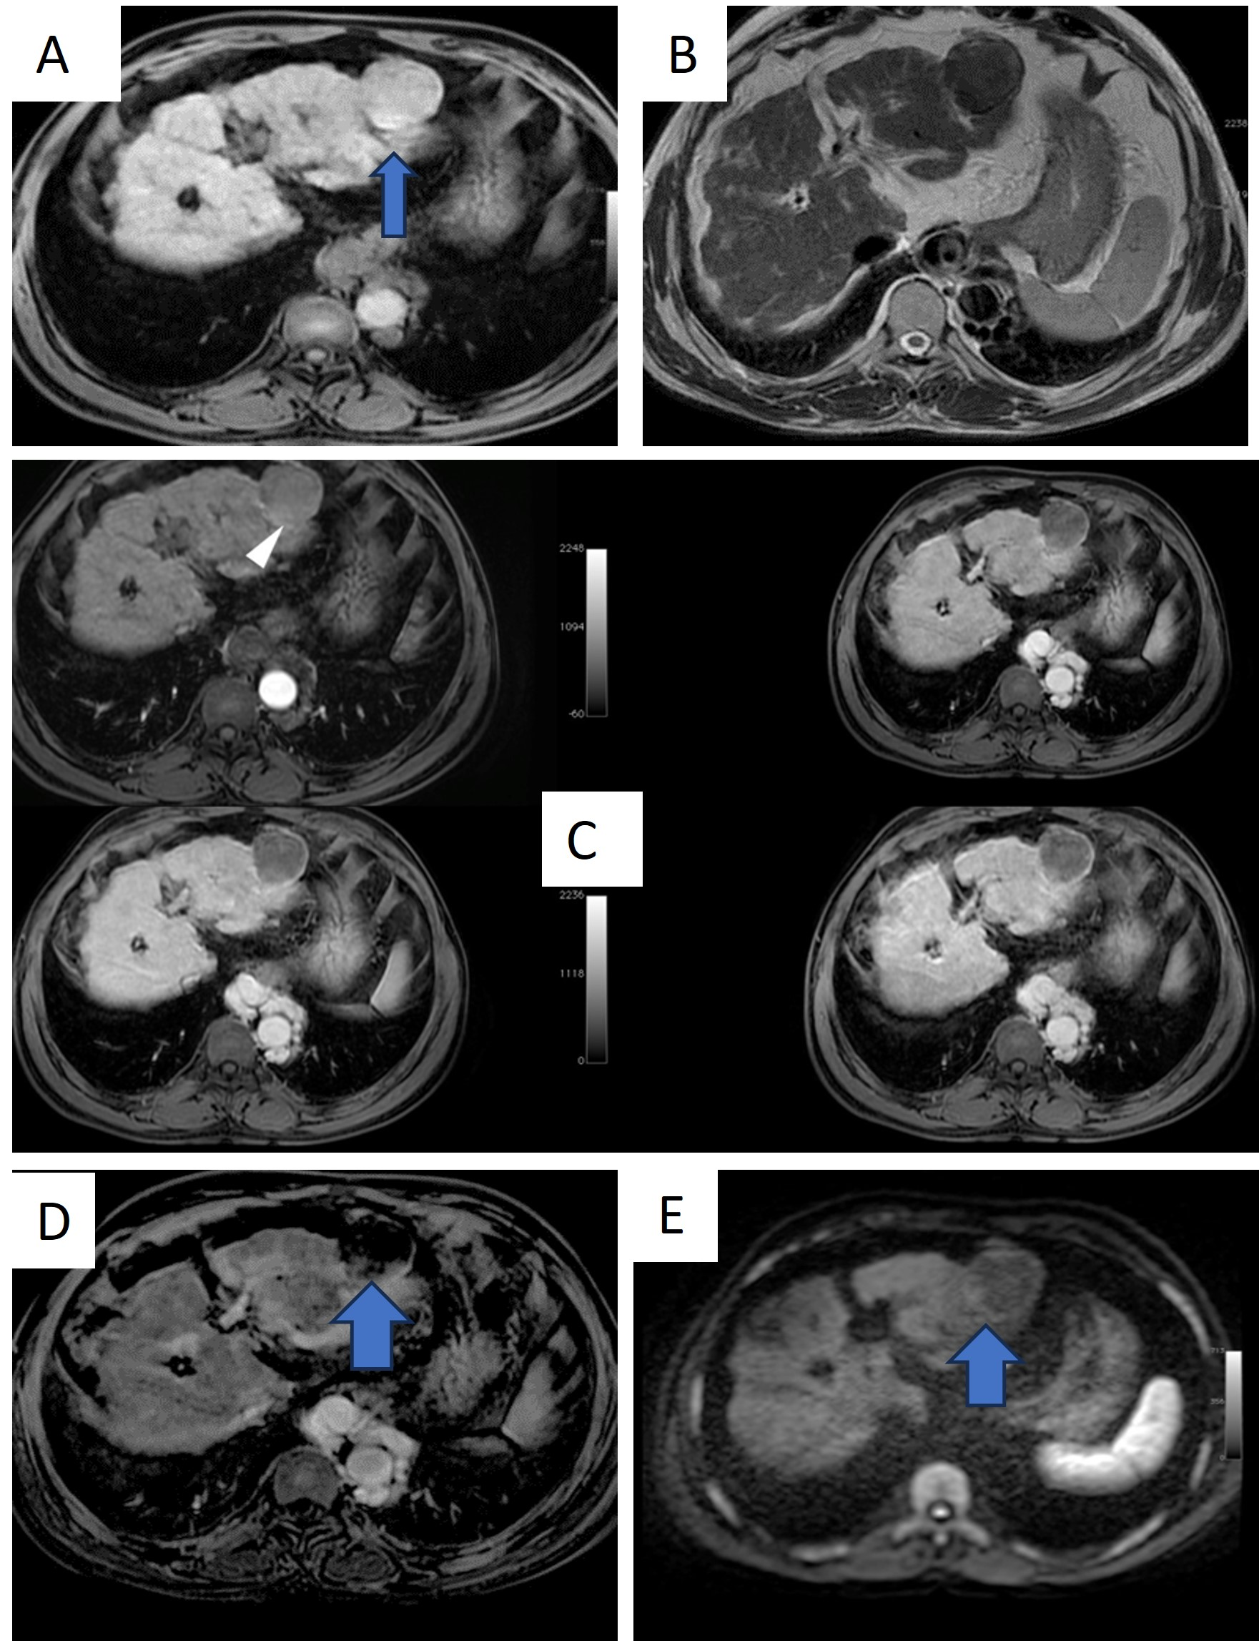
Fig3. A 47-year-old male patient with cirrhosis underwent a TACE session for a left hepatic lobe segment II exophytic focal lesion. Dynamic MRI was done with a subtraction technique1 a month later. A. Axial T1WI pre-contrast: Slight high signal intensity of the managed lesion (white arrow). B. Axial post-T2WI: Low signal intensity lesion. C. Axial dynamic images: No definite enhancement was seen in the arterial phase (white arrowhead). D. Axial subtraction image: evidence of a small area of peripheral enhancement denoting peripheral residual activity (blue arrow). E. Axial diffusion image: Evidence of a small area of peripheral diffusion restriction (blue arrow).
Discussion
Image-guided locoregional therapy, including trans-arterial chemoembolization (TACE) or ablative therapy (Chemical, thermal or cold ablation), is currently advised as a palliative treatment of hepatocellular carcinoma (HCC) for non-surgical patients [14].
Monitoring HCC response to the therapeutic intervention is vital in hepatic imaging. The appropriate response represents the efficacy of treatment with adequate outcomes. Early recognition of failed therapy is a severe step in HCC management with the ability to repeat treatment sessions before advanced-stage disease [15, 16].
Recent advances in MR imaging have yielded the ability to observe cellular tumor changes, thus assessing the tumor response after locoregional therapy by detecting alterations in tumor perfusion with recognizing tumor viability [17]. Dynamic subtraction MR imaging is a post-processing technique as a pre-contrast T1WI is subtracted from the post-contrast arterial image to remove any native T1 signal leaving a signal that is clearly due to enhancement [18].
Good response of hepatocellular carcinoma (HCC) after loco-regional therapy expressed coagulative necrosis, displaying a high T1 signal intensity on the non-contrast MRI, with a tricky assessment of tumor enhancement on the postcontrast dynamic study [19]. In the present survey, we assessed the role of dynamic subtraction MRI in HCC follow-up after interventional management. Our findings illustrated the diagnostic importance of subtraction imaging in detecting tumor viability with high confidence in radiologists.
In our study, the T1 signal was variable in the treated lesions, with 37.5% of our 40 lesions displaying pre-contrast high T1 signal. Our findings agreed with Winters et al. [20], who showed that half of the ablated HCCs displayed a high T1 signal on the non-contrast image [20]. Other examiners also reported similar results, with most of their managed hepatic lesions showing heterogeneous high T1 signal intensity [21, 22].
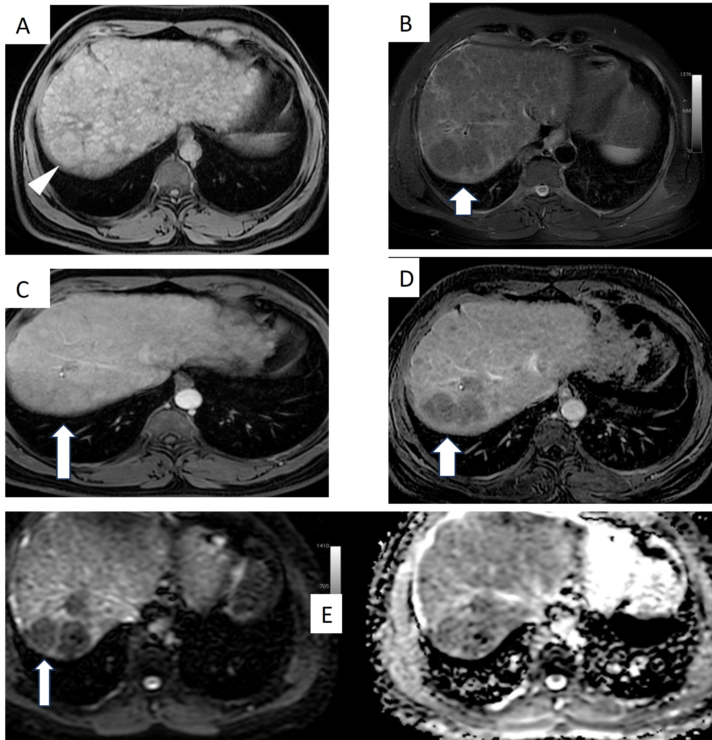
fig4. A 66-year-old female patient with liver cirrhosis underwent a TACE session for a right hepatic lobe segment VII focal lesion. Dynamic MRI was done with subtraction technique one month later: A. Axial T1WI pre-contrast: High signal intensity of the managed lesion (white arrowhead). B. Axial T2WI: Low signal intensity lesion. C. Axial post-contrast arterial image: No definite enhancement of the lesion (blue arrow). D. Axial subtraction image: No enhancement denoting no residual/recurrent activity (blue arrow). E. Axial DWI and ADC images: No evidence of restriction diffusion (white arrow).
Correlation between pre-contrast high T1 signal intensity and the dynamic subtraction MRI (Fig. 1-5), 13 out of 22 viable lesions (59.1%) on subtraction imaging exhibited high signal on non-contrast T1 images. Our data disagreed with Abdallah et al. [23], who noted that a high pre-contrast T1 signal was seen in only 9.7% of their residual lesions.
Regarding the T2 signal intensity, our included lesions showed variable T2 signals, with most (42.5 %) displaying intermediate signals with no significant correlation between T2 signal and tumor activity on
subtraction MRI, especially at the early follow-up imaging. Our findings matched Hussein et al. [24], who also detected varying intensities on T2 WI, and Granata et al. [22], who found no remarkable relation between T2 signal and tumor viability.

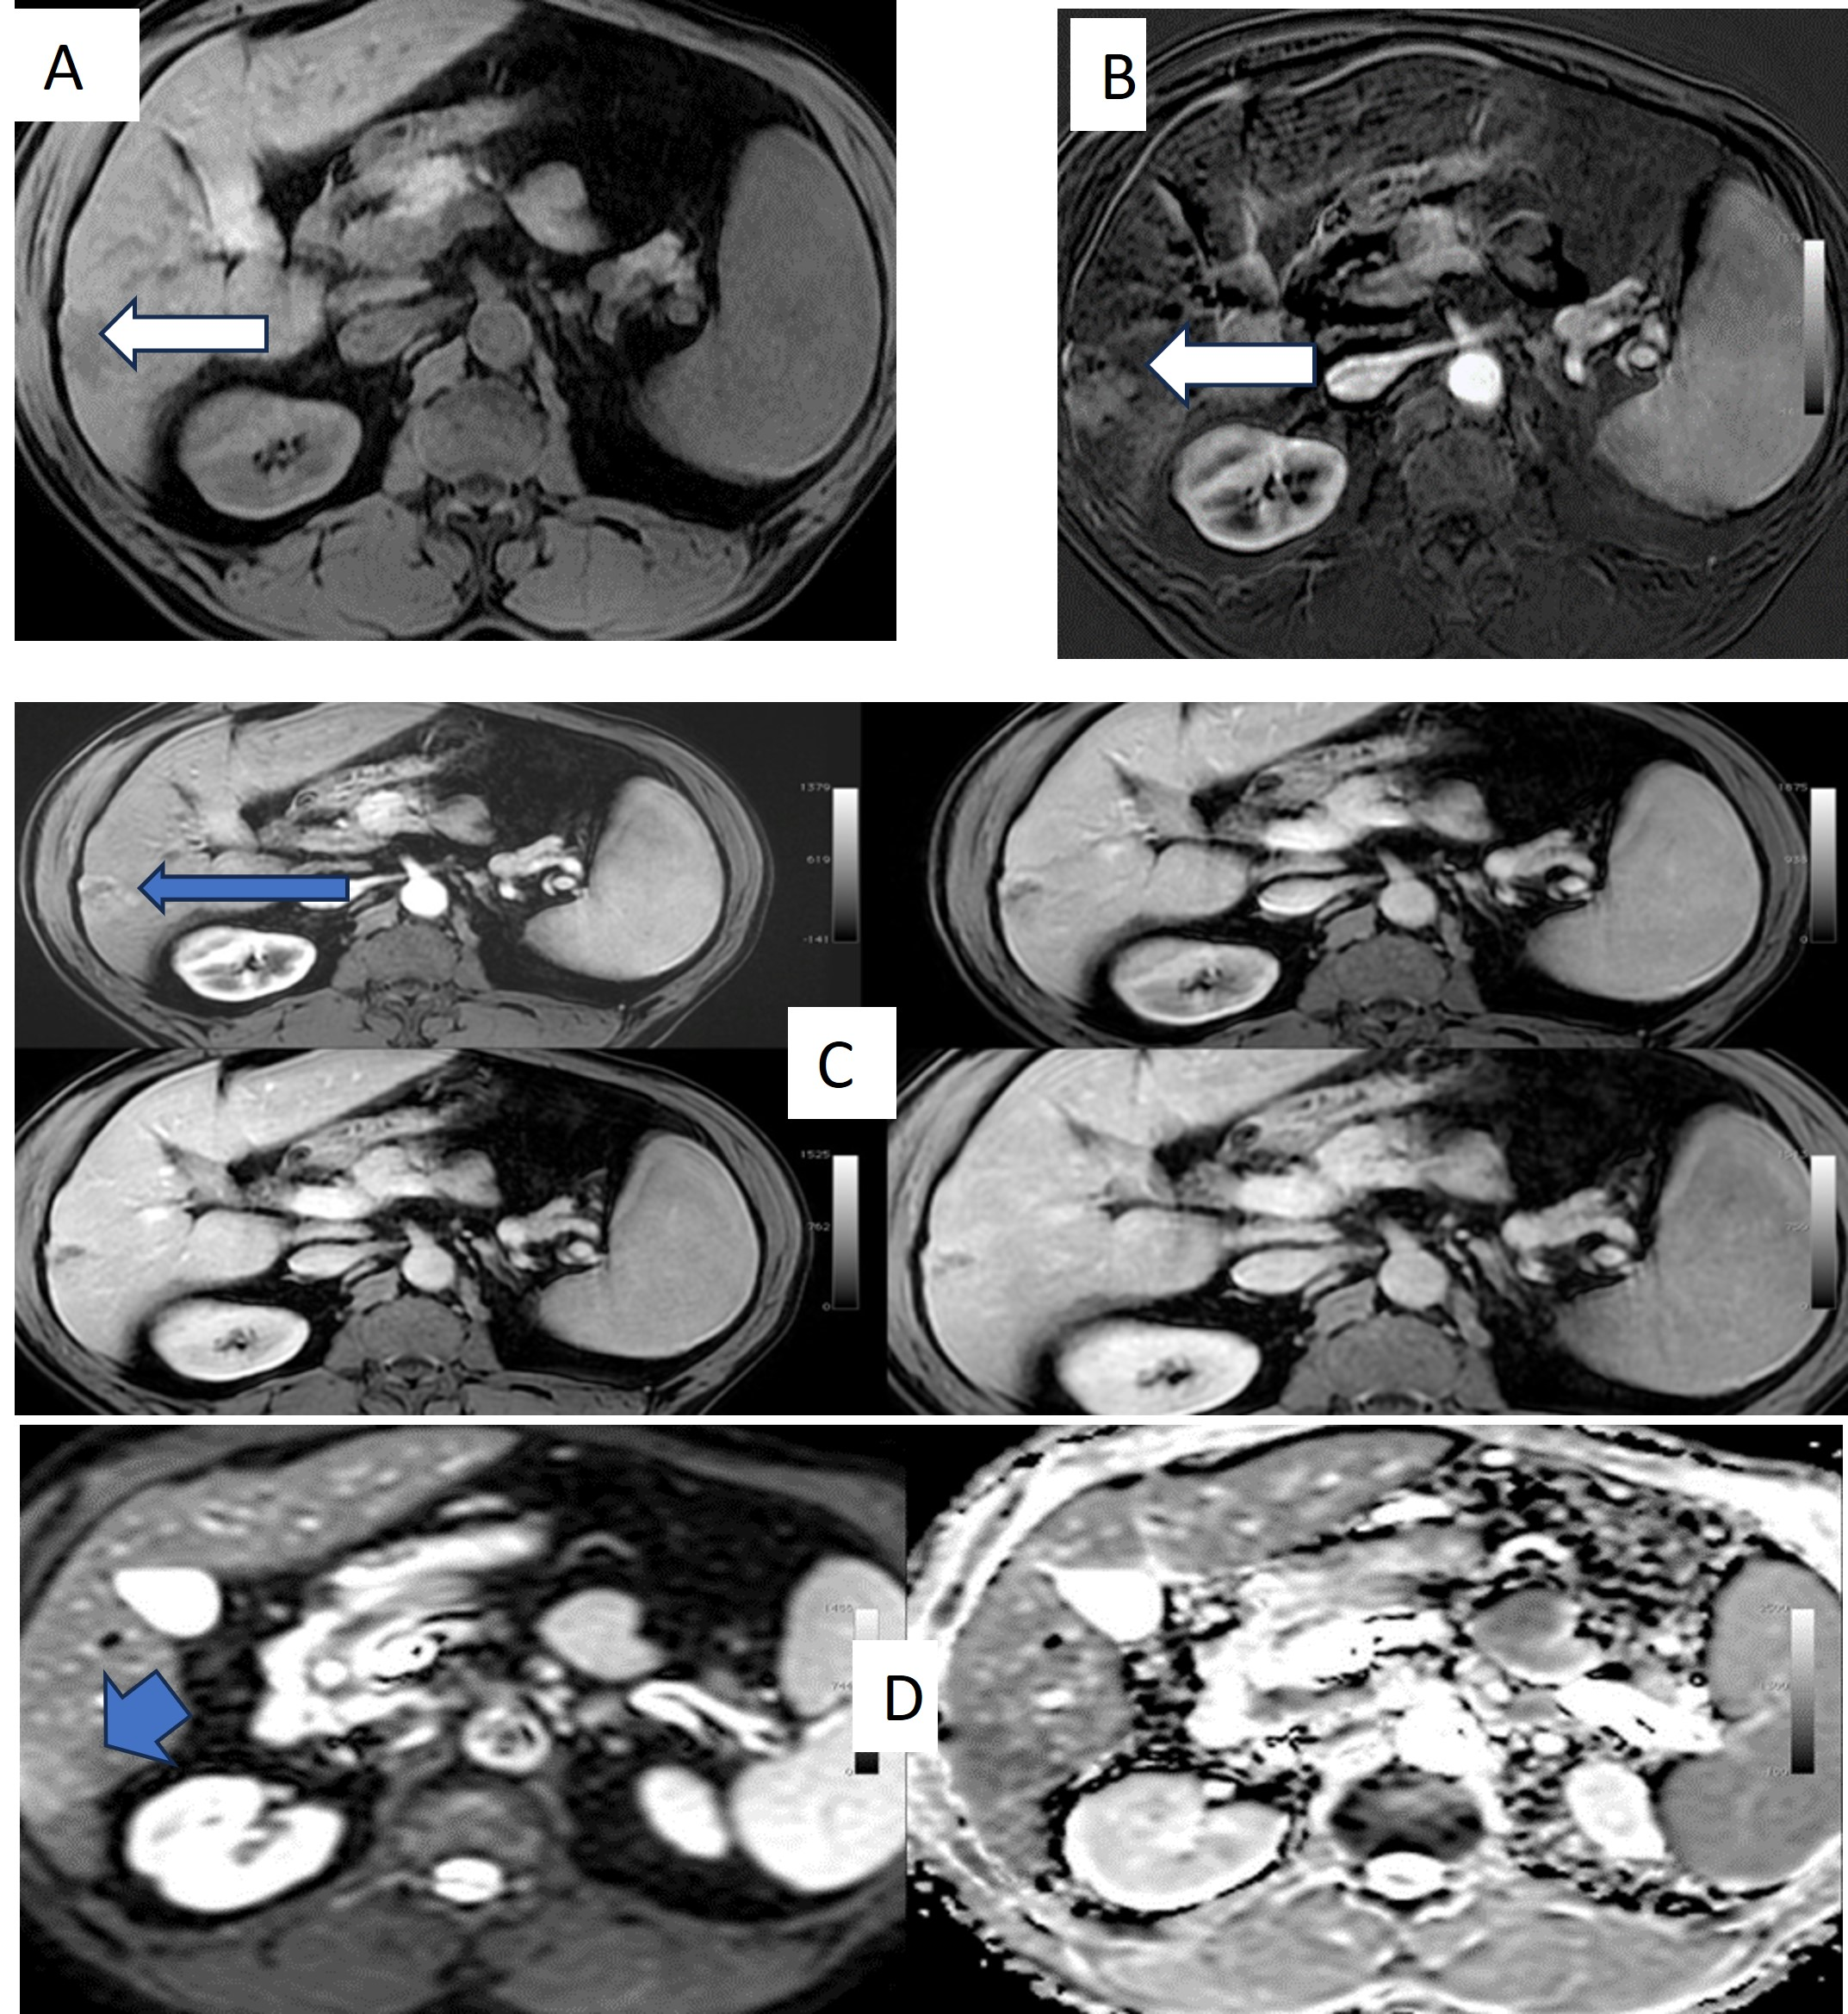
Fig 5: A 46-year-old male patient with liver cirrhosis undergoes radiofrequency ablation (RFA) for a right hepatic lobe segment VI focal lesion. Dynamic MRI was done with subtraction technique one month later: A. Axial T1WI pre-contrast: Low signal Intensity of the ablated lesion (white arrow). B. Axial subtraction image: Lesion enhancement denoting residual activity (white arrow). C. Axial dynamic images: Arterial enhancement of the lesion with delayed wash-out (blue arrow). D. Axial DWI and ADC images: Diffusion restriction of the lesion (blue arrow).
For diffusion-weighted imaging (DWI), our study stated that DWI was not an effective indicator of HCC activity after management, where DWI showed a 45.45% sensitivity, a 100% specificity, a 100% PPV, a 60% NPV and an accuracy of 70% compared to subtraction dynamic MRI with a 100% sensitivity, a 100% specificity, a 100% PPV, a 100% NPV and an accuracy of 100%. Our results agreed with Bolog et al. [10], who observed a low accuracy of DWI in follow-up of managed HCC.
According to the current study, the subtraction imaging has an extra value to the dynamic MRI (P-value <0.001), helping assess the therapeutic efficacy of the locoregional management for HCC with increased observer confidence level. Our results were consistent with Winters et al. [20] and Newatia et al. [25], who get to similar findings about the significance of subtraction MRI in detecting enhancement in the managed hepatic lesions by excluding the preceding high T1 signal from the post-processed images leaving only the signal of enhancement with a better assessment of tumor activity.
Also, subtraction imaging may aid in differentiating the indefinite perilesional enhancement due to post-therapy hyperemia from the interrupted nodular enhancement of viable tumors.
The small sample size leading to reducing the efficacy of statistical analysis and the need for the histopathological assessment of the managed hepatic lesions to confirm complete tumor necrosis or residual disease are considered limitations of our study.
Conclusions
Dynamic subtraction MRI assessment response following loco-regional therapy becomes challenging as the post-treatment coagulative necrosis on early follow-up studies eliciting high pre-contrast T1 signal by adding subtraction technique; detection of enhancement within the increased T1 signal lesions becomes more achievable rising the radiologists’ confidence. Therefore, it is advised to contribute this robust tool as a standard technique for dynamic MRI examination of the liver.
Footnotes.
List of abbreviations
HCC; Hepatocellular carcinoma. MRI; Magnetic resonance imaging. PPV; Positive predictive value. NPV; Negative predictive value. TACE; Transarterial chemoembolization. RFA; Radiofrequency ablation. MWA; Microwave ablation. TARE; Transarterial Yttrium-90 radioembolization. CT; Computed tomography. SGPT; Serum glutamic oxaloacetic transaminase. SGOT; Serum glutamic pyruvic transaminase. DCE-MRI; Dynamic contrast-enhanced magnetic resonance imaging. DWI; Diffusion weighted imaging. ADC; Apparent diffusion coefficient. Gd-DTPA; Gadolinium-diethylenetriamine penta-acetic acid. 3D; Three-dimensional. THID; Transient hepatic intensity difference. SPSS; Statistical Package for Social Science.
Peer-Reviewers: Emad Emara (lecturer of radiology), Ola Elfarargy (professor of medical oncology), Sameh Saber (assistant professor of interventional radiology), and Mohamed Gawad (professor of clinical oncology).
E- Editor: Salem Youssef Mohamed, Osama Ahmed Khalil.
Copyright ©. This open-access article is distributed under the Creative Commons Attribution License (CC BY). The use, distribution, or reproduction in other forums is permitted, provided the original author(s) and the copyright owner(s) are credited. The original publication in this journal is cited by accepted academic practice. No use, distribution, or reproduction is permitted, complying with these terms.
Disclaimer: All claims expressed in this article are solely those of the authors and do not necessarily represent their affiliated organizations or those of the publisher, the editors, and the reviewers. Any product evaluated in this article or its manufacturer's claim is not guaranteed or endorsed by the publisher.
Ethics Approval and Consent to Participate: All procedures followed were by the ethical standards of the responsible committee on human experimentation (Institutional Review Board (IRB)” (00464/2023) of National Liver Institute Menoufia University and with the Helsinki Declaration of 1964 and later version.
Consent for publication: All patients included in this research gave written informed permission to publish the data contained within this study.
Availability of data and materials: The datasets used or analyzed during the current study are available from the corresponding author upon reasonable request.
Competing interests: The authors declare that they have no competing interests.
Funding: This study had no funding from any resource.
Authors’ contributions: RAA, writing the research, selecting research cases, preparing the figures for case demonstration, and reviewing the study. DH, assess patients for initial diagnosis. RAM and HS were considered in case selection and carried out cases on workstations. “All authors read and approved the final manuscript.”
Acknowledgments: Not Applicable.
References
- Willatt J, Ruma JA, Azar SF, Dasika NL, and Syed F. Imaging of hepatocellular carcinoma and image-guided therapies-how we do it. Cancer Imaging 2017; 17(1):9
- Gaia S, Ciruolo M, Ribaldone DG, et al. Higher efficiency of percutaneous microwave (MWA) than radiofrequency ablation (RFA) in achieving a complete response in cirrhotic patients with early hepatocellular carcinoma. Curr Oncol 2021; 28:1034–1044
- Sugawara Y, Yamamoto H, and Hibi T. Living donor liver transplantation for patients with hepatocellular carcinoma in Japan. Hepatoma Res. 2018; 4:33
- Yoshida H, Taniai N, Yoshioka M, et al. Current status of laparoscopic hepatectomy. J Nippon Med Sch 2019; 86:201–206
- Bréhier G, Besnier L, and Delagnes A. Imaging after percutaneous thermal and non-thermal hepatic tumor ablation: normal appear- ances, progression and complications. Br J Radiol 2021 https://doi.org/10. 1259/bjr.20201327.
- Dendy M, Ludwiga J, Steinc S, and Kim H. Locoregional Therapy, Immunotherapy and the Combination in Hepatocellular Carcinoma: Future Directions. Liver Cancer 2019; 8:326–340
- Liu B, Jiang C, Chen S, et al. Multipronged ethanol ablation combined with TACE for intermediate hepatocellular carcinoma. Minim Invasive Ther Allied Technol. 2018; 27(5):300–8.
- Riaz A, Miller FH, Kulik LM, et al. Imaging response in the primary index lesion and clinical outcomes following transarterial locoregional therapy for hepatocellular carcinoma. JAMA 2010; 303:1062–9.
- Violi N, Gnerre J, Law A, et al. Assessment of HCC response to Yttrium-90 radioembolization with gadoxetate disodium MRI: correlation with histopathology. European Radiology, 2022; 32: 6493–6503
- Bolog N, Pfammatter T, Mullhaupt B, Andreisek G, and Weishaupt D. Double-contrast magnetic resonance imaging of hepatocellular carcinoma after transarterial chemoembolization. Abdom. Imaging 2008; 33:313–323.
- Sainani NI, Gervais DA, Mueller PR, and Arellano RS. Imaging after percutaneous radiofrequency ablation of hepatic tumors: part 1, normal findings. Am J Roentgenol 2013; 200:184–193
- European Association for the Study of the Liver; European Organization for Research and Treatment of Cancer EASL–EORTC clinical practice guidelines: management of hepatocellular carcinoma. J Hepatol 2012; 56:908–943
- El said N, Kaddah R, Abdel Fattah M, and Salama N. Subtraction MRI versus diffusion weighted imaging: Which is more accurate in assessment of hepatocellular carcinoma after Trans Arterial Chemoembolization (TACE)? The Egyptian Journal of Radiology and Nuclear Medicine 2016; 47: 1251–1264.
- Özkavukcu E, Haliloglu N, and Erden A. Post-treatment MRI findings of hepatocellular carcinoma. Diagn Interv Radiol 2009; 15:111–20.
- Kim KW, Lee JM, andChoi BI. Assessment of the treatment response of HCC. Abdom Imaging 2011; 36:300–314.
- Borde T, Nezami N, Gaupp FL, et al. Optimization of the BCLC Staging System for Locoregional Therapy for Hepatocellular Carcinoma by Using Quantitative Tumor Burden Imaging Biomarkers at MRI. RSNA; https://doi.org/10.1148/radiol. 2022; 212426.
- Yaghmai V, Besa C, Kim E, Gatlin JL, Siddiqui NA, and Taouli B. “Imaging assessment of hepatocellular carcinoma response to locoregional and systemic therapy,” American Journal of Roentgenology, vol. 201, no. 1, 2013; p: 80–96.
- Eid M, and Abougabal A. Subtraction images: a really helpful tool in non-vascular MRI. Egypt J Radiol Nucl Med 2014; 45(3):909–919.
- Gordic S, Corcuera-Solano I, Stueck A, et al. Evaluation of HCC response to locoregional therapy: Validation of MRI-based response criteria versus explant pathology. J Hepatol 2017; 67(6): 1213–1221.
- Winters SD, Jackson S, Armstrong GA, Birchall IW, Lee KH, and Low G. Value of subtraction MRI in assessing treatment response following image-guided loco-regional therapies for hepatocellular carcinoma. Clin. Radiol 2012; 67:649–655.
- Kierans AS, Elazzazi M, Braga L, et al. Thermoablative treatments for malignant liver lesions: 10-year experience of MRI appearances of treatment response. Am J Roentgenol 2010; 194:523–529. https://doi.org/10.2214/AJR.09. 2621.
- Granata V, Petrillo M, Fusco R, Setola SV, de Lutio di Castelguidone E, Catalano O, et al. (Surveillance of HCC patients after liver RFA: role of MRI with hepato-specific contrast versus three-phase CT scan-experience of high-volume oncologic institute. Gastroenterolo Res ract. https://doi.org/10.1155/2013; 2013/469097.
- Abdallah MFH, Desouky SHI, Madbouly M,
Hassan M, Hanna A, and Mahmoud AA. Follow-up after radiofrequency ablation of hepatocellular carcinoma: diffusion weighted and dynamic contrast-enhanced MRI characteristics. Med J Cairo Univ 2021; 89:297–305.
- Hussein RS, Tantawy W, and Abbas YA. MRI assessment of hepatocellular carcinoma after locoregional therapy. Insights Imaging 2019; 10:8. https://doi. org/10.1186/s13244-019-0690-1
- Newatia A, Khatri G, Friedman B, and Hines J. Subtraction imaging: applications for nonvascular abdominal MRI. AJR 2007; 188:1018–1025.

