ORIGINAL RESEARCH
Targeted drug delivery of capecitabine to mice xenograft gastric cancer by PAMAM dendrimer nanocarrier
Sharareh Jafari^{1a, 1b}, Fatemeh Nabavizadeh^{1b}*, Jalal Vahedian², Mehdi Shafie Ardestani³, Hedayat Samandari¹, Ali Zare Mehrjerdi⁴
1ª- Electrophysiology Research Center, Neurosciences Institute, Tehran University of Medical Sciences, Tehran, Iran
1^{b}- Department of Physiology, Medical school, Tehran University of Medical Sciences, Tehran, Iran
2- Department of Surgery, Firoozgar Hospital, Iran University of Medical Sciences, Tehran, Iran
3- Department of Radiopharmacy, Faculty of Pharmacy, Tehran University of Medical Sciences, Tehran, Iran
4- Department of Pathology, Firoozgar Hospital, Iran University of Medical Sciences, Tehran, Iran
Running title: Capecitabine and xenograft gastric cancer
* Fatemeh Nabavizadeh (Corresponding author).
DOI: https://dx.doi.org/10.52378/fkh195276
E-mail: nabavizadeh@tums.ac.ir
Fax: +98 (21)66419484
Phone: +98 (21)66419484
Mobile: +989133410451.
Received: February 12, 2019.
Peer-review started: February 15, 2019.
First decision: February 27, 2019.
Revised: March 1, 2019.
The second round of peer review, copyediting, and proofreading (by journal editors): March 15, 2019.
Accepted: March 20, 2019.
The article in press: March 21, 2019.
First online: March 24, 2019.
Informed consent statement: Informed consent was obtained from the patients.
Conflict-of-interest statement: All authors declare no conflict-of-interest related to this article.
Abstract
Aims:
This study used an animal xenograft model of gastric cancer induction to investigate the therapeutic effects of capecitabine polyamidoamine (PAMAM) dendrimer complex against cancer and its potential side effects.
Methods and Materials:
Human gastric cancer tissue was obtained from patients with gastric carcinoma and transplanted into mice. Anticancer drug capecitabine was loaded into PAMAM dendrimer nano-carrier and injected into the animals. All animals received cyclosporine before the surgery.
Results:
Capecitabine-dendrimer complex reduced the size of the axillary implanted tumor, the levels of AST and ALP, and the drug-induced adverse effects on other body organs. Furthermore, it increased apoptotic and necrotic responses in the grafted tumor, RBC, WBC, and platelet counts compared to free capecitabine.
Conclusions:
In the gastric cancer settings, the PAMAM dendrimer drug delivery method effectively improved therapeutic index and outcomes and reduced undesirable side-effects of the capecitabine.

Keywords: Gastric cancer, Xenograft, Capecitabine, Cyclosporine, Poly amidoamine dendrimer (PAMAM), Mice.
Introduction
Gastric carcinoma (GC) is the third leading cause of cancer-related death worldwide [1]. It is somewhat rare before the age of 40, but its occurrence steadily increases and reaches a peak around 70 [2]. Gastric cancer pathophysiology is complicated, so people with the same clinical stage may face a different prognosis. According to the new atlas of the cancer genome, gastric cancer can be classified into four major types based on multi-dimensional profiling, (1) tumor based on Epstein -Barr virus, (2) microsatellite unstable tumor, (3) genomically solid tumor, and chromosomal instable one [3].
Radical therapy, i.e., surgical resection of the cancerous area, is the primary treatment for gastric cancer, although recurrence is still high in this approach, even with total gastrectomy[4]. The high recurrence rate is related to abundant lymphatics within the gastric wall that provides channels for mucosal skip lesions and numerous potential lymphatic drainage pathways away from the stomach[4]. Combination therapy, radiotherapy, and chemotherapy are highly recommended [5]. Capecitabine (Xeloda®) is a prodrug that is routinely prescribed for gastric, colorectal, and breast cancers [6, 7]. Upon administration, it is converted to 5-fluorouracil (5-Fu) in the tumor that can inhibit DNA synthesis and slow down tumor growth [8, 9]. In mice, capecitabine has a maximum tolerance dose (MTD) of 700mg/kg/day administered orally once a day for two weeks with one week rest [10, 11]. The treatment of 400mg/kg/day administered orally for 14 days with one week rest is also effective though MTD (700mg/kg/day) protocol is more efficacious.
Despite suppressive tumor effects of the chemotherapeutics, undesirable side effects owing to the cytotoxic nature of the agents are a matter of concern [12-14]. Furthermore, these are relatively nonspecific and can damage other cells, mainly proliferative. Myelosuppression, diarrhea, alopecia, and liver malfunction should also be added. Broad body drug distribution makes high doses and re-administration inevitable.
A safe and sound medical modality free from dose limits and sequels persuades researchers to adopt a targeted drug delivery approach as one of the main subjective cancer treatments nowadays [16-20]. Dendritic architecture has more advantages over the other carrier systems, particularly in drug delivery, because of its unique properties. Compared with traditional linear polymers, dendrimers exhibit significantly improved physical and chemical properties[21].
In that sense, the enhanced permeability and retention (EPR) effect would be a reliable index to assess polymeric drug delivery characteristics used mainly in cancer research. The index describes the propensity of macromolecules to accumulate in solid tumors [26]. Tumoral tissues have a stable nature and incontrollable angiogenesis with leaky walls that allow easy molecule permeation. Lack of lymphatic drainage causes the drug molecules to be retained and slowly released in the cancer cells and conceivably increases the curative power compared to the standard drug delivery systems [26, 27].
Poly (amidoamine) dendrimers (PAMAM) are polymeric macromolecules that can find their use as carriers of biologically and medically essential molecules such as fragments of genetic material, drugs, or vitamins. The most frequently tested polymers of this kind include dendrimers of the PAMAM class, especially those belonging to the fourth (G4) and fifth (G5) generations.
A single molecule of PAMAM G4 with ethylenediamine core contains about 250 potential binding sites comprising 64 surface primary amine groups, 62 internal tertiary amine, and 124 amide chains [28]. Oral administration of PAMAM dendrimers was first reported by Wiwattanapatapee et al. [29].
Accordingly, the PAMAM dendrimer drug delivery method seems to have a practical philosophy for drug transport and can increase prognosis outcomes with less unwanted aftermath.
In this study, we tested the PAMAM dendrimer-capecitabine complex for treating bilateral mouse axillary implanted tumors with human sources and compared it with the conventional free capecitabine chemotherapy in low and high doses on tumor size, damage; blood cells count, liver enzymes, and apoptosis pathway.
Material and method:
1.1. Materials
PAMAM-G4-NH2 (14,215 g/mol, 64 amine end groups) was purchased from Aldrich chemical company, Germany. Capecitabine (500mg tablet) and cyclosporine were taken from NOVARTIS, Switzerland. Cyclosporin was diluted with distilled water to the desired concentration and injected into the animals. Capecitabine tablets were grounded, dissolved in methanol, passing through a filter paper, and then a rotary evaporator evaporated methanol, and a pure powder of the drug was obtained. The drug was dissolved in 10 percent DMSO and used for animal injections or formulation with PAMAM dendrimer nano-carrier.
1.2. Animals
Forty male NMRI inbred albino mice aged 6-8 weeks (30-35 g) were provided from the Physiology Department at Tehran University of Medical Sciences (TUMS). The animals were divided into five equal-sized study groups. This weight range decreased inevitable surgical and chemotherapeutic effects, e.g., gross weight loss. Animals were kept in a temperature-controlled environment with a 12:12 light/dark cycle with free access to food and water. All procedures were according to the guidelines for the care and use of laboratory animals of Tehran University of medical sciences.
1.3 Collection of Tumor Tissues
Patients with pathologically proven Lauren’s intestinal-type gastric cancer received curative resection at the general surgery Department, Firoozgar Hospital, Iran University, Tehran, Iran, between July; 2015 till August 2016. Patients received no preoperative anticancer treatments such as neoadjuvant chemotherapy or radiotherapy. The ethics committee approved the study of the surgery Department in Firoozgar Hospital. Patients gave written consent before the research based on the inclusion criteria. We kept the resected tumors in a solution that contained normal saline, heparin, and streptomycin. Fine pieces (0.5× 1× 1mm) of tumor tissues were taken and implanted to the mice armpit during an hour post-resection. In this study, the tumor was bilaterally implanted in the animal's axillary region to increase the chances of grafting and its growth. Cyclosporine (10mg/kg; i.p.), an immune suppressor, was used from the working day until grafted tumor reached about 1500mm3 in size [30]. Tumor volume was measured every three days with a suitable caliper according to the following formula [30]:
Tumor volume= length × depth × height/2
1.4 Study design
According to the study protocol, forty male NMRI inbred albino mice were equally divided into five groups of 8 as follows:
- Control cancer group (Cancer) in which animals received cyclosporine first and underwent the surgical procedure as per study protocol
In the Capecitabine group, animals received cyclosporine first and then oral capecitabine (700mg/kg/day) for a week through a feeding tube followed by a week rest [11].
- PAMAM dendrimer group in which animals received cyclosporine first and then PAMAM dendrimer (20µg/kg) [31] for a week through a feeding tube followed by a week rest.
- Capecitabine (700 mg/kg) -PAMAM dendrimer complex group (700 C+P) in which animals received cyclosporine first and then oral capecitabine (700mg/kg/day) + PAMAM dendrimer (5:1 v/v %) for a week through a feeding tube followed by a week rest [11].
- Capecitabine (400 mg/kg) -PAMAM dendrimer complex group (400 C+P) in which animals received cyclosporine first and then oral capecitabine (400mg/kg/day) + PAMAM dendrimer (5:1 v/v %) for a week through a feeding tube followed by a week rest.
Subcutaneous axillary tumor implant was carried out in sterile condition under general anesthesia with ether inhalation in a bell jar. The surgical site was sewn with a 7-0 nylon stitch. Animals were individually placed in their respective cages to recover post-anesthesia. On first post-op day, they received cyclosporine (10mg/kg/day; i.p.) as per above-mentioned protocol.
Capecitabine calibration curve, capecitabine dendrimer encapsulation; Drug Loading Concentration (DLC), and Encapsulation Efficiency (EE) were adopted from our previous studies [31].
1.5 Capecitabine preparation:
Capecitabine tablets (500 mg) were grounded and solved using a unique shaker in met. The solution was filtered with filter paper and then placed in the Rota evaporator at 37 ^{ο}C for methanol evaporation [31]. Ethanol Prepared solution kept in the dark container at four οC degrees until use. The estimated purity degree was %87 as per the following formula [31]:
Purity degree= (purified yield mass / total mass) × 100
1.6 Laboratory tests
At the end of the study, animals were anesthetized with ketamine (50 mg/kg, i.p.) to perform a midline laparotomy. Midsternotomy was also done for cardiac blood sampling [27]. One ml of blood sample was centrifuged for 5 min at 7000 rpm for serum collections [32]. Serological parameters including alanine aminotransferase (ALT), aspartate aminotransferase (AST), and alkaline phosphatase (ALP) were then measured using appropriate Commercial ELISA kits (Provided from Biorbyt Canada) as previously described [27, 33]. Complete cell blood count was also done using an extra 1 ml blood sample.
1.7 Genetic testing
Upon completion of the study, grafted tumors were excised under general anesthesia with Ketamine (50 mg/kg i.p.), kept in a nitrogen tank, and finally put in -70 °C deep freeze till real-time PCR measurement for Bax and Bcl2 gene expression compared with GAPDH line as previously described [34].
Total RNA was extracted from the tissue with TRIzol (GIBCO, Grand Island, NY, USA). With a Spectrophotometer, we determined the RNA quantity and purity. Also, agarose gel electrophoresis was performed to check RNA integrity (0.8% agarose; Gibco/BRL). cDNA synthesis was carried out with Prime Script First-Strand (cDNA Synthesis Kit, Takara, Japan). One μg of total RNA was converted to the complementary DNA in the final volume of 20 μl (reversely transcript). All primers (Bax, Bcl-2, and GAPDH as an endogenous control gene) were purchased from a Qiagen primer bank. We used Step One Plus Real-Time PCR System (Applied Biosystems, USA) for the real-time PCR reaction. Two μl of cDNA, two μl of primer, and SYBR Green Master Mix (Takara, Japan) were mixed according to the manufacturer’s protocol in a total volume of 20 μl.
Real-time PCR designed primers
BCL2- forward | TGGTCTTCTTTGAGTTCGG
BCL2- reverse | GGCTGTACAGTTCCACAA
BAX-forward | CGCCCTTTTCTACTTTGACA
BAX-reverse | GTGACGAGGCTTGAGGAG
GAPDH- forward | GCA GGG ATG ATG TTC TGG
GAPDH- reverse | CTT TGG TAT CGT GGA AGG AC
1-8 Pathological assay:
Grafted tumors were collected together with other organs like the stomach, colon, small intestine, and liver to check for possible tissue metastasis with microscopic examination of the metastatic nodules. Tissues were fixed in 10% formaldehyde first and then packaged and embedded in paraffin. Paraffin blocks of nine serial sections (3-5 µm thickness) were taken for the hematoxylin and eosin staining technique.
1-9 Statistical analysis:
Results were expressed as means ± SEM. Analysis of variance (ANOVA) and post hoc Tukey test were used to compare groups. P-values below 0.05 were considered statistically significant. Pathological results were presented in graphic form. We used SPSS version 22 to analyze the DATA.
Results
2.1. Tumor growth
Tumor grafts were bilaterally embedded to have more available tissues. In 32 out of 40 mice (80%), tumoral tissues were remarkably grown in the left armpit than the right. In 8 remaining mice (20%), right side tissues became more prominent than the left (Fig 1).
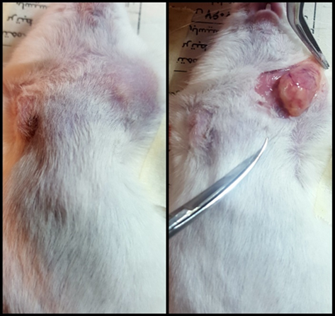
Fig1: tumor growth site. The left side was more developed than the right side
2.2. Effect of capecitabine and capecitabine-PAMAM dendrimer complex on tumor size
Tumor size in the control cancer group was significantly bigger than capecitabine received animals (P <0.001). In 700 C+P, tumor tissues were considerably smaller than capecitabine received animals (P <0.05). In the 400 C+P groups, tumoral size changes were negligible to the size in this group was significantly bigger than 700 C+P, and capecitabine received animals (P <0.001). In PAMAM dendrimer received animals, tumor size was nearly unchanged compared to the cancer group (Fig 2).
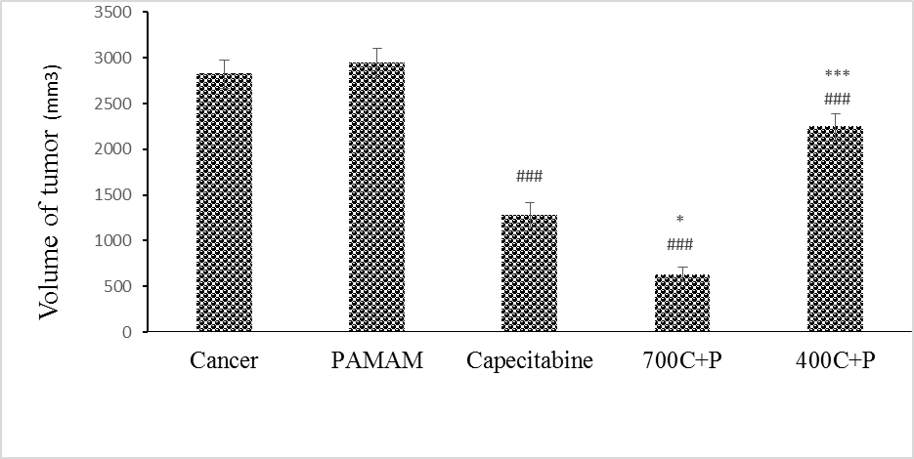
Fig2: tumor volume changes (PAMAM= Poly Amido Amin, 700C+P= Capecitabine (700mg/kg) – PAMAM dendrimer, 400C+P= Capecitabine (400mg/kg) – PAMAM dendrimer).
### shows a significant difference in comparison with the cancer group at the level of P <0.001. * indicates a significant difference in comparison with the Capecitabine group at the level of P <0.05.*** showed a substantial difference in comparison with the Capecitabine group at the level of P <0.001.
2.3. Liver enzymes:
In capecitabine received animals, AST (Fig 3), ALT (Fig 4), and ALP (Fig 5) were significantly elevated compared to the control of cancer animals.
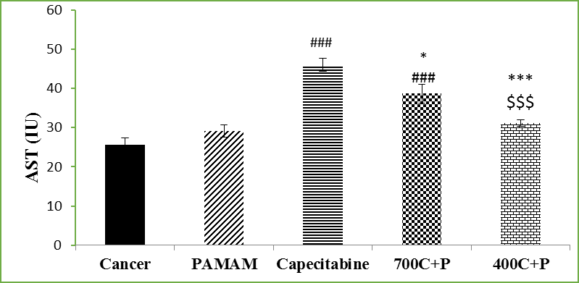
Fig 3: AST level in experimental groups. ### The significant difference compared with the control cancer (cancer) group at p <0.001. *** Significant difference compared with the capecitabine group at p <0.001.* Significant difference compared with the capecitabine group at p <0.05. $$$ significant difference compared with Capecitabine (700 mg/kg) -PAMAM dendrimer complex group (700 C+P) (700C+P) group at the level of p <0.001.
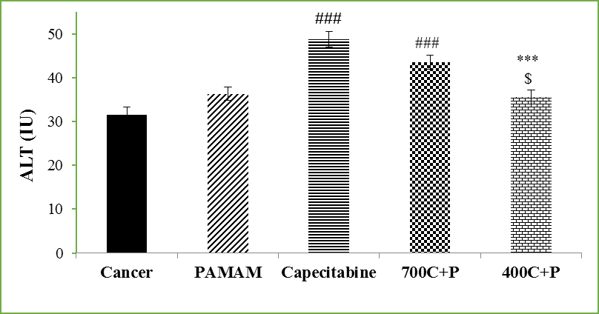
Fig 4: ALT level in experimental groups. ### shows a significant difference compared to the control cancer group at P <0.001. *** showed a substantial difference compared to the Capecitabine group at P <0.001. $ showed a considerable difference compared to the 700C+P group at P <0.05.
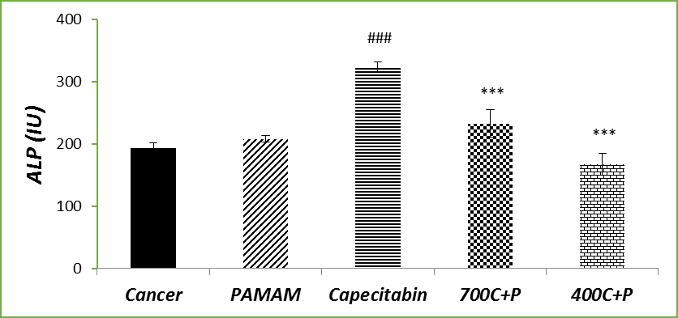
Fig5: ALP level in experimental groups. ### shows a significant difference compared to the cancer group at the level of P <0.001. *** showed a substantial difference compared to the Capecitabine group at P <0.001.
However, in the 700 C+P groups, both AST and ALP were significantly reduced compared with capecitabine received animals (p <0.05, P <0.001, respectively). In 400 C+P, all liver enzymes were significantly decreased compared with 700 C+P. No significant changes in ALP, AST, and ALT levels were seen in PAMAM dendrimer received animals.
2.4. Blood cell study:
Red blood cell (RBC) count significantly lowered in the capecitabine group than control cancer group (P <0.001, Fig 6).
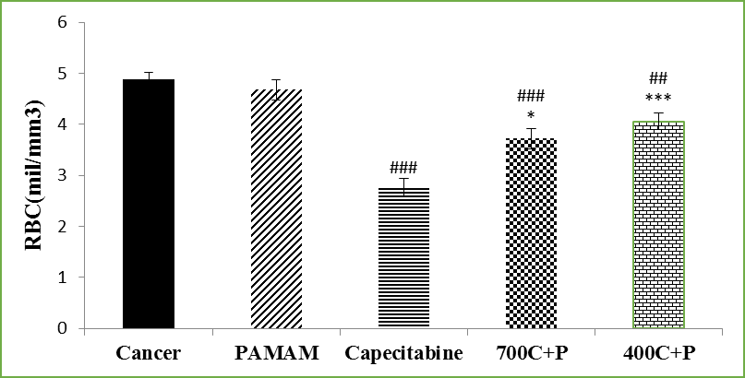
Fig 6: RBC count in different experimental groups. ### shows a significant difference in comparison with the cancer group at the level of P <0.001. ## shows a substantial difference in comparison with the cancer group at the level of P <0.01. *** showed a significant difference in comparison with the Capecitabine group at the level of P <0.001. * Showed a substantial difference in comparison with the Capecitabine group at the level of P <0.05.
However, in the 700 C+P groups, the RBC count was significantly increased compared to capecitabine received animals (P <0.05). In the 400 C+P groups, the RBC count significantly increased with an astonishing rise compared with 700 C+P. White blood cell (WBC) and platelet counts followed the same changes (Fig 7) and (Fig 8), respectively.
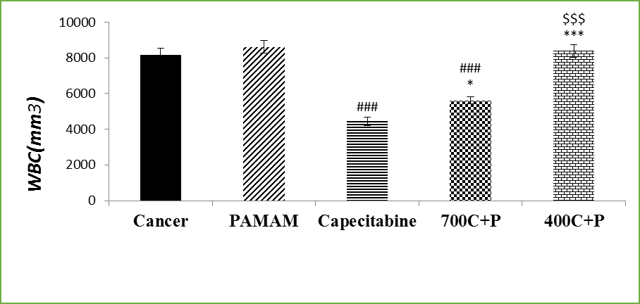
Fig 7: WBC count in different experimental groups. ### shows a significant difference compared to the cancer group at P <0.001. *** showed a substantial difference compared to the Capecitabine group at P <0.001. * showed a significant difference compared to the Capecitabine group at P <0.05. $$$ showed a substantial difference in contrast with the 700C+P group at P <0.001.
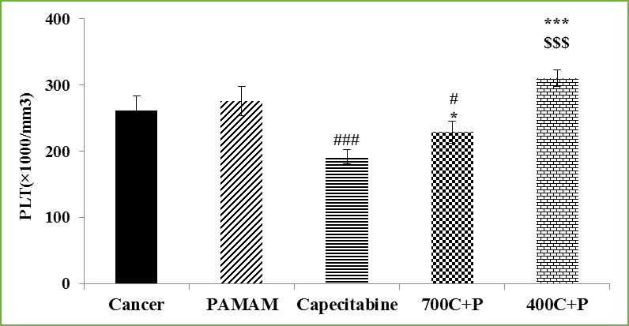
Fig 8: PLT count in different experimental groups. ### shows a significant difference in comparison with the cancer group at the level of P <0.001. # shows a substantial difference in comparison with the cancer group at the level of P <0.05. $$$ showed a considerable difference in contrast with the 700C+P group at the level of P <0.001. * showed a significant difference in comparison with the Capecitabine group at the level of P <0.05. *** showed a substantial difference in comparison with the Capecitabine group at the level of P <0.001
2.5 Real-time PCR:
In this study, capecitabine significantly increased Bax but decreased Bcl2 gene expressions compared with animals in the control cancer group (P <0.05, P <0.001 respectively, Fig 9 and 10). In the 700 C+P groups, Bax was increased, and Bcl2 decreased significantly compared to control cancer and capecitabine groups (P <0.001, P <0.001, respectively). In 400 C+P groups, Statistical analysis showed that Bax expression was increased, and Bcl2expression was reduced compared to 700 C+P groups. Unexpectedly in PAMAM dendrimer received animals, Bax protein gene expression was significantly increased while the Bcl2 was decreased compared with capecitabine and control cancer groups. (Fig 9, Fig 10).
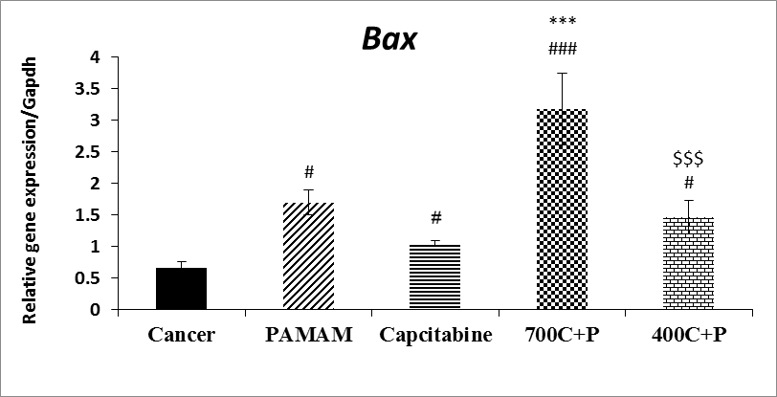
Fig 9: Protein expressing the gene Bax changes in different experimental groups. ### shows a significant difference compared to the cancer group at P <0.001. # shows a substantial difference compared to the cancer group at P <0.05. *** showed a considerable difference compared to the Capecitabine group at P <0.001. $$$ demonstrated a substantial difference in contrast to the 700C+P group at P <0.001.
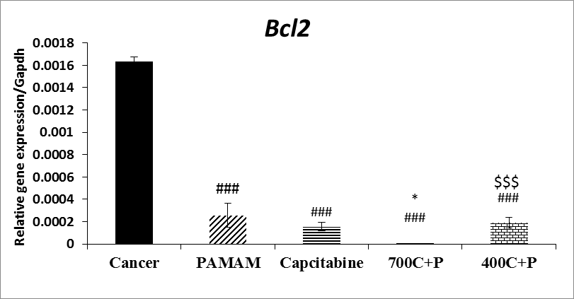
Fig 10: Protein expressing the gene Bcl2 changes in different experimental groups. ### shows a significant difference in comparison with the cancer group at the level of P <0.001. $$$ showed a substantial difference in contrast with the 700C+P group at the level of P <0.001. * showed a significant difference in comparison with the Capecitabine group at the level of P <0.05.
2-6 Histological findings:
No significant histological changes indicating metastatic process were noted in other body organs such as the colon, stomach, and pancreas. In capecitabine received animals, portal inflammation and diffuse hepatocyte hydronic changes were observed (Fig 11).
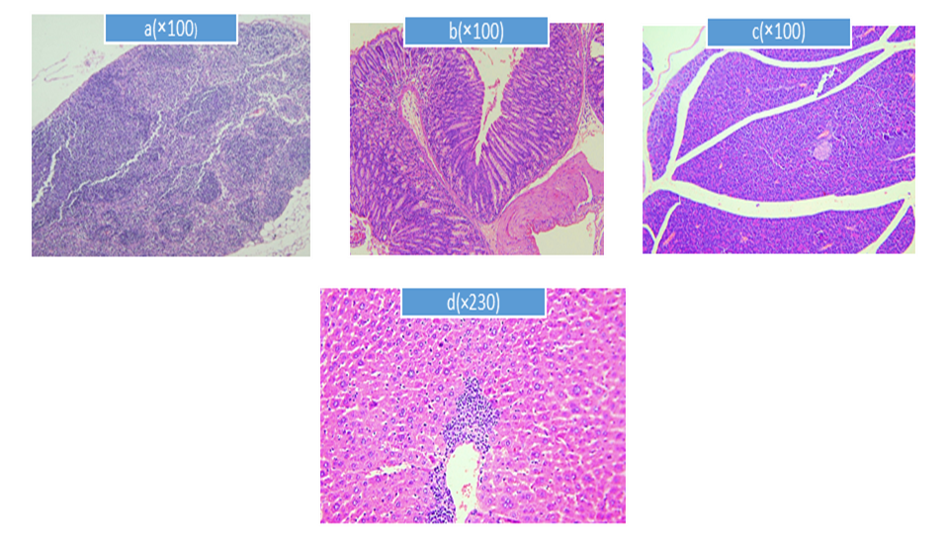
Fig11: Histological changes after H and E staining in organs. This picture was selected randomly from all groups. a: stomach didn’t show any pathological changes. b: Colon was clear from metastasis and any pathological changes. c: Pancreas was also evident. d: portal inflammation and diffuse hydronic change in the hepatocyte. Scale bar: 100 µm.
Xenograft tumor in the control cancer group showed adenocarcinomatous appearance with body inflammatory reaction. In capecitabine received animals, despite extensive drug-induced necrosis, pre-cancerous changes also been appeared. In the 400 C+P groups, little necrotic response to visible invasive cancer cells was noted. In the 700 C+P groups, drug-induced a highly intensive necrotic response with no viable cancer cells were found. Implanted tumor in PAMAM dendrimer received group is like the control cancer group, i.e., visible cancer cells were also seen (Fig 12).
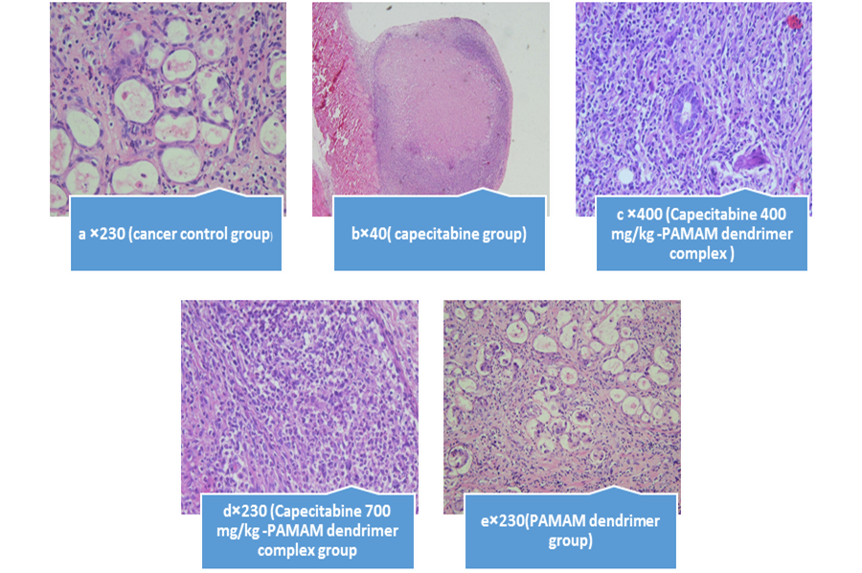
Fig12: Histological changes after H and E staining in the implanted tumor. A (cancer control group): adenocarcinoma cell with body inflammatory reaction; b (capecitabine group): extensive necrosis with pre-cancerous lesion; c (Capecitabine 400 mg/kg -PAMAM dendrimer complex group) little necrotic response to invasive cancer cells; d (Capecitabine 700 mg/kg -PAMAM dendrimer complex) high intensive necrotic response, there is no viable cancer cell; e (PAMAM dendrimer group) cancer cells are visible. Scale bar: 100 µm.
Discussion
Decreasing chemotherapeutic side effects is one of the primary goals of cancer chemotherapy in a clinical atmosphere that can be attained in different ways. The drug delivery approach is among the safest and vastly used modalities in the clinical setting. In the current study, we first made a human-based mouse gastric cancer model using live human tumoral tissues grafted to the mice armpits in cyclosporine received immune-suppressed animals.
We investigated capecitabine-PAMAM dendrimer complex administration to improve drug delivery and attenuate high chemotherapeutics’ side effects. Capecitabine in complex form could remarkably reduce liver side effects and decrease tumor size in neoadjuvant chemotherapy.
The growth of tumors in most animals (80%) was on the left, and only a slight (20%) tumor was shown on the right side of the body. In a study of arterial blood flow in mice in 2016, the arterial branches of this animal were identified by location and side. The axillary artery responsible for the blood flow to the underlying region has nine branches on the right and 19 branches to the left [35]. Growing the tumor requires an adequate blood supply to the tissue and the necessary factors to grow through the blood. Perhaps the cause of further tumor growth on the left is related to the more vascular branches on that side.
The growth of the tumor was minimal in-depth, which could be due to the implantation of a tumor under the skin and above the muscle that limits tumor growth.
Studies show that the vascular permeability of the cancerous tissues is higher than healthy tissues. Enhanced permission and retention effect (EPR) caused the capecitabine-PAMAM dendrimer complex to accumulate in tumoral tissues and decreased tumor size compared to other experimental groups[36].
It seems that prescription capecitabine in a complex form with dendrimer can better target affected tissues, prevent drug distribution to other organs, and increase health index. Failure to observe a significant difference between the complex group at 700 and 400 on the length, width, and depth scale and the presence of cancerous cells in the histological examination at 400 dose may be due to shortened chemotherapy duration in the treatment cycle. Tumor sizes in the two study groups were statistically significant in our pathology findings.
As chemotherapy drug carriers, Dendrimers can provide specific treatment for different tumor tissues, prevent the distribution of drugs in healthy tissues, and prevent broad drug distribution without interfering with the healing process or tumor size in various tissues [15].
In this study, capecitabine could significantly reduce RBCs, WBCs, and platelet count in the capecitabine-treated group compared to the control. Blood cell counts in the capecitabine-treated group were substantially lower than capecitabine-dendrimer complex received animals.
However, in our study, blood cell count in the PAMAM dendrimer group was not significantly different from the control group, which is incongruent with other similar studies in which PAMAM dendrimers could reduce red blood cells. In contrast, it increases white blood cells count [37].
Our results also showed increased Bax protein gene expression and reduced Bcl2 protein gene expression together with increased cell death and degradation following capecitabine administration in both 400 and 700 doses in complex form though in different quality, irrespective of the low therapeutic cycle.
Despite previous research findings, we showed that PAMAM dendrimer might affect the apoptosis process via increased Bax protein gene expression and reduced Bcl2 protein expression. This finding may be due to possible interactions between dendrimers side chains such as amine groups and the affected cells. Our results need further research to be confirmed.
Conclusion:
Targeted chemotherapy has always been a wish for researchers to prevent the adverse effects of chemotherapy in cancer research and nano dendrimers seem to be very close to this ideal. Although we showed positive proapoptotic and safe drug delivery findings in the capecitabine PAMAM dendrimer complex method, a long way is still on our horizon to clarify the precise mechanisms and prove its efficacy and safety.
Acknowledgment
This study was financially supported by the Tehran University of medical sciences (TUMS), and we would like to thank TUMS for this support.
Footnotes
The ARRIVE Checklist statement: The author has read the ARRIVE Checklist, and the manuscript was prepared and revised according to the ARRIVE Checklist.
Citation of this article: Jafari S, Nabavizadeh F, Vahedian J, Ardestani MS, Samandari H, Mehrjerdi AZ. Targeted drug delivery of capecitabine to mice xenograft gastric cancer by PAMAM dendrimer nanocarrier. African journal of gastroenterology and hepatology [Internet]. Egypt’s Presidential Specialized Council for Education and Scientific Research; 2019 Mar 24;2(1):30-55. Available from: http://dx.doi.org/10.52378/fkh195276.
Peer- Reviewers: Hayam Rashed, Samia Hussein, Amr Hanafy, Nisreen Elway. Executive- Editors: Mohamed Elmedames, E- Editor: Salem Y Mohamed, Nahed Hussein.
Copyright ©. This open-access article is distributed under the Creative Commons Attribution License (CC BY). The use, distribution, or reproduction in other forums is permitted, provided the original author(s) and the copyright owner(s) are credited. The original publication in this journal is cited by accepted academic practice. No use, distribution, or reproduction is permitted, which does not comply with these terms. Disclaimer: All claims expressed in this article are solely those of the authors and do not necessarily represent their affiliated organizations or those of the publisher, the editors, and the reviewers. Any product that may be evaluated in this article or claim that its manufacturer may make it not guaranteed or endorsed by the publisher.
References:
1. Chu SJ, Wang G, Zhang PF, Zhang R, Huang YX, Lu YM, et al. MicroRNA-203 suppresses gastric cancer growth by targeting PIBF1/Akt signaling. J Exp Clin Cancer Res. 2016;35:47.
2. Dicken BJ, Bigam DL, Cass C, Mackey JR, Joy AA, Hamilton SM. Gastric adenocarcinoma: review and considerations for future directions. Ann Surg. 2005;241(1):27-39.
3. Choi YY, Noh SH, Cheong JH. Molecular Dimensions of Gastric Cancer: Translational and Clinical Perspectives. J Pathol Transl Med. 2016;50(1):1-9.
4. Jung JJ, Cho JH, Shin S, Shim YM. Surgical treatment of anastomotic recurrence after gastrectomy for gastric cancer. Korean J Thorac Cardiovasc Surg. 2014;47(3):269-74.
5. Lim DH, Kim DY, Kang MK, Kim YI, Kang WK, Park CK, et al. Patterns of failure in gastric carcinoma after D2 gastrectomy and chemoradiotherapy: a radiation oncologist's view. Br J Cancer. 2004;91(1):11-7.
6. Schull B, Scheithauer W, Kornek GV. Capecitabine as salvage therapy for a breast cancer patient with extensive liver metastases and associated impairment of liver function. Onkologie. 2003;26(6):578-80.
7. Cats A. New developments in systemic chemotherapy in advanced colorectal cancer. Scand J Gastroenterol Suppl. 2003(239):78-86.
8. O'Shaughnessy JA. Potential of capecitabine as first-line therapy for metastatic breast cancer: dosing recommendations in patients with diminished renal function. Ann Oncol. 2002;13(6):983.
9. Ishitsuka H. Capecitabine: preclinical pharmacology studies. Invest New Drugs. 2000;18(4):343-54.
10. Cao S, Durrani FA, Rustum YM. Synergistic antitumor activity of capecitabine in combination with irinotecan. Clin Colorectal Cancer. 2005;4(5):336-43.
11. Kolinsky K, Shen BQ, Zhang YE, Kohles J, Dugan U, Zioncheck TF, et al. In vivo activity of novel capecitabine regimens alone and with bevacizumab and oxaliplatin in colorectal cancer xenograft models. Mol Cancer Ther. 2009;8(1):75-82.
12. Twibanire JDK, Grindley TB. Polyester Dendrimers: Smart Carriers for Drug Delivery. Polymers-Basel. 2014;6(1):179-213.
13. Mignani S, El Kazzouli S, Bousmina M, Majoral JP. Dendrimer space concept for innovative nanomedicine: A futuristic vision for medicinal chemistry. Progress in Polymer Science. 2013;38(7):993-1008.
14. Lee IH, Yu MK, Kim IH, Lee JH, Park TG, Jon S. A duplex oligodeoxynucleotide-dendrimer bioconjugate as a novel delivery vehicle for doxorubicin in vivo cancer therapy. J Control Release. 2011;155(1):88-95.
15. Richardson JL, Marks G, Levine A. The influence of disease symptoms and side effects of treatment on compliance with cancer therapy. J Clin Oncol. 1988;6(11):1746-52.
16. Maslov MY, Edelman ER, Wei AE, Pezone MJ, Lovich MA. High drug concentrations in target tissues following local controlled release are utilized for both drug distribution and biologic effect: an example with epicardial inotropic drug delivery. J Control Release. 2013;171(2):201-7.
17. Najlah M, D'Emanuele A. Synthesis of dendrimers and drug-dendrimer conjugates for drug delivery. Curr Opin Drug Discov Devel. 2007;10(6):756-67.
18. Minagawa K, Berber MR, Hafez IH, Mori T, Tanaka M. Target delivery and controlled release of the chemopreventive drug sulindac by using an advanced layered double hydroxide nanomatrix formulation system. J Mater Sci Mater Med. 2012;23(4):973-81.
19. Langer R. Drug delivery. Drugs on target. Science. 2001;293(5527):58-9.
20. Falciani C, Accardo A, Brunetti J, Tesauro D, Lelli B, Pini A, et al. Target-selective drug delivery through liposomes labeled with oligobranched neurotensin peptides. ChemMedChem. 2011;6(4):678-85.
21. Kesharwani P, Jain K, Jain NK. Dendrimer as nanocarrier for drug delivery. Progress in Polymer Science. 2014;39(2):268-307.
22. Maeda H, Matsumura Y. EPR effect based drug design and clinical outlook for enhanced cancer chemotherapy. Adv Drug Deliv Rev. 2011;63(3):129-30.
23. Keereweer S, Mol IM, Kerrebijn JD, Van Driel PB, Xie B, Baatenburg de Jong RJ, et al. Targeting integrins and enhanced permeability and retention (EPR) effect for optical imaging of oral cancer. J Surg Oncol. 2012;105(7):714-8.
24. Park K. Questions on the role of the EPR effect in tumor targeting. J Control Release. 2013;172(1):391.
25. Fang J, Nakamura H, Maeda H. The EPR effect: Unique features of tumor blood vessels for drug delivery, factors involved, and limitations and augmentation of the effect. Adv Drug Deliv Rev. 2011;63(3):136-51.
26. Maeda H, Bharate GY, Daruwalla J. Polymeric drugs for efficient tumor-targeted drug delivery based on EPR-effect. Eur J Pharm Biopharm. 2009;71(3):409-19.
27. Zhang Y, Sun M, Huang G, Yin L, Lai Q, Yang Y, et al. Maintenance of antiangiogenic and antitumor effects by orally active low-dose capecitabine for long-term cancer therapy. Proc Natl Acad Sci U S A. 2017;114(26):E5226-E35.
28. Buczkowski A, Sekowski S, Grala A, Palecz D, Milowska K, Urbaniak P, et al. Interaction between PAMAM-NH(2) G4 dendrimer and 5-fluorouracil in aqueous solution. Int J Pharm. 2011;408(1-2):266-70.
29. Wiwattanapatapee R, Carreno-Gomez B, Malik N, Duncan R. Anionic PAMAM dendrimers rapidly cross adult rat intestine in vitro: a potential oral delivery system? Pharm Res. 2000;17(8):991-8.
30. Jivrajani M, Shaikh MV, Shrivastava N, Nivsarkar M. An improved and versatile immunosuppression protocol for the development of tumor xenograft in mice. Anticancer Res. 2014;34(12):7177-83.
31. Barzegar Behrooz A, Nabavizadeh F, Adiban J, Shafiee Ardestani M, Vahabpour R, Aghasadeghi MR, et al. Smart bomb AS1411 aptamer-functionalized/PAMAM dendrimer nanocarriers for targeted drug delivery in the treatment of gastric cancer. Clin Exp Pharmacol Physiol. 2017;44(1):41-51.
32. Lemoine S, Pillot B, Augeul L, Rabeyrin M, Varennes A, Normand G, et al. Dose and timing of injections for effective cyclosporine A pretreatment before renal ischemia reperfusion in mice. PLoS One. 2017;12(8):e0182358.
33. Friedman TC, Sinha-Hikim I, Parveen M, Najjar SM, Liu Y, Mangubat M, et al. Additive effects of nicotine and high-fat diet on hepatic steatosis in male mice. Endocrinology. 2012;153(12):5809-20.
34. Wang JM, Xiao BL, Zheng JW, Chen HB, Zou SQ. Effect of targeted magnetic nanoparticles containing 5-FU on expression of bcl-2, bax and caspase 3 in nude mice with transplanted human liver cancer. World J Gastroenterol. 2007;13(23):3171-5.
35. Roche. XELODA®(capecitabine) PRODUCT MONOGRAPH [Available from: http://www.rochecanada.com/en/products/pharmaceuticals/consumer_information/xeloda.html.
36. Tanaka T, Shiramoto S, Miyashita M, Fujishima Y, Kaneo Y. Tumor targeting based on the effect of enhanced permeability and retention (EPR) and the mechanism of receptor-mediated endocytosis (RME). Int J Pharm. 2004;277(1-2):39-61.
37. Domanski DM, Klajnert B, Bryszewska M. Influence of PAMAM dendrimers on human red blood cells. Bioelectrochemistry. 2004;63(1-2):189-91.

