Fibrofast and Fibrosis-4 versus Fibroscan as Indicators of Hepatic Fibrosis in Non-Alcoholic Fatty Liver Disease Patients: A Cross-Sectional Study
Rehab Badawi¹, Boshra El-Sayed Hussein¹, Mona Mohamed Watany² Hala Moustafa Elsabagh³⁻⁴, and Walaa Elkhalawany¹
- Tanta University Hospital, Tropical Medicine and Infectious Diseases Department, Faculty of Medicine, El-Geesh St., Tanta, Egypt
- Clinical Pathology Department, Faculty of Medicine, Tanta University Hospital, El-Geesh St., Tanta, Egypt
- Basic Medical Science Department, Faculty of Dentistry, Majmaah University, Majmaah, 11952, Saudi Arabia
- Public Health and Community Department, Faculty of Medicine, Tanta University, El-Geesh St., Tanta, Egypt
Corresponding Author
Rehab Badawi, MD.
Department of Tropical Medicine and Infectious Diseases, Faculty of Medicine, Tanta University
El-Giash Street 31527, Tanta, Egypt.
Tel: +2-01014860506.
Email: dr.rb.badawi@gmail.com, rehab.elsheshtawy@med.tanta.edu.eg.
DOI:10.21608/AJGH.2022.153872.1010
Type of manuscript: original research
Conflict of interest: N / A
Funding source: This research received no specific grant from any funding agency in the public, commercial, or not-for-profit sectors.
Date of submission: 2 August 2022.
Revised: 10 September 2022.
Accepted: 12 September 2022.
First online: 12 September 2022.

Abstract:
Aims:
Non-alcoholic fatty liver disease (NAFLD) is a broad category for a disease spectrum that includes simple steatosis, which can proceed to non-alcoholic steatohepatitis, cirrhosis, and, finally, hepatocellular carcinoma. Owing to the invasive nature of liver biopsy, the need for non-invasive tools were required for diagnosis.
Objective:
To compare the performance of simple biochemical scores (fibroblast) FIB-5 and (fibrosis-4) FIB-4 with fibroscan to differentiate mild to moderate fibrosis (MF; F0 to F2) from advanced fibrosis (AF; F3 to F4) in patients with NAFLD.
Patients and methods:
This cross-sectional study was done on 116 NAFLD patients. All patients were scanned with the FibroScan examination. FIB-5 and FIB-4 were calculated for all patients.
Results:
The mean kPa score (liver stiffness measurement score) of the patients belonging to advanced fibrosis [9.53 ± 1.05]. The FIB-4 score was significantly higher in patients with advanced fibrosis (1.54 ± 0.38) compared with patients with mild to moderate fibrosis (1.18 ± 0.44), p-value = 0.001, whereas the FIB-5 score was insignificant between patients.
Conclusion:
FIB-4 is superior to FIB-5 as a non-invasive simple marker in diagnosing advanced fibrosis in NAFLD patients.
Keywords: fibroscan, liver biopsy, non-invasive markers, FIB-5, FIB-4, non-alcoholic fatty liver disease, CAP, liver fibrosis, LSM, fatty liver.
Introduction:
Non-alcoholic fatty liver disease (NAFLD) was identified as a pathological entity in 1980 as a disorder that resembles alcoholic fatty liver disease with significant fat infiltration to the liver but without excessive alcohol use or other causes of liver disease [1].
With an estimated prevalence of twenty to forty percent, NAFLD is one of the most frequent liver disorders in the developed and developing world [2]. Our expertise in NAFLD has progressed over the last forty years to broadly establish a relationship to metabolic dysregulation as a significant factor in the disease's pathophysiology [3-6].
NAFLD is a broad category for a disease spectrum that includes non-alcoholic fatty liver (NAFL) or simple steatosis, which can proceed to non-alcoholic steatohepatitis (NASH), and cirrhosis. Finally, hepatocellular carcinoma (HCC) and end-stage liver disease (ESLD), in the end, severely impaired liver function has occurred [7]. Even without cirrhosis, advanced cases of NAFLD can develop into HCC [8].
The liver biopsy is the gold standard for diagnosing NAFLD patients. However, due to its intrusive nature and related complications (e.g., hemorrhage), non-invasive techniques for evaluating liver fibrosis and steatosis have been developed in recent years, such as transient elastography, controlled attenuation parameter, or magnetic resonance depending. As a result, emphasis was placed on non-invasive imaging modalities, particularly transient elastography. For example, vibration-controlled transient elastography (VCTE) is a novel technology for measuring mean liver stiffness in a non-invasive way. In addition, some devices offer a controlled attenuation parameter (CAP) that may measure hepatic steatosis, allowing for the assessment of both hepatic fibrosis and steatosis in the same situation without any side consequences [9, 10].
The FIB-5 score was developed by Attallah et al. and is based on three biochemical markers (AST/ALT ratio, albumin, alkaline phosphatase (ALP), and one hematological marker (platelet count). The score was verified on 604 chronic HCV patients [11].
Fibrosis- 4 (FIB-4) is a scoring system to estimate the grade of liver fibrosis using a combination of the patient's age, platelet count, aspartate transaminase (AST), and alanine transaminase (ALT), all readily available to a primary care physician, besides being inexpensive [12].
The objective of this study was to compare the performance of simple biochemical scores; FIB-5 and FIB-4, with fibroscan to differentiate mild to moderate fibrosis (MF; F0 to F2) and advanced fibrosis (AF; F3 to F4) in patients with NAFLD.
Patients and methods:
The site, Type, and Study Period
This cross-sectional study was done on 116 patients who presented to Tanta University Hospital's Department of Tropical Medicine and Infectious Diseases between December 2021 and June 2022.
Before the study began, the Ethical Committee approved it following the Helsinki Declaration (approval number:35108 \12\ 21). The purpose of the research was explained to all participants, and each patient signed an informed consent form before being enrolled in the study.
Three hundred fifteen patients were screened by abdominal ultrasound for the presence of bright liver. Grading of steatosis revealed by ultrasound was done according to Saadeh et al. as follows [29]:
- Grade 1: the echogenicity of the liver is just increased.
- Grade 2: echogenicity of liver obscures the echogenicity of walls of portal vein branches.
- Grade 3: echogenicity of the f liver obscures the diaphragmatic outline.
200 Patients with bright liver then undergo fibroscan examination.
The diagnosis of hepatic steatosis in NAFLD patients was confirmed by a CAP score of more than 237 dB/ m. Of these, 116 male or female patients older than 18 with CAP score More than 237 dB/ m are included in the study (figure 1).
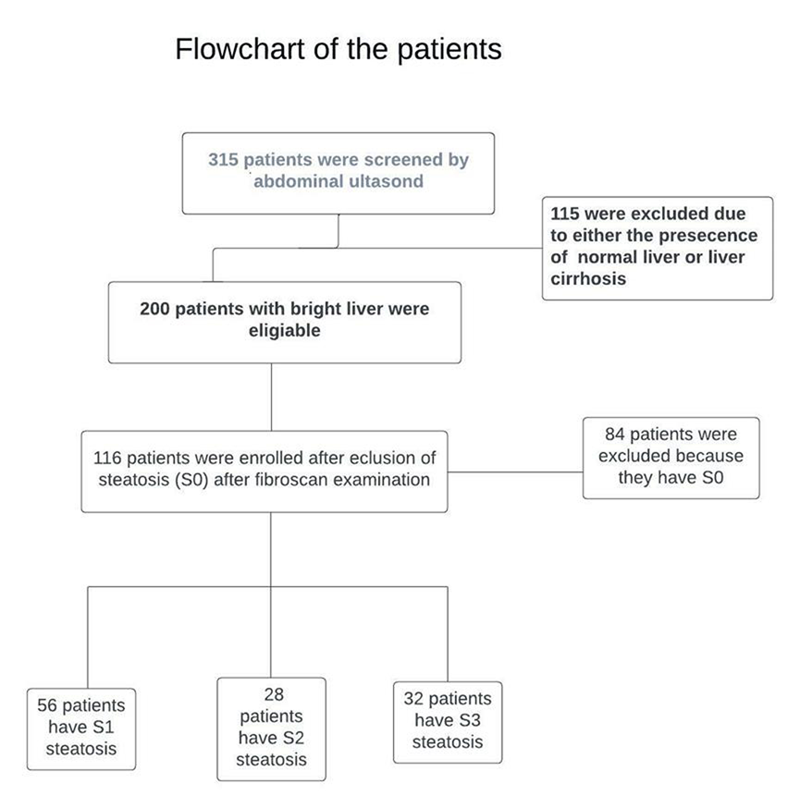
Fig 1: Flowchart of the patients
Any patient with chronic hepatitis B, hepatitis C, drug-induced liver disease, autoimmune liver disease, renal failure, febrile patients, or any stress condition was excluded from the study.
All patients who fulfilled the inclusion criteria were encouraged to get a detailed history. Therefore, they were subjected to thorough clinical examination, including height, weight, body mass index, waist-hip ratio (WHR), history of other metabolic diseases, e.g., diabetes mellitus and hypertension, as well as basic laboratory tests such as complete blood count (CBC), blood urea, serum creatine, ALT, AST, international normalization ratio (INR), total bilirubin, serum albumin, alkaline phosphatase, and total lipid profile.
The laboratory investigations were carried out in the clinical pathology department, faculty of medicine, Tanta University. CBC was performed on K3 EDTA blood using an automated cell coulter (ERMA PCE 210, Tokyo, Japan). Serum levels of urea, creatinine, total bilirubin, albumin, and complete lipid profile, as well as ALT, AST, and ALP enzymes activity were measured using a fully automated chemistry analyzer (Konelab Prime 60i, Konelab, Helsinki, Finland) with the compatible chemicals supplied from ThermoFisher scientific ™.
The score was calculated using the following equation:
- FIB 5 score = [albumin (g/L) x 0.3+ platelet count (10 (9) /L) x 0.05] - [alkaline phosphatase (IU/L) x 0.014+AST/ALT ratio x6+14[11]
- FIB-4 score= Age [years]×AST(IU/L))/(platelet count(109/L)×(ALT (IU/L))1\2[13]
Fibroscan; Transient Elastography
All patients were scanned with the EchosensTM FibroScan. A 3.5 MHz ultrasonic transducer is installed on the axis of a low amplitude vibrator in the Fibroscan® probe (frequency of 50 Hz and amplitude of 2 mm peak-to-peak).
An experienced operator blinded to the patient's diagnosis and data performed the liver stiffness measurement (LSM) and Controlled Attenuation Parameter (CAP). Only findings with ten accurate shots and an interquartile range IQR/median liver stiffness ratio of 30% were considered credible. Both liver stiffness measurement (LSM) and CAP were collected from the same region of the liver parenchyma (between 25 and 65mm in depth) [14].
The final LSM and CAP values were presented in Kpa and dB/ m, respectively [15].
According to the METAVIR scoring system, significant fibrosis was classified as fibrosis stage ≥ F2, severe fibrosis was defined as fibrosis stage ≥ F3, and cirrhosis was defined as fibrosis stage = F4. These categories constituted at least significant fibrosis and impacted patient management in therapy indications [16, 17].
The following CAP cut-off values were adopted from another investigation to indicate liver steatosis (S): S0 denotes no steatosis (237 dB/m), S1 represents mild steatosis (that range from 237.0 to 259.0 dB/m), S2 represents moderate steatosis (that range from 259. To 291.0 dB/m), and S3 denotes severe steatosis (that range from 291.0 to 400.0 dB/m) [30].
Statistical analysis: Data was analyzed using the Statistical Package for Social Sciences program (SPSS), version 21.0. For categorical variables, the descriptive analysis is reported as frequency, proportion, and percent; for continuous variables, it is presented as mean, standard deviation, median, or interquartile range, depending on whether the data are distributed or abnormally distributed. The continuous s data was tested for normal distribution using the one sample Shapiro-Wilk test.
The association between normally distributed continuous variables was tested using an independent sample t-test. In contrast, the Mann-Whitney U test was used for continuous data, which is not normally distributed. The Chi-square test was used to test an association between two categorical variables.
FIB-4 and FIB-5 scores were calculated. Then, the receiver operating characteristic (ROC) curve was plotted for FIB-4 and FIB-5 to obtain the area under the curve (AUROC), cut-off score, the sensitivity of the cut-off score, positive predictive value (PPV), and negative predictive value (NPV) were calculated. A P-value of ≤ 0.05 was considered statistically significant.
Results
The present study included 116 patients. The mean age of patients was 45.47 ± 9.01 years, with no significant age difference between the advanced fibrosis group (group II) and mild to moderate fibrosis group (group I). Seventy patients were females (60.34%), while 46 patients were males (39.65%) (Tab 1).
Table 1 Demographic characteristics of the patients according to the stage of fibrosis
P- value | GroupII, advanced Fibrosis (AF)(n=20) | Group I, Mild/ Moderate (MF) Fibrosis (n=96) | Overall | Character
0.269 | 47.50 ± 9.09  36- 66 | 45.04 ± 8.79  21- 67 | 45.47± 9.01  21- 67 | Age (years)  Mean (SD)  Range
0.23 | 6 (30.0)  14 (70.0) | 40 (41.7)  56 (58.2) | 46 (39.65)  70 (60.34) | Sex n (%)  Male  Female

Advanced fibrosis [F3, F 4] was reported in 17.3% of patients, whereas 82.7% had mild/moderate fibrosis [F0- F2] (Tab 2).
Table 2: The distribution of patients according to their degree of liver fibrosis
The degree of liver fibrosis LSM (KPa) | Frequency (%)
F0 (0-5.9) | 70(60.3)
F 1 (6-6.9) | 18 (15.5)
F 2 (7-9) | 8 (6.9)
F 3 (9.1- 10.3) | 16 (13.8)
F 4 (> 10.4) | 4 (3.5)
LSM: liver stiffness measurements
The mean liver stiffness measurement (LSM) score of group II patients was (9.53 ± 1.05 kPa) which was significantly higher than group I (5.18 ± 0.99 kPa) (p-value <0.001) (Table 3).
Table 4: The distribution of patients according to their degree of liver steatosis
U/S finding | Frequency (n=200)
Grade 1 fatty liver | 94
Grade 2 fatty liver | 44
Grade 3 fatty liver | 62
Total | 200
CAP finding | Frequency (n=116)
Grade 1 steatosis (S1) | 56
Grade 2 steatosis (S2) | 28
Grade 3 steatosis (S3) | 32
Total | 116

Table4: laboratory findings of patients according to the stage of fibrosis

P- value |  | GroupII, advanced Fibrosis (AF)  (n=20) | Group I, Mild/ Moderate Fibrosis (MF) (n=96) | Overall | Character
0.005* | 32 (32- 33.14) |  | 41.5 (33- 53) | 39.0(32-50) | ALT(IU/L)
0.16 | 36 (33- 37) |  | 39.5 (32.5- 63.75) | 37.0 (33- 60) | AST(IU/L)
0.153 | 4.2 ± 0.33 |  | 3.89 ± 0.95 | 3.95 ± 0.88 | Albumin(gm/dl)
0.001* | 11.25 ± 1.02 |  | 12.56 ± 1.24 | 12.34 ± 1.29 | Hemoglobin(gm/dl)
0.214 | 7.65 ± 2.51 |  | 7.03 ± 1.93 | 7.13 ± 2.04 | WBC (×10³)
0.001* | 1.02± 0.22 |  | 0.82 ±0.21 | 0.85 ± 0.23 | Bilirubin (mg/dl)
0.199 | 193.70 ± 55.84 |  | 207.28 ± 39.64 | 204.94±42.89 | Alkaline phosphatase (U/L)
0.745 | 273.3 ± 88.34 |  | 268.06 ± 59.60 | 268.97±65.02 | Platelet count(×10³)
0.002* | 0.90 ± 0.05 |  | 0.86 ± 0.05 | 0.87 ± 0.06 | WHR (waist/hip ratio)
0.001* | 41.73 ± 8.79 |  | 34.744 ± 8.47 | 35.95 ± 8.89 | BMI (kg/ m²)
0.001* | 113.50 ± 30.93 |  | 172.79 ± 57.27 | 162.56± 8.08 | LDL (mg/dL)
0.437 | 38.34 ± 9.79 |  | 36.27 ± 10.93 | 36.63 ± 10.74 | HDL (mg/dL)
0.001* | 39.34 ± 15.46 |  | 26.30 ±13.81 | 29.37 ± 14.76 | VLDL (mg/dL)
0.008* | 194.1 ±87.47 |  | 159.69 ± 41.78 | 165.62 ± 53.6 | TG (mg/dL)
0.001 | 9.53 ± 1.05 |  | 5.18 ± 0.99 | 5.93 ± 1.92 | Mean fibrosis score KPa (SD)
0.640 | 319.4± 43.49 |  | 284.5± 38.85 | 290.51± 41.6 | Steatosis score dB/m
ALT, alanine transaminase; AST, aspartate transaminase; WBC, white blood cells; BMI, body mass index; LDL, low-density lipoprotein; HDL, lipoprotein; VLDL, very low-density lipoprotein; TG, triglycerides
The mean steatosis score of groups II (319.4± 43.49 dB/m) is higher than group I (284.5± 38.85 dB/m) but with no significant difference between the two groups (p-value = 0.640). The frequency of liver steatosis according to ultrasound criteria and fibroscan CAP examination was shown in (Tab. 3).
In an attempt to compare the laboratory data of both groups; the patients with advanced fibrosis (group II) had statistically significant higher Bilirubin (p value = 0.001), waist hip ratio (p value =0.002), BMI (p value = 0.001), VLDL (p value =0.001), TG (p value = 0.008) as compared with mild to moderate fibrosis patients (group I) respectively. While, significantly low Hb (p value = 0.001), LDL (p value =0.001) and ALT (p value = 0.005) were noted among group II as compared with group I respectively (Table 4).
The FIB-4 score was significantly higher in group II (1.54 ± 0.38) as compared with group I (1.18 ± 0.44) (p-value = 0.001). The FIB-5 score has no significant difference between groups (p-value = 0.942) (Tab. 5).
Table4: FIB-4 and FIB-5 scores of cases according to the fibrosis stage
P- value | Group II, Advanced Fibrosis (AF)  (n=20) | Group I, Mild/ Moderate Fibrosis (MF)  (n=96) | Overall | Character
0.001* | 1.54 ± 0.38 | 1.18 ± 0.44 | 1.24 ± 0.45 | FIB-4
0.942 | -5.47(-9.55, -.96) | -6.43(-7.35, -4.75) | -6.43 (-7.35, -3.69) | FIB-5

The cut-off point for FIB-4 is 1.37, with a sensitivity of 75%, specificity of 65.9%, PPV of 39.6%, NPV of 88.9%, and AUROC 0.714, considered a proper diagnostic tool for the diagnosis of advanced fibrosis (fig 2).
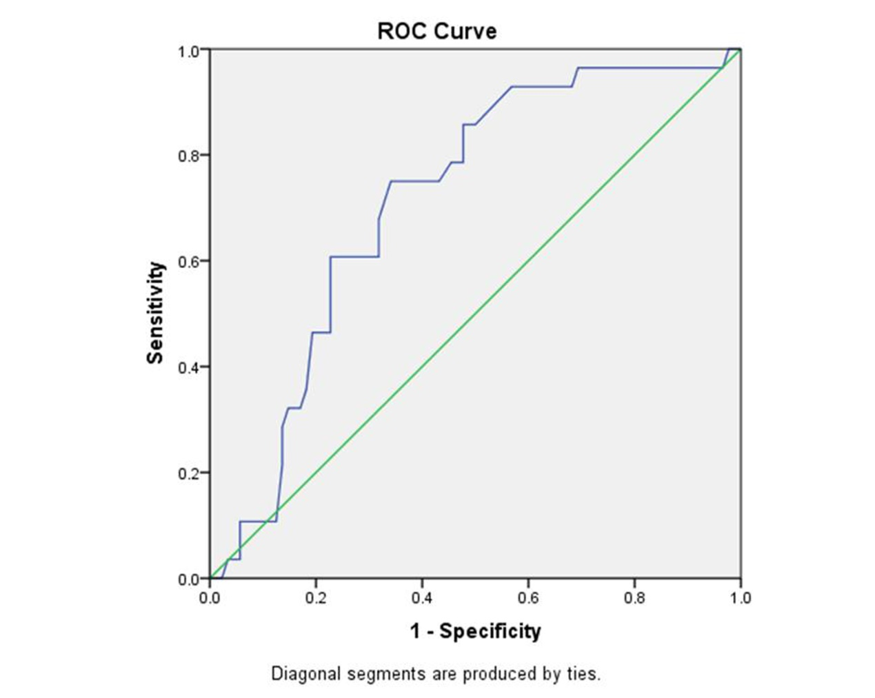
Fig 2: ROC curve for FIB-4
The cut off point for FIB-5 is -3.96, it had sensitivity 42.9 %, specificity 77.3%, PPV 37.5%, NPV 81.0% and AUROC of 0.523 which considered failed as diagnostic tool (fig. 3) (Tab 6).
Table 6: Diagnostic characteristics of FIB-4 and FIB-5 scores of patients
Score | FIB-4 score | FIB-5 score
Cut- off (kPa) | 1.37 | -3.96
Sensitivity | 75% | 42.9%
Specificity | 65.9% | 77.3%
AUROC (confidence interval or CI) | 0.714(0.612-.815) | 0.523 (0.391- 0.655)
Positive predictive value | 39.6% | 37.5%
Negative predictive value | 88.9% | 81.0%
AUROC: Area Under Receiver Operator characteristic
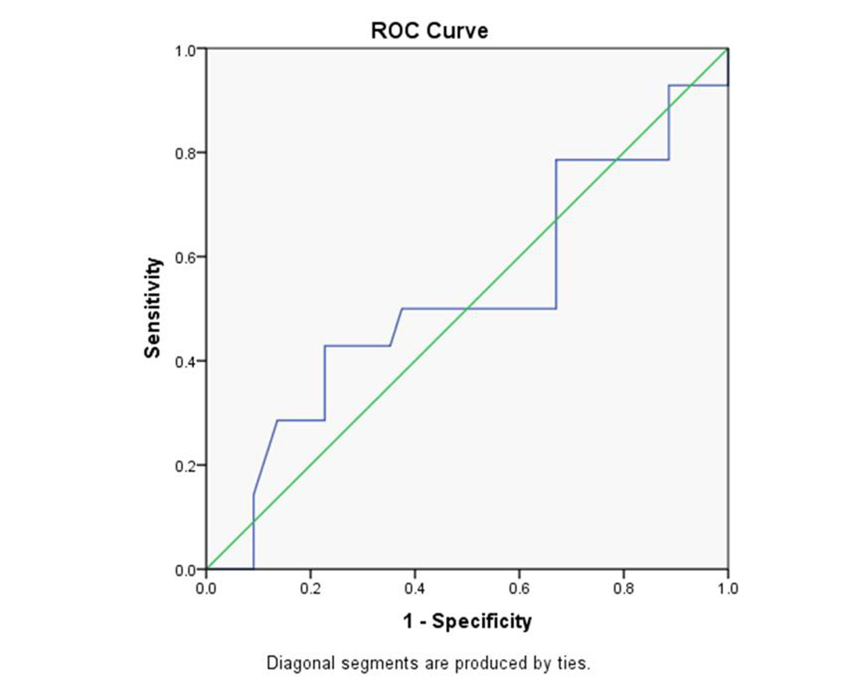
Fig 3: ROC curve for FIB-5
Discussion

In our study, we compared the performance of biochemical scores, including FIB-4 and FIB-5, with fibroscan to rule out the advanced stages of liver fibrosis in patients with NAFLD.
Our study revealed no significant age difference between AF and MF, in contrast to the previous research, which found a high prevalence of fibrosis (40%) and cirrhosis (14%) in the liver biopsies of these older individuals [18]. This may be attributable to the inclusion of older patients in this study.
Our results showed that the patients with AF had higher BMI, VLDL, and TG than those with MF. This is consistent with other studies [19, 20] that concluded that fibrosis frequently occurs in overweight and obese patients.
In this study; the cut off point for FIB-4 is 1.37 had sensitivity 75%, specificity 65.9%, PPV 39.6%, NPV 88.9% and AUROC 0.714 The cut off point for FIB-5 is -3.96, it had sensitivity 42.9%, specificity 77.3%, PPV 37.5%, NPV 81.0% and AUROC of 0.523. FIB-4 score was significantly higher in group II (1.54 ± 0.38) as compared with group I (1.18 ± 0.44); this is in agreement with a previous study [21] that reported FIB-4 showing higher scores among significant or advanced fibrosis compared to mild to moderate fibrosis. Also agree with previous studies [22] that found FIB-4 has great potential in diagnosing liver fibrosis caused by viral hepatitis and NAFLD in patients with advanced fibrosis. This was in agreement with Kumari et al. [23], who concluded that FIB-4 is one of the best indices to assess liver fibrosis in NAFLD patients [23]. Also, Amernia et al. supported this finding; their study showed that FIB-4 is the best index to assess liver fibrosis in NAFLD patients [24]. Another study is consistent with our results; this study showed that The FIB4 index was superior to other tested non-invasive markers of fibrosis in Japanese patients with NAFLD [25].
We also found in our study; that the FIB-5 score has no significant difference between groups. This was in agreement with Kolhe et al., who stated that FIB 5 could not be used to rule out advanced fibrosis [28], but this is in contrast to the previous study [23] that reported the FIB-5 score of the group with advanced fibrosis was significantly lower as compared with patients with mild to moderate fibrosis in NAFLD patients. Also, other studies showed FIB-5 score was more specific than FIB-4 for diagnosing significant from non-significant hepatic fibrosis in patients with chronic HBV infection [26, 27].
Conclusion: FIB-4 is considered a diagnostic tool for fibrosis in NAFLD patients and can be used for differentiation between advanced fibrosis and mild to moderate fibrosis in NAFLD patients.
Funding
This research received no specific grant from public, commercial, or not-for-profit funding agencies.
Declaration of competing interest
There are no conflicts of interest related to this study.
Authors contributions:
All authors had direct exposure to the study data and read and agreed with the final text.
Footnotes.
Peer- Reviewers: Samia Hussien (professor of biochemistry), Samah Soliman (professor of tropical medicine), Sadek, Hany (professor of internal medicine), Alagrody, Ahmed I(professor of internal medicine)
E- Editor: Salem Y Mohamed.
Copyright ©. This open-access article is distributed under the Creative Commons Attribution License (CC BY). The use, distribution, or reproduction in other forums
is permitted, provided the original author(s) and the copyright owner(s) are credited. The original publication in this journal is cited by accepted academic practice. No use, distribution, or reproduction is permitted, complying with these terms.
Disclaimer: All claims expressed in this article are solely those of the authors and do not necessarily represent their affiliated organizations or those of the publisher, the editors, and the reviewers. Any product evaluated in this article or its manufacturer’s claim is not guaranteed or endorsed by the publisher.
References:
1- Ludwig J, Viggiano TR, McGill DB, Oh BJ. Nonalcoholic steatohepatitis: Mayo Clinic experiences with a hitherto unnamed disease. Mayo Clin Proc 1980;55(7):434-438.
2 - Zelber-Sagi S, Shoham D, Zvibel I, Abu-Abeid S, Shibolet O, Fishman S. Predictors for advanced fibrosis in morbidly obese non-alcoholic fatty liver patients. World Journal of Hepatol. 2017;9(2):91.
3- Loria P, Lonardo A, Carulli N. Should nonalcoholic fatty liver disease be renamed? Dig Dis. 2005;23(1):72-82. doi: 10.1159/000084728. PMID: 15920328.
4- Dufour JF. Time to Abandon NASH? Hepatol 2016;63(1):9-10.5.
5- Bellentani S and Tiribelli C. Is it time to change NAFLD and NASH nomenclature? Lancet Gastroenterol Hepatol 2017;2(8):547-548.
6- Eslam M, Sanyal AJ, George J. Toward. More Accurate Nomenclature for Fatty Liver Diseases. Gastroenterology 2019;157(3):590-593.
7- Sivell C. Nonalcoholic Fatty Liver Disease: A Silent Epidemic. Gastroenterol Nurs. 2019 Sep/Oct;42(5):428-434. doi: 10.1097/SGA.0000000000000443. PMID: 31574071.
8- Huang DQ, El-Serag HB and Loomba R: Global epidemiology of NAFLD-related HCC: trends, predictions, risk factors and prevention. Nat Rev Gastroenterol Hepatol. 2021, 18:223-238.
9- Park CC, Nguyen P, Hernandez C, Bettencourt R, Ramirez K, Fortney L, et al. Magnetic Resonance Elastography vs. Transient Elastography in Detection of Fibrosis and Noninvasive Measurement of Steatosis in Patients with Biopsy-Proven Nonalcoholic Fatty Liver Disease. Gastroenterol. 2017;152(5): S70.
10 - Boursier J, Vergniol J, Guillet A, Hiriart J-B, Lannes A, Le Bail B, et al. Diagnostic accuracy and prognostic significance of blood fibrosis tests and liver stiffness measurement by FibroScan in non-alcoholic fatty liver disease. J Hepatol 2016; 65: 570–578.
11- Attallah AM, Shiha GE and Omran MM. A discriminant score based on four routine laboratory blood tests for accurate diagnosis of severe fibrosis and/or liver cirrhosis in Egyptian patients with chronic hepatitis C. Hepatol Res 2006; 34:163–169.
12- Sterling RK, Lissen E, Clumeck N, Sola R, Correa MC, Montaner J, S Sulkowski M, Torriani FJ, Dieterich DT, Thomas DL, Messinger D, Nelson M; APRICOT Clinical Investigators. Development of a simple noninvasive index to predict significant fibrosis in patients with HIV/HCV coinfection. Hepatology. 2006 Jun;43(6):1317-25. doi: 10.1002/hep.21178. PMID: 16729309.
13- Vallet-Pichard A, Mallet V, Nalpas B, Verkarre V, Nalpas A, Dhalluin-Venier V, et al. FIB-4: an inexpensive and accurate marker of fibrosis in HCV infection. Comparison with liver biopsy and fibrotest. Hepatol 2007; 46:32–6.
14- Sandrin L, Tanter M, Gennisson JL, Catheline S, Fink M. Shear elasticity probe for soft tissues with 1-D transient elastography. IEEE Transactions on Ultrasonics, Ferroelectrics and Frequency Control. 2002;49(4):436–446.
15- Castéra L, Bail BL, Roudot-Thoraval F, Bernard P-H, Foucher J, Merrouche W, et al. Early detection in routine clinical practice of cirrhosis and oesophageal varices in chronic hepatitis C: Comparison of transient elastography (FibroScan) with standard laboratory tests and non-invasive scores. J Hepatol. 2009;50(1):59–68.
16- Sarin SK, Kumar M, Lau GK, Abbas Z, Chan HLY, Chen CJ, et al. Asian-Pacific clinical practice guidelines on the management of hepatitis B: a 2015 update. Hepatol Int. 2015, 13;10(1):1–98.
17- EASL Clinical Practice Guidelines: Management of chronic hepatitis B virus infection. J Hepatol. 2012 57(1):167–85.
18- Frith J, Day CP, Henderson E, Burt AD, Newton JL. Non- Alcoholic Fatty Liver Disease in Older People. Gerontol. 2009;55(6):607–13.
19- Moran-Lev H, Cohen S, Webb M, Yerushalmy-Feler A, Amir A, Gal DL, et al. Higher BMI predicts liver fibrosis among obese children and adolescents with NAFLD - an interventional pilot study. BMC Pediatrics. 2021 3;21(1).
20-Ratziu V, Giral P, Charlotte F, Bruckert E, Thibault V, Theodorou I, et al. Liver fibrosis in overweight patients. Gastroenterol. 2000; 118(6):1117–1123.
21-Shimada M. Nonalcoholic steatohepatitis: risk factors for liver fibrosis. Hepatol Research. 2002 Dec;24(4):429–38.
22- Ballestri S, Mantovani A, Baldelli E, Lugari S, Maurantonio M, Nascimbeni F, Marrazzo A, Romagnoli D, Targher G, Lonardo A. Liver Fibrosis Biomarkers Accurately Exclude Advanced Fibrosis and Are Associated with Higher Cardiovascular Risk Scores in Patients with NAFLD or Viral Chronic Liver Disease. Diagnostics (Basel). 2021 Jan 9;11(1):98. doi: 10.3390/diagnostics11010098. PMID: 33435415; PMCID: PMC7827076.
23- Kumari B, Kumar R, Sharma S, Banerjee A, Kumar V, Kumar P, et al. Diagnostic Accuracy of FIB-4 and FIB-5 Scores as Compared to Fibroscan for Assessment of Liver Fibrosis in Patients With Non-Alcoholic Fatty Liver Disease. Cureus. 2021 31; e17622.
24- Amernia B, Moosavy SH, Banookh F, Zoghi G. FIB-4, APRI, and AST/ALT ratio compared to FibroScan for the assessment of hepatic fibrosis in patients with non-alcoholic fatty liver disease in Bandar Abbas, Iran. BMC Gastroenterol. 2021 Dec [cited 2022 May 4];21(1). Available from: https://dx.doi.org/10.1186%2Fs12876-021-02038.
25- Sumida Y, Yoneda M, Tokushige K, Kawanaka M, Fujii H, Yoneda M, Imajo K, Takahashi H, Eguchi Y, Ono M, Nozaki Y, Hyogo H, Koseki M, Yoshida Y, Kawaguchi T, Kamada Y, Okanoue T, Nakajima A, Japan Study Group Of Nafld Jsg-Nafld. FIB-4 First in the Diagnostic Algorithm of Metabolic-Dysfunction-Associated Fatty Liver Disease in the Era of the Global Metabodemic. Life (Basel). 2021 Feb 14;11(2):143. doi: 10.3390/life11020143. PMID: 33672864; PMCID: PMC7917687.
26- Metwally K, Elsabaawy M, Abdel-Samiee M, Morad W, Ehsan N, Abdelsameea E. FIB-5 versus FIB-4 index for assessment of hepatic fibrosis in chronic hepatitis B affected patients. Clinical and Experimental Hepatol. 2020; 6(4):335–338.
27-Shiha G, Seif S, Eldesoky A, Elbasiony M, Soliman R, Metwally A, et al. A simple bedside blood test (Fibrofast; FIB-5) is superior to FIB-4 index for the differentiation between non-significant and significant fibrosis in patients with chronic hepatitis C. Hepatol Int. 2017 19;11(3):286–291.
28- Kolhe KM, Amarapurkar A, Parikh P, Chaubal A, Chauhan S, Khairnar H, et al. Aspartate transaminase to platelet ratio index (APRI) but not FIB-5 or FIB-4 is accurate in ruling out significant fibrosis in patients with non-alcoholic fatty liver disease (NAFLD) in an urban slum-dwelling population. BMJ Open Gastroenterol. 2019;6(1): e000288.
29- Singh D, Das CJ, Baruah MP. Imaging of non-alcoholic fatty liver disease: A road less travelled. Indian J Endocrinol Metab. 2013 Nov;17(6):990-5. doi: 10.4103/2230-8210.122606. PMID: 24381873; PMCID: PMC3872717.
30- Kamali L, Adibi A, Ebrahimian S, Jafari F, Sharifi M. Diagnostic Performance of Ultrasonography in Detecting Fatty Liver Disease in Comparison with Fibroscan in People Suspected of Fatty Liver. Adv Biomed Res. 2019 Nov 27;8:69. doi: 10.4103/abr.abr_114_19. PMID: 31897407; PMCID: PMC6909544.

