ORIGINALRESEARCH RESEARCH
Early complications in adult liver transplant recipients at the Wits Donald Gordon Medical Centre, South Africa
Authors:
1. Sheetal Chiba (MBBCh, FCP(SA), MMed (Wits))¹
2. Warren Lowman (MBBCh, MMed (Wits), FC Path (SA))²
3. Gunter Schleicher (MBBCh, FCP(SA), MMed (Wits), Cert Pulmonology (SA), FCCP)³.
Author institutions:
(1) University of the Witwatersrand, Department of Internal Medicine, Johannesburg, South Africa
(2) Vermaak and Partners/ Pathcare Pathologists, Johannesburg, South Africa: Wits Donald Gordon Medical Centre Parktown, South Africa
(3) Wits Donald Gordon Medical Centre ICU, Parktown, South Africa.
DOI: 10.52378/hmer7639
Corresponding Author:
Sheetal Chiba
Email: sheetalchiba@yahoo.com.
Received: March 23, 2020.
Peer-review started: April 1, 2020.
First decision: April 10, 2020.
Revised: May 12, 2020.
The second round of peer review, copyediting, and proofreading (by journal
editors): June 2020.
Accepted: June 29, 2020.
The article in press: July 7, 2020.
First online: July 12, 2020.
Informed consent statement: Informed consent was obtained from the patients.
Conflict-of-interest statement: All authors declare no conflict-of-interest related to this article.
Abstract
Background
Deceased donor liver transplantation (DDLT) is a transplant modality performed routinely in adults at Wits Donald Gordon Medical Centre (WDGMC). Infection, graft dysfunction, surgical and medical complications are common in the early post-transplant period, accounting for early15 morbidity and mortality.
Objectives
To provide a descriptive analysis of all complications in the first 30 days post DDLT.
To investigate associations between recipient demographic data, comorbid diabetes, MELD score, and subsequent complications.
Methods
A retrospective review of adult DDLT recipients for the first 30 days post-transplant was performed at WDGMC from January 2015 - December 2016. Fischer's exact test was used to assess relationships between demographic data and infectious complications, while an independent sample t-test was used for non-infectious complications.
Results
Seventy-eight DDLTs were performed, with 6 (8%) mortalities in the first 30 days. The median age was 54 years; 54% were male. In total, 24 recipients (31%) developed infectious complications. Sixteen patients (67% of the infectious cohort) had intra-abdominal sepsis, 6 (25%) developed lower respiratory tract infections, 6 (25%) skin and soft tissue infections, and 3 (13%) urinary tract infections. Of all infectious complications, seven patients (29%) developed bacteremia. Non-infectious complications were developed in 55 patients (71%); renal complications were more common (67%). There was no significant association between age, gender, ascites, diabetes mellitus, MELD score, and complications.
Conclusion
Non-infectious complications were more prominent than infectious complications in adult recipients in the first 30 days post-DDLT. There was no significant association between recipient demographic data, comorbid diabetes, CMV status, and MELD score.
Keywords: Early complications, liver transplant recipients, Deceased donor liver transplantation, Wits Donald Gordon Medical Centre, Model for End-Stage Liver Disease.
Introduction
In adults, deceased donor liver transplantation (DDLT) is the only routine transplant performed in sub-Saharan Africa, while living donor liver transplants (LDLT) are commonly performed in other centers worldwide.¹
There are only two adult liver transplant centers in sub-Saharan Africa, Groote Schuur Hospital in Cape Town and Wits Donald Gordon Medical Centre (WDGMC) in Johannesburg, South Africa.¹ The adult liver transplant protocol used at WDGMC utilizes standardized protocols and immunosuppressive therapy for recipients of DDLT in the pre-, intra-, and post-operative periods.
Numerous non-infectious and infectious complications are reported post-liver transplantation.¹⁻⁵ Biliary leaks, biliary obstruction, and hepatic artery thrombosis are some of the most common hepato-biliary complications in the early postoperative period following liver transplantation.^{5,6}Multifactorial etiologies account for early renal complications, including hypovolemia, sepsis, nephrotoxic drugs, underlying CKD, pre-existing hepato-renal syndrome and surgical complications.⁵⁻⁹ Independent risk factors for developing AKI post orthotopic liver transplantation include blood loss, cold and warm ischemia time, overexposure to calcineurin inhibitors (CNI), and combined immunosuppression therapy (mycophenolate mofetil (MMF) with CNI use), female gender, high Child-Pugh score, presence of underlying diabetes mellitus.^{10,11} Of infectious and non-infectious respiratory complications post-liver transplantation, pleural effusions, atelectasis, pulmonary edema, and pneumonia are more commonly noted in the early postoperative period, contributing to morbidity and mortality.¹² Acute respiratory distress syndrome (ARDS), frequently an early complication, can manifest severe reperfusion syndrome, prolonged surgical time, significant blood loss, and severe sepsis.⁵
Complications of immunosuppression can result in sepsis, multi-organ dysfunction, and graft failure.¹³⁻¹⁵ Post-transplant infections are significant contributors to morbidity and mortality yet remain potentially preventable.^{3,16-17} In this period, bacterial infections are most prominent.^{3,16} Hospital-acquired pathogens, donor-derived infections, diabetes mellitus, hypoalbuminemia, and cytomegalovirus (CMV) seropositivity are risk factors for bacterial infections following a liver transplant.^{3,5,16,18} Besides the direct cytopathic effects of CMV, growing evidence emphasizes the immunomodulating effects of the CMV virus itself and the consequent increase in the incidence of bacterial superinfection and bacteremia in CMV-infected recipients post-transplant. Immunomodulation leads to excessive interleukin ten productions, decreased synthesis of viral neutralizing antibodies, reduced interferon production, impairment of lymphocytic stimulation responses such as decreased cytotoxic T lymphocyte activity, all of which are essential inhibitors of immunity, resulting in susceptibility not only to bacterial infections but viral and fungal infections too.^{3,5,16,18}
There is very little literature on the common early complications after adult liver transplants in South Africa. We describe a retrospective review of complications in adult liver transplant recipients over two years at the WDGMC, Johannesburg, South Africa.
Materials and Methods
1. Study population
A retrospective chart review was conducted on all adult DDLT recipients for the first 30 days post-transplant. This was performed at WDGMC for the period January 2015 to December 2016. The University of Witwatersrand Human Research Ethics Committee (Medical) granted permission to conduct the review, approval certificate M170265 as included in appendix 1.1.
2. Data collection
The following information from all adult DDLT recipients was documented: age, gender, indication for transplant, presence of ascites, diabetes mellitus (DM) (insulin-requiring and non-insulin requiring), hepatitis status (HAV, HBV, HCV), and CMV status. CMV status from donors was obtained. The length of ICU stay was documented up to thirty days. Following liver transplantation, hospital charts and laboratory results were reviewed for the first 30 days post-transplant, documenting all complications in this period, including mortality. Non-infectious complications were reported by organ involvement. Infectious complications were identified upon chart review and correlated with serological/microbiology findings. Diagnoses and antibiotic use found on chart reviews were documented. Contagious pathogens, susceptibility to antimicrobial agents, and site of infection were identified from the available microbiology reports, hospital charts, clinical information, and serology reports. The location of infection was categorized according to the CDC/NHSN guidelines.¹⁹
3. Assays
Analyses of blood serum samples and microbiology reports were performed by the following accredited laboratories according to good laboratory practice: South African National Health Laboratory Services (NHLS), Ampath Laboratories, Lancet Laboratories, and Vermaak and Partners Pathologists. Where applicable, adult reference ranges were applied for the various blood tests.
4. Inclusion and Exclusion Criteria
Inclusion Criteria:
All liver transplants were performed at the WDGMC from January 1, 2015-December 31, 2016, in recipients aged 18 years and older. All donors and recipients with complete pre-transplantation data and total post-transplant records were included.
Second transplants/ re-transplants were included in this study.
Exclusion Criteria:
Age < 18 years
Combined liver-kidney transplant
5. Statistical analysis
Data were analyzed using SAS version 9.4 for windows. Categorical and continuous variables were used for this descriptive analysis. The former was represented by frequency and percentage tabulation and demonstrated on bar charts. Mean, standard deviation, median, and interquartile range (IQR) represent continuous variables. Histograms were used to illustrate their distribution. The relationship between the presence/absence of infectious/non-infectious complications and age, diabetes mellitus (DM) in a recipient, ascites, and hepatitis status of both donor and recipients were depicted using Fischer's exact test. For the above, the phi coefficient measures the strength of association. Independent samples T-test was used to assess the relationship between the presence/absence of infectious/non-infectious complications with age and MELD score. Cohen's d was used to measure the strength of association. Results were taken as statistically significant for p-values of less than 0.05.
Results
Seventy-eight adult liver transplant recipients with complete data were retrospectively identified and reviewed over two years.
Sixty-three recipients (81%) developed complications within the first-month post orthotopic liver transplantation (OLT).
Sixteen recipients of the 63 (25%) had one complication only, while the remainder (75%) experienced multiple complications.
Twenty-four patients (31%) developed infectious complications, and 55 patients (71%) developed non-infectious complications, respectively, as some recipients developed both infectious and non-infectious complications.
Chronic liver cirrhosis with end-stage liver disease (ESLD), diagnosed in 70 recipients (89%), was the most common indication for liver transplants in this cohort. However, some individuals have more than one underlying indication.
In this subgroup, the 3 commonest causes of cirrhosis were non-alcoholic fatty liver disease (NAFLD) (n=20, 29%), chronic viral hepatitis (n=13, 19%) and biliary pathology (n=14, 20%).
Chronic HBV followed by HCV were the leading causes of chronic viral hepatitis, while primary sclerosing cholangitis (PSC) accounted for most of the biliary cirrhosis subgroup. Only four individuals (5%) required emergency liver transplantation due to acute fulminant liver failure. Primary graft dysfunction, drug-induced hepatitis, and two recipients with acute viral hepatitis were the underlying etiologies, respectively. As noted, this study included re-transplants, as per inclusion criteria.
Demographics, comorbidities, and complications post-transplantation
The median age of 78 adult liver transplant recipients was 54 years (IQR 39-60). Fifty transplants (64%) were performed on male patients.
Uncontrolled ascites and DM pre-transplantation occurred in 36 recipients (46%) and 19 (24%).
Fifty-seven donors (73%) had a positive CMV serology status (IgG⁺).
The presence of DM (4 individuals (17%) of the infectious cohort and 15 (24%) of the non-infectious cohort) proved statistically insignificant when associated with complications (table 1).
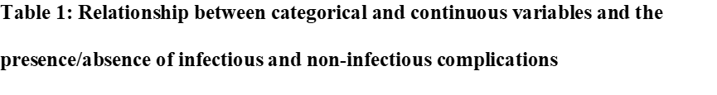
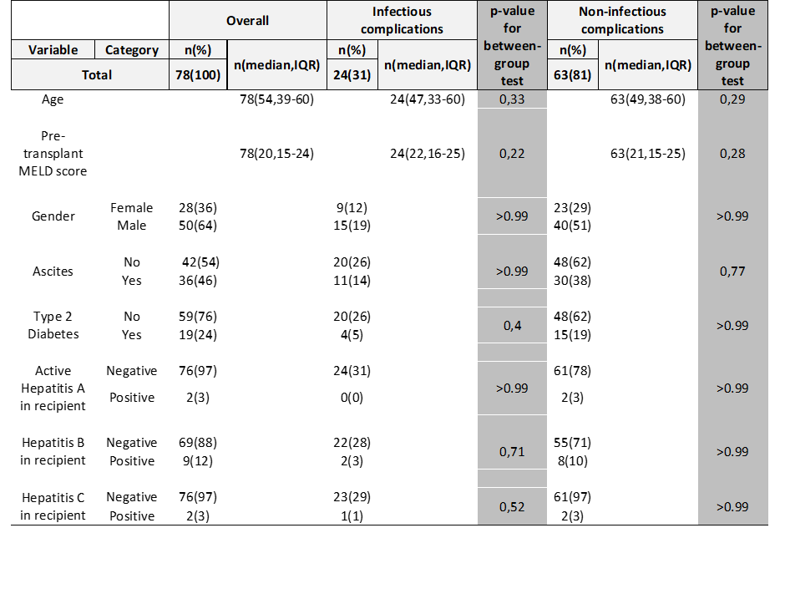
IQR: interquartile range.
Continuous Variables: Age, Pre-transplant MELD score.
Categorical Variables: Gender, Ascites, Diabetes Mellitus, HAV, HBV, HCV.
The median MELD score of recipients' pre-transplant was 20 (IQR 15-24). Of all 78 liver transplants performed, 6 (8%) resulted in mortality in the first thirty days post-transplantation.
The median length of ICU stays post-transplantation was six days for the entire cohort. However, the median length of ICU stays for those who died within the first 30 days was 13 days (range 7-30d), without the statistical significance of the length of stay between survivors and non-survivors.
Hospital stay within the 30 days included ICU, High Care, and step down to the general ward. All non-survivors were managed in the ICU only.
There was no association between continuous variables (age, pre-transplant MELD score) and infectious complications (table 1). Likewise, no statistically significant association was evident when comparing these variables with non-infectious complications (table 1). Categorical variables (gender, diabetes mellitus, ascites, hepatitis) compared to the presence/absence of infectious and non-infectious complications were statistically non-significant (Table 1).
Infectious complications
In the first 30 days following liver transplantation, infectious complications (n=24, 31%) were less frequently seen than non-infectious complications (n=55, 71%).
Most patients who developed infectious complications (n=16) developed intra-abdominal sepsis, accounting for 67% of the infectious complication subgroup. Six (25%) recipients with infectious complications had lower respiratory tract infections.
Many recipients also developed skin and soft tissue infections (25%).
Three recipients (13%) developed urinary tract infections.
Seven patients of the infectious complication subgroup (29%) had documented bacteremia. Of the 14 recipients (58%) with pathogen-proven infection, 100% were bacterial. Fifteen recipients (63%) received directed antimicrobial therapy, 6 (25%)
received empiric treatment, and 5 (21%) received both empiric and directed antimicrobial therapy as empiric therapy was considered appropriate and continued following available microbiology reports.
Microbiologically proven Klebsiella pneumoniae was the most typical organism, isolated in 11 patients (46% of the infectious cohort), of which 7 (64%) were extended-spectrum beta-lactamase (ESBL) producing bacteria, 2 (11%) Carbapenem-sensitive Enterobacteriaceae, and 2 (11%) Carbapenem-resistant Enterobacteriaceae (CRE). Based on the WDGMC ICU microbiological surveillance data, Klebsiella pneumoniae was consistently the most common pathogen, with an ESBL rate of 47% and a CRE rate of 25%, exclusively OXA-48 during this time. Unsurprisingly, Klebsiella pneumonia (ESBL/OXA) is the most common hospital-acquired infection at WDGMC. Ninety percent of infections due to Klebsiella pneumonia had an intra-abdominal source (figure 1).
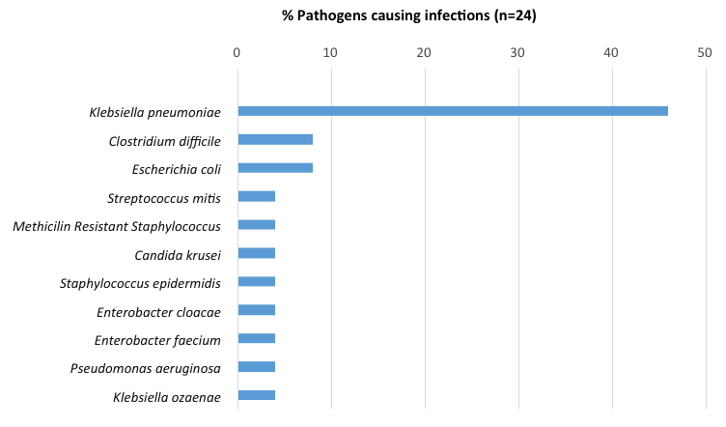
Fig1:Culture has proven pathogens causing infectious complications
Microbiological reports did not reveal any confirmed fungal or viral organisms within the 30 days of review. The diagnosis of viral and fungal infections is limited by the difficulties in diagnosis and compounded by CMV administration and fungal prophylaxis post-transplantation.
Non-infectious complications
Renal complications were the most frequently encountered non-infectious complication (n=37, 67% of the non-infectious cohort) (figure 2).
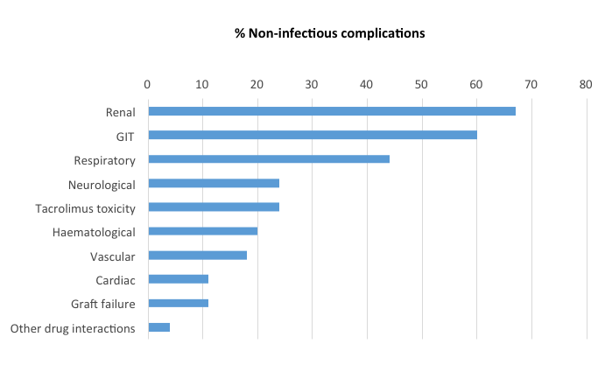
Fig2:Non-infectious complications post-OLT
This was followed by 33 recipients with GIT complications, which accounted for 60% of the non-infectious subgroup. Thereafter, in descending frequency with percentages of the non-infectious complication subgroup: respiratory complications (n=24, 44%), neurological complications and tacrolimus toxicity, both occurred in 13 patients each (24%), hematological (n=11, 20%), vascular (n=10, 18%), cardiac and graft failure both occurred in 6 recipients (11%), suspected acute rejection (n=3, 5%), and other drug reactions (n=2, 4%).
Of the renal non-infectious complications, acute kidney injury (AKI) proved the most common finding (n=39, 71%). Sixteen recipients (42%) in the non-infectious subgroup with renal complications also experienced infectious complications.
In 8 recipients (22%), the renal complications were considered to be directly due to sepsis. AKI not requiring dialysis appeared more prevalent than AKI requiring acute dialysis (n=21, 38%, and n=18, 33% respectively).
Of all non-infectious GIT complications, hepatic complications (rejection, cholestasis, ischemia-reperfusion injury, venous congestion) developed most commonly (n=12, 22%), followed by GIT bleed (n=10, 18%), biliary (biliary leaks, obstruction) (n=8, 15%) and intestinal complications (ileus, malabsorption, perforation, ischemia, obstruction) (n=7, 13%).
Of all the non-infectious respiratory complications (pneumonia, atelectasis, pleural effusions, pulmonary embolus) (n=29), pleural effusions occurred most frequently (n=22), of which 64% were drained.
Delirium was the most common neurological complication (n=11, 85% of all neurological complications).
Of all vascular complications, hepatic artery thrombosis (n=6) was most prevalent, followed by portal vein complications (n=2), IVC complications (thrombus and bleed) (n=2), and other (n=1).
Eleven patients (20% of the subgroup with non-infectious complications) developed hematological complications (pancytopenia, neutropenia, thrombocytopenia, anemia, hemolysis), of which pancytopenia (n=6, 55%) was the most frequent finding. Cardiac failure (n=5, 83%) predominantly due to sepsis and stress cardiomyopathy was the most typical complication in those with overall cardiac complications (n=6, 11%). Graft failure (n=6) occurred in 11% of the non-infectious complication subgroup. Drug reactions (n=2, 4%) were uncommon in this study. Acute rejection was clinically suspected in 3 patients (5%) based on biochemical signs of liver dysfunction in the absence of any other cause (no evidence of infection, biliary pathology, drugs/ toxins), unfortunately not confirmed with liver biopsy within the 30 days of review.
Discussion
Local data in South Africa on liver transplantation and its early complications remains scarce.^{1,2} This is the first comprehensive 30-day report from Africa of all complications occurring in adult DDLT recipients following transplantation. The period of 30 days post-transplantation focuses on complications seen predominantly within the ICU/ High Care setting. In our cohort of 78 adult recipients, it is unsurprising that the primary indication for liver transplantation is ESLD and cirrhosis. Cirrhosis, the result of numerous causes of ESLD, accounts for approximately 80% of all indications for liver transplantation throughout the USA,²⁰ consistent with this study. The increasing prevalence of obesity, diabetes and hyperlipidemia in western countries contributes to most non-alcoholic fatty liver disease (NAFLD).²¹ NAFLD is estimated to occur 20-30% more frequently in western countries.²¹
In this cohort, NAFLD is the leading cause of cirrhosis (n=20, 29%), followed by chronic viral hepatitis (n=19, 16%) and biliary cirrhosis (n=14, 20%). This differs slightly from data published in both developing and developed countries, which indicate that hepatitis B and C, alcoholic steatohepatitis, and hepatocellular carcinoma are the most common indications for liver transplantation, in descending frequency.¹ Finding from local data at WDGMC and that published from Cape Town also differ, with PSC and alcoholic steatohepatitis accounting for the most common causes of end-stage cirrhosis requiring liver transplantation.^{1,2} These studies include both adult and pediatric populations, ^{two} possible reasons for higher incidences of biliary disease, which is common to the pediatric population.² Possible contributors to the higher proportion of NAFLD in this study are the whole adult population and the presence of type 2 DM (24%). Notably, obesity is prevalent amongst South African adults, particularly females,²² another risk for NAFLD, despite the male predominance in this study (64%). This study's finding of non-infectious complications (71%) occurring more commonly than infectious complications (31%) differs from data of the ten-year retrospective review from WDGMC.¹The significantly shorter time frame (30d) of this study influences this finding, a period in which patients are susceptible to both acute infectious and non-infectious complications. Complications such as biliary strictures, chronic kidney disease (CKD), calcineurin inhibitor (CNI) toxicity, and opportunistic infections are a few anticipated complications expected over a longer review time, as noted in the WDGMC decade study.^{1,2,5,9,23,24} Non-infectious biliary complications (20.9%) followed by infectious complications (19.9%) and vascular complications (17.5%) proved the most common outcomes from the decade review, ^{one}. In contrast, renal (47%), GIT (42%), respiratory and infectious complications (31% each) are the most frequent findings of this study, as expressed as percentages of the total cohort (n=78). Long-term vascular complications are also expected to occur less frequently in this study due to the shorter review period.^{1,6}
Notably, biliary complications are reported as a component of GIT complications in this study. This study's biliary complications are approximately 50% lower (10%) than the WDGMC decade review.¹ Biliary leak and obstruction are observed as early as 1-month post-transplantation, while strictures tend to occur later, contributing to this discordant finding.^{5,24} These findings are, however, still consistent with the reported incidence of 10-25% of biliary complications following liver transplantation in developed countries.^{7-9,23, 25-27}
Hepatic artery thrombosis (HAT), the most frequent vascular complication (8%), parallels findings from the decade retrospective review performed at WDGMC.¹ The decade review reports an incidence of 5.3% of early HAT, which accounts for most vascular complications (17.5%).¹ Early HAT is defined as 0-100 days post-transplant in this decade-review. ¹ A systematic review of 77 studies from developed and developing countries reports a lower incidence (2.9%) of early HAT (defined as the first 60 days) in adult liver transplant recipients.⁶ The age references for pediatric and adult populations are not clearly defined in the systematic review.⁶ This systematic review acknowledges a higher incidence of early HAT in DDLT vs. LDLT, the latter being the significant representation of trials reviewed.⁶ The decade review performed in Cape Town, which includes both adult and pediatric groups, also revealed a low incidence of HAT (3.4%).² Despite DDLT being the only type of transplant performed in this study, the low incidence of early HAT is attributed to microsurgical techniques, routine post-transplant thrombo-embolism prophylaxis, and aspirin administration in the pediatric population.²
This study reveals a 51% incidence of AKI post-transplantation, consistent with reflections from the USA, which report a 5-50% incidence.²⁸⁻²⁹ Sepsis leading to hemodynamic instability, hypoperfusion, and acute tubular necrosis remain essential contributors to renal complications,^{5,13-15,28,30} highlighted in this study. However, the small sample size appears to be one of the most significant limitations in proving statistical significance between the presence of DM and renal dysfunction.
Findings of respiratory complications are inconsistent between this study and the decade-review done at WDGMC.¹ This study's higher incidence of respiratory complications (37%) is predominantly attributed to pleural effusions. In contrast, the 6.8% incidence of respiratory complications noted in the WDGMC decade-review results from unknown thromboembolism etiologies requiring ventilation.¹ The lack of extensive categorical data in other studies limits data comparison to this comprehensive descriptive study.
More extensive cohort studies demonstrate an incidence of 10-70% of acute cellular rejection (ACR),³¹ findings much higher than this study (4%), and the WDGMC decade review (11.7%).¹ Liver biopsies were not routinely performed within the first-month post-transplant during this study's review period, with the presumptive diagnosis of acute rejection based on clinical and biochemical findings. Notably, this study's limitations include its duration of the evaluation, recipients who have normal biochemistry despite possible underlying ACR, and the time frame (0-90d) of the globally accepted definition of ACR. ^{1,32}
Bacterial infections as the predominant cause of infection in this study, within the first-month post-transplantation, concurs with literature worldwide.^{1,3,16} Ten recipients (42%) of the infectious complication subgroup had no identifiable pathogen yet were clinically suspected of having infections. Sepsis with multi-organ failure (MOF) was present in all death cases in this cohort (8%). Fungal sepsis was considered a role in these patients with early mortality, based on positive beta-d-glucan serology, multiple risk factors for fungal sepsis, and the poor response to broad-spectrum antibiotics. However, this was not confirmed microbiologically, and postmortem reports are unavailable to confirm the clinical suspicion of systemic fungal sepsis. The clinical limitation to accurately diagnose and microbiologically ensure life-threatening infections in recipients post solid organ transplantation remains an ongoing challenge.
Both South African studies reviewing outcomes over ten years reveal a predominance of bacterial infections over viral and fungal infections.^{1,2} This differs from the well-documented emergence of viral and fungal infections seen more commonly following one month after transplantation.^{30,33} The findings of this study concur with international studies, reporting the most typical sites of infection as abdominal and lung in the first-month post-transplantation.^{30,33} The frequent complication of bacteremia following an illness in these sites is comparable to this cohort.^{30,33} Interestingly, 83% of all skin and soft tissue infections were reported to originate from the surgical abdominal wound, consistent with international reports.^{30,33} Furthermore, in keeping with global data,^{30,33} 60% of all cases of bacteremia have an intra-abdominal source, while 20% have a lower respiratory source and the remaining 20% are due to urinary tract infection infections.
Despite extensive documentation of the direct association between bacterial infections in the first-month post-transplantation and DM, hypoalbuminemia, CMV seropositivity, and donor-derived infections, ^{3,5,16,18} this study could not confirm this association. However, ascites appears to negatively predict recipient and graft survival (P-value 0.011 and hazard ratio 3.06) in the retrospective decade review done at WDGMC.¹
This cohort revealed a mortality of 8% of all recipients at 30 days post-transplant, unfortunately without access to any postmortem reports. A key finding in all mortalities is the presence of sepsis. Based on record review, biochemical and microbiological findings, death resulted from graft failure, severe sepsis, and MOF in the abovementioned subgroup. The trend toward improving survival, with decreasing death rate as time progresses, is comparable to local and international data.¹ The 30day period of review provides limitations for comparisons of recipient survival to other studies.
Conclusion
Non-infectious complications were more prominent than infectious complications in the first 30 days post DDLT in adult recipients in a large South African transplant center, with no significant association between recipient demographic data, comorbid diabetes, CMV status, and MELD score.
ABBREVIATIONS
DDLT- deceased donor liver transplant
LDLT- living donor liver transplant
WDGMC- Wits Donald Gordon Medical Centre
MELD- the model for end-stage liver disease
ESLD- end-stage liver disease
ACR- acute cellular rejection
CMV- cytomegalovirus
AKI- acute kidney injury
CNI- calcineurin inhibitor
MMF- mycophenolate mofetil
KDIGO- Kidney Disease Improving Global Outcomes
CKD- chronic kidney disease
OLT- orthotopic liver transplant
HRS- hepatorenal syndrome
ARDS- acute respiratory distress syndrome
HAT- hepatic artery thrombosis
NAFLD- non-alcoholic fatty liver disease
DM- diabetes mellitus
IQR- interquartile range
ESBL- extended-spectrum beta-lactamase
CRE- carbapenem-resistant Enterobacteriaceae
ICU- intensive care unit
GSH- Groote Schuur Hospital
GIT- gastrointestinal
HAT- hepatic artery thrombosis
IVC- inferior vena cava
d- days
Acknowledgment
The authors thank Dr. June Fabian, Ms. Heather Maher, Dr. Petra Gaylard for their support.
Footnotes
This work was done according to the STROBE guidelines
Citation of this article: Chiba S, Lowman W, Schleicher G. Early complications in adult liver transplant recipients at the Wits Donald Gordon Medical Centre, South Africa. liver transplantation [Internet]. Egypt's Presidential Specialized Council for Education and Scientific Research; 2020 August 12;3(1):1-24. Available from: http://dx.doi.org/10.52378/hmer7639.
Peer- Reviewers: Amr Hanafy, Emad Fawzi
E- Editor: Salem Y Mohamed.
Copyright ©. This open-access article is distributed under the Creative Commons Attribution License (CC BY). The use, distribution, or reproduction in other forums is permitted, provided the original author(s) and the copyright owner(s) are credited. The original publication in this journal is cited by accepted academic practice. No use, distribution, or reproduction is permitted, which does not comply with these terms. Disclaimer: claims expressed in this article are solely those of the authors and do not necessarily represent their affiliated organizations or those of the publisher, the editors, and the reviewers. Any product that may be evaluated in this article or claim that its manufacturer may make it not guaranteed or endorsed by the publisher.
References
1) Song, E et al. Adult liver transplantation in Johannesburg, South Africa (2004 - 2016): Balancing good outcomes, constrained resources, and limited donors. SAMJ. 2018;108(11):929-36.
2) Botha J, Spearman C, Millar A, et al. Ten years of liver transplantation at Groote Schuur Hospital. SAMJ. 2000;90(9):880-3.
3) Romero FA, Razonable RR. Infections in liver transplant recipients. World J Hepatol. 2011;3(4):83-92.
4) Razonable RR, Findlay JY, O'Riordan A, et al. Critical Care Issues in Patients After Liver Transplantation. Liver Transpl. 2011; 17:511-27.
5) Feltracco P, Barbieri S, Galligioni H, et al. Intensive care management of liver
transplanted patients. World J Hepatol. 2011;3(3):61-71.
6) Bekker J, Ploem S, De Jong, KP. Early Hepatic Artery Thrombosis after Liver Transplantation: A Systematic Review of the Incidence, Outcome, and Risk Factors. American Journal of Transplantation. 2009; 9:746–57.
7) Pfau PR, Kochman ML, Lewis JD, et al. Endoscopic management of postoperative biliary complications in orthotopic liver transplantation. Gastrointest Endosc. 2000; 52:55.
8) Thuluvath PJ, Atassi T, Lee J. An endoscopic approach to biliary complications following orthotopic liver transplantation. Liver Int. 2003; 23:156.
9) Thethy S, Thomson BNj, Pleass H, et al. Management of biliary tract complications after orthotopic liver transplantation. Clin Transplant. 2004; 18:647.
10) Zongyi Y, Baifeng L, Funian Z, et al. Risk factors of acute kidney injury after orthotopic liver transplantation in China. Sci Rep 2017; 7:41555.
11) Hilmi IA, Damian D, Al-Khafaji A, et al. Acute kidney injury following orthotopic liver transplantation: incidence, risk factors, and effects on patient and graft outcomes. British Journal of Anaesthesia 2015;114(6):919-26.
12) Feltracco P, Carollo C, Barbieri S, et al. Early respiratory complications after liver transplantation. World J Gastroenterol 2013;19(48):9271-81.
13) Laish I, Braun M, Mor E, et al. Metabollic syndrome in liver transplant recipients: prevalence, risk factors, and association with cardiovascular events. Liver Transpl. 2011;17(1):15-22.
14) Madhwal S, Atreja A, Albeldawi M, et al. Is Liver Transplantation a Risk Factor for Cardiovascular Disease? A Meta-Analysis of Observational Studies. Liver Transpl. 2012; 18:1140-46.
15) Gisbert C, Prieto M, Berenguer M. et al. Hyperlipidemia in Liver Transplant Recipients: prevalence and risk factors. Liver Transpl Surg. 1997; 3:416.
16) Blair JE, Kusne S. Bacterial, Mycobacterial, and Protozoal Infections after Liver Transplantation-Part I. Liver Transpl. 2005;11(12):1452-59.
17) Liu X, Ling Z Li L et al. Invasive fungal infections in liver transplantation. Int J Infect Dis. 2011;15(5):298-304.
18) Hernandez MDP, Martin P, Simkins J. Infectious Complications After Liver Transplantation. Gastroenterol Hepatol. 2015;11(11):741-53.
19) Centres for Disease Control and Prevention (2017). Sepsis l CDC. [online] Available at: http://cdc.gov/sepsis/index.html.
20) Wong RJ, Aguilar M, Cheung R, et al. Nonalcoholic steatohepatitis is the second leading etiology of liver disease among adults awaiting liver transplantation in the United States. Gastroenterology. 2015; 148:547.
21) Le MH, Devaki P, Ha NB, et al. Prevalence of non-alcoholic fatty liver disease and risk factors for advanced fibrosis and mortality in the United States. PLoS One. 2017;12(3): e0173499.
22) T Puoane, K Steyn, D Bradshaw, et al. Obesity in South Africa: The South African Demographic and Health Survey. 2002; 10:1038–48.
23) Seehofer D, Eurich D, Veltzke-Schlieker W, et al. Biliary complications after liver transplantation: old problems and new challenges. Am J Transplant. 2013; 13:253.
24) Thuluvath PJ, Pfau PR, Kimmey MB et al. Biliary complications after liver transplantation: the role of endoscopy. Endoscopy 37. 2005; 37:857.
25) Stratta RJ, Wood RP, Langnas AN, et al. Diagnosis and treatment of biliary tract complications after orthotopic liver transplantation. Surgery. 1989;106(4):675-84.
26) Greif F, Bronsther OL, Van Thiel DH, et al. The incidence, timing, and management of biliary tract complications after orthotopic liver transplantation. Ann Surg. 1994; 219:40.
27) Rerknimitr R, Sherman S, Fogel EL, et al. Biliary tract complications after orthotopic liver transplantation with choledochocholedochostomy anastomosis: endoscopic findings and results of therapy. Gastrointest Endosc. 2002; 55:224.
28) Paramesh, AS, Roayaie S, Doan Y, et al. Post-liver transplant acute renal failure: factors predicting development of end-stage renal disease. Clinical Transplantation. 2004;18: 94–9.
29) Corman, SL, Coley KC, Schonder KS. Effect of Long-term Tacrolimus Immunosuppression on Renal Function in Liver Transplant Recipients. Pharmacotherapy. The Journal of Human Pharmacology and Drug Therapy. 2006; 26:1433–37.
30) Kusne S, Dummer JS, Singh N, et al. Infections after liver transplantation. An analysis of 101 consecutive cases. Medicine. 1998;67(2):132-43.
31) Bartlett AS, Ramadas R, Furness S, et al. The natural history of acute histologic rejection without biochemical graft dysfunction in orthotopic liver transplantation: A systematic review. Liver Transpl. 2002; 8:1147–53.
32) Levitsky J, Goldberg D, Smith AR, et al. Acute Rejection Increases Risk of Graft Failure and Death in Recent Liver Transplant Recipients. Clin Gastroenterol Hepatol. 2017; 15:584.
33) Singh N, Wagener MM, Obman A, et al. Bacteremias in liver transplant recipients: shift toward gram-negative bacteria as predominant pathogens. Liver Transpl. 2004;10(7):844-49.

