**A prolapsed juvenile rectal polyp in a 9-year-old female patient was successfully managed by hot snare polypectomy**

Wudassie Melak Asmare1, Zelalem Mulu Lashitie2

1Internal medicine, Medical, Bahirdar University, Bahirdar, Ethiopia

2Gastroenterology, Internal Medicine, Felege Hiwot Comprehensive Specialized Hospital, Bahirdar, Ethiopia

**Mail address:** <wudasemelak14@gmail.com>.

**Telephone number:** 251911823396.

**DOI:**[**10.21608/ajgh.2025.350001.1074.**](mailto:salemyousefmohamed@gmail.com)

**Submission** **date:** 02 January 2025.

**Revision date (End of revision):** 10 February 2025.

**Acceptance date:** 13 March 2025.

**Abstract**

**Background**: Juvenile polyps typically present as painless rectal bleeding following defecation, and a small proportion of patients may develop prolapse. Although most juvenile polyps are naturally inflammatory, colorectal adenomatous polyps that grow from the mucosa harbor neoplastic characteristics. They have a malignant potential according to their size, grade of dysplasia, and patient’s age. Obstruction, prolapse, bleeding, or infection, which are anorectal emergencies, are among potential complications of large polyps, mainly when located at the distal rectum close to the anal verge.

**Case presentation:**

We present a 9-year-old tween who was successfully treated for a large tubulovillous rectal adenoma using a hot snare polypectomy. The patient has had recurrent bleeding and prolapsing dark red mass lesion through the anal opening during defecation and straining for the past year.

**Conclusion:**

Despite being the most common cause of painless hematochezia in children, diagnosis of Juvenile Polyps can easily be missed, and presentation could be delayed, resulting in various complications. A colonoscopy in a well-prepared colon is essential for diagnosis and appropriate intervention.

***Keywords****: Rectal polyp, Juvenile, Juvenile polyp, colonoscopy, polypectomy, hot snare, Bowel preparation, Anorectal emergency, malignancy risk, case report.*

**Introduction**

Colonic polyps most commonly present with rectal bleeding in children, and the most common type of polyp seen in the pediatric age group is the isolated juvenile polyp (1). A small portion of children may manifest with prolapse as an initial manifestation (2).

Histologically, colorectal polyps can be classified as neoplastic (which can be either benign or malignant) and non-neoplastic (including hyperplastic, inflammatory, and hamartomatous) polyps. Adolescents and adults with multiple juvenile polyps are at a significant risk of intestinal cancer (1).The risk is higher among older pediatric patients, those with multiple polyps, and those with a positive family history. The pathogenesis of pediatric CRC is still not well understood. Pediatric CRC may arise in the setting of predisposing conditions, such as polyposis syndromes and inflammatory bowel disease, but it more frequently develops in children without known predisposing factors.

Imaging techniques such as ultrasound and computed tomographic colonoscopy are utilized to identify simple juvenile colonic polyps in children with rectal bleeding in whom there is a high index of suspicion (3).

In an emergency setting, prolapsing anorectal polyps can be easily mistaken for benign anorectal conditions like hemorrhoids, posing treatment challenges. Hence, clinicians should consider juvenile polyps as part of the differential diagnosis of anorectal diseases (2). Bleeding from self-amputated polyps has also been reported (4).

**Case presentation**

A 9-year-old girl was referred to our hospital for bleeding per rectum for more than a year. Her vital signs were typical, and she had a regular anthropometric assessment. There were no symptoms of intestinal obstruction or abdominal discomfort, nor did her Physical examination reveal abdominal tenderness or signs of intestinal obstruction.

On the perianal examination, there was no active bleeding or visible mass. Upon the Valsalva maneuver, a dark red mass lesion protruded from her anal canal, demanding manual reduction without bleeding. Her laboratory profiles revealed mild iron deficiency anemia, hemoglobin 10.7 mg/dl, MCV- 73 fl. The rest of her biochemical profiles and abdominopelvic sonography were regular. Multiple differential diagnoses were entertained, including hemorrhoids, rectal prolapse, abscess, anal /rectal polyps, condyloma, pilonidal cysts, and even possible malignant conditions.

Diagnostic ileo-colonoscopy was planned. After careful bowel preparation and using conscious sedation, a colonoscopy was performed on the third day of the presentation. A single pedunculated polyp with a diameter of 2 cm was noted in the lower rectum, 1 cm above the dentate line. The rest of the colon was free of polyps, angiodysplasia, or potential lesions causing bleeding. A hot snare polypectomy was performed successfully with no bleeding. The tissue was later retrieved using a foreign body removing basket and sent for histopathologic study. The pathological findings included dilated microcystic ducts and edematous stroma with abundant inflammatory cells, confirming the solitary rectal juvenile polyp diagnosis. The patient was observed for 24 hours and appointed in 3 days to the outpatient clinic to report any complications, including delayed bleeding. Further evaluation or follow-up was not indicated after the polypectomy since she had a solitary polyp.

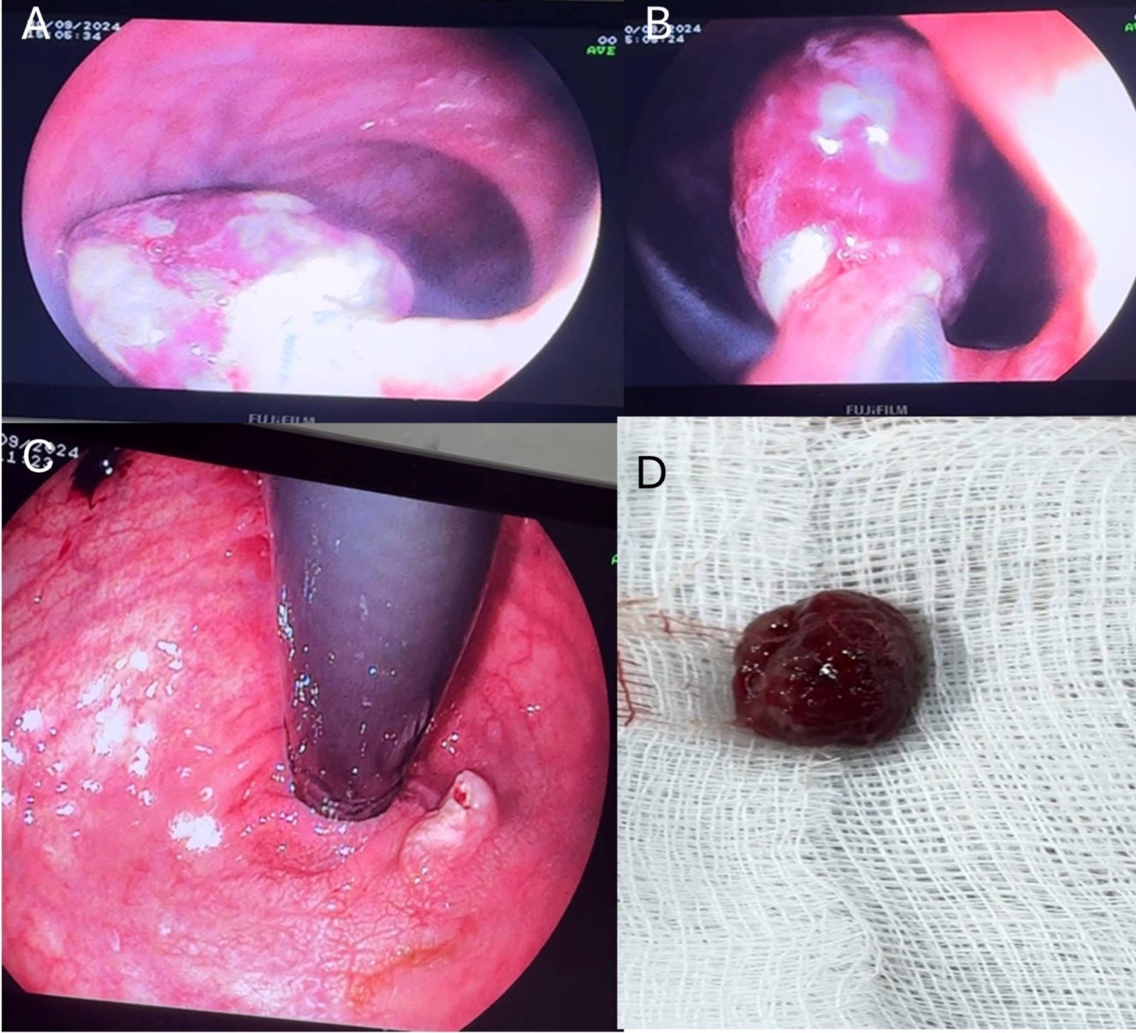

Fig . Pedunculated polyp in the lower rectum before and after resection.

**Discussion**

Juvenile polyposis syndrome predisposes to hamartomatous polyps in the GI tract, including the small intestine and colon. The term "juvenile" refers to the type of polyp, not the presentation age (5).

Regarding non-syndromic Juvenile Polyps, Isolated larger distal lesions are the most common phenotype. These isolated hamartomatous lesions have a low risk of recurrence. Similar to our case, the most frequent presentation is painless hematochezia in children, which can cause anemia (6).

Although juvenile polyps typically present as painless rectal bleeding after defecation, a small portion may manifest with prolapse, posing a clinical dilemma. Clinicians should consider juvenile polyps a potential diagnosis and undergo timely evaluation. Colonoscopy, Capsule endoscopy, Genetic testing, and radiologic studies, including intravenous contrast-enhanced computed tomography colonoscopy (IVCTC), have been mentioned as modalities of diagnosis (3).

A colonoscopy is recommended to evaluate the presence of polyps outside the rectum, though most polyps are in the rectum. Our patient had a solitary polyp that was resected completely without causing pain or bleeding, ensuring the safety of the polypectomy. (7).Similar to most cases in the literature, our patient had a smooth post-procedure course. She was followed for 24 hours in the hospital and appointed at an outpatient clinic after 72 hours without any bleeding or local complications.

**Conclusion**

For children presenting with painless rectal bleeding, diagnosis and intervention for Juvenile Polyps can be made with proper and timely investigation using a colonoscopy without causing significant complications. A colonoscopy in a well-prepared colon is essential for diagnosis and appropriate intervention.

**Footnotes.**

Ahmed Agrodey (Professor of internal medicine, gastroenterology, and hepatology unit), Nevin Fouad (Assistant professor of internal medicine, gastroenterology, and hepatology unit), and Sara Salem (lecturer of internal medicine, gastroenterology, and hepatology unit) were the peer reviewers.

**E- Editor:** Salem Youssef Mohamed, Osama Ahmed Khalil, Amany Mohammed.

**Copyright ©.** This open-access article is distributed under the Creative Commons Attribution License (CC BY). It may be used, distributed, or reproduced in other forums, provided the original author(s) and the copyright owner(s) are credited. The original publication in this journal must be cited according to accepted academic practice.

**Disclaimer:** The authors' claims in this article are solely their own and do not necessarily represent their affiliated organizations or those of the publisher, the editors, and the reviewers. Any product evaluated in this article or its manufacturer's claim is not guaranteed or endorsed by the publisher.

**Ethical approval:**

Written informed consent was obtained from the patient and her parents after the studies were well explained before data collection. The hospital's Research Ethics Review Committee approved the study.

**Study protocol:**

In adherence to the principles outlined in the Helsinki Declaration, the study protocol was implemented with approval from the institutional review board. Before commencing the research, written consent was obtained to utilize their clinical information.

**Data and materials availability:** The datasets used or analyzed during the current study are available from the corresponding author upon reasonable request.

**Competing interests**: The authors declare that they have no competing interests.

**Funding**: This study had no funding from any resource.

This work was done according to the **CARE** guidelines.

**Authors' contributions**

Wudassie Melak Asmare and Zelalem Mulu Lashitie collected and followed up on the patients, carrying out the requested investigations. They also followed up with the patients and analyzed the collected data. All authors authorized the manuscript.

**Acknowledgment**: none.

*References*

1. Durno CA. Colonic polyps in children and adolescents. Can J Gastroenterol. 2007;21(4):233–9.

2. Kakiuchi T, Yoshiura M. Juvenile polyp presenting as prolapsed mass per rectum in a 5‐year‐old child. Clin Case Reports. 2023;11(3):10–1.

3. Kay M, Eng K, Wyllie R. Colonic polyps and polyposis syndromes in pediatric patients. Curr Opin Pediatr. 2015;27(5):634–41.

4. Arredondo Montero J, Bronte Anaut M, Antona G. Self-amputated rectal juvenile polyp: An entity to consider in diagnosing rectal prolapse in childhood. A Pediatr. 2023;99(1):77–8.

5. Haidle JL, Howe JR. Juvenile Polyposis Syndrome Summary GeneReview Scope Suggestive Findings. 2019;1–19.

6. Ibrahimi N, Septer SS, Lee BR, Garola R, Shah R, Attard TM. Polyp Characteristics of Nonsyndromic and Potentially Syndromic Juvenile Polyps: A Retrospective Cohort Analysis. J Pediatr Gastroenterol Nutr. 2019;69(6):668–72.

7. Mahmud S, Parvez M, Baidya M, Tasneem F, Hasan AR, Farhana T, et al. Colonoscopic polypectomy of juvenile polyps in children: Experience from a tertiary center of Bangladesh. Gastroenterol Endosc. 2024;2(1):1–6.