# Pancreas-Sparing Distal Duodenectomy for Distal Duodenal Malignancies: A Single-Center Experience

Redha Khalfallah, Walid Kebieche, Kahina Dahbia Tadrist, Abderrahim Cherfa, Kamal Bennabi, Youcef Mahmoudi, Rafik Dahdouh, Zohra Imessaoudene

Mustapha University Hospital, Algeria

**Corresponding Author**

khalfallah.rd@gmail.com

Mustapha University Hospital, Algeria

Mail: khalfallah.rd@gmail.com.

DOI: **10.21608/ajgh. 2025.391561.1082****.**

Submission date: 2 June 2025.

Revision date (End of revision): 23 August 2025.

Acceptance(final): 13 September 2025.

**Abstract**

**Background:**

Pancreas-sparing distal duodenectomy (PSDD) has emerged as a technically feasible and less morbid alternative to pancreatoduodenectomy (PD) for tumors of the third and fourth portions of the duodenum. This study presents a single-center experience with PSDD, emphasizing histology-adapted surgical techniques.

**Methods:**

We retrospectively reviewed six patients (4 adenocarcinomas, two gastrointestinal stromal tumors) who underwent PSDD between 2016 and 2023. The preoperative workup included endoscopy, endoscopic ultrasound, and a contrast-enhanced CT scan. Surgical techniques were tailored to tumor histology: lymphadenectomy with SMA-first dissection for adenocarcinomas and limited resection for GISTs.

**Results :**

All patients achieved R0 resection. Postoperative morbidity included delayed gastric emptying (66.6%) and diarrhea (50%), both managed conservatively. No operative mortality occurred. One patient with pT3N1 adenocarcinoma died from metastatic recurrence at 48 months. Median hospital stay was 12 days. Median lymph node yield was 12.33.

**Conclusion:**

PSDD is a safe and feasible procedure that may serve as an alternative to PD for malignancies of the distal duodenum.

***Keywords:*** *Duodenal tumors, Pancreas-sparing surgery, GIST, Adenocarcinoma, Lymphadenectomy, Duodenum, Distal duodenum, Gastrointestinal surgery, Surgical oncology, Organ-preserving surgery.*

1. **Introduction :**

Duodenal tumors of the third and fourth portions (D3/D4) require tailored surgical strategies due to their distinct biological behaviors. Pancreaticoduodenectomy (PD), while standard, carries high morbidity (30–50%) from pancreatic fistulas and anastomotic leaks [1]. Pancreas-sparing distal duodenectomy (PSDD), popularized by Maher et al. [2], preserves pancreatic function and reduces complications. This study details our experience with PSDD, emphasizing technical nuances for GISTs and adenocarcinomas, supported by video documentation.

1. **Materials and Methods:**
   1. **Study design :**

Single-center retrospective study of six patients (4 males, two females) between 2016 and 2023. The indication for PSDD was neoplasms involving the 3rd to 4th part of the duodenum (4 adenocarcinomas, 2 GISTs).

.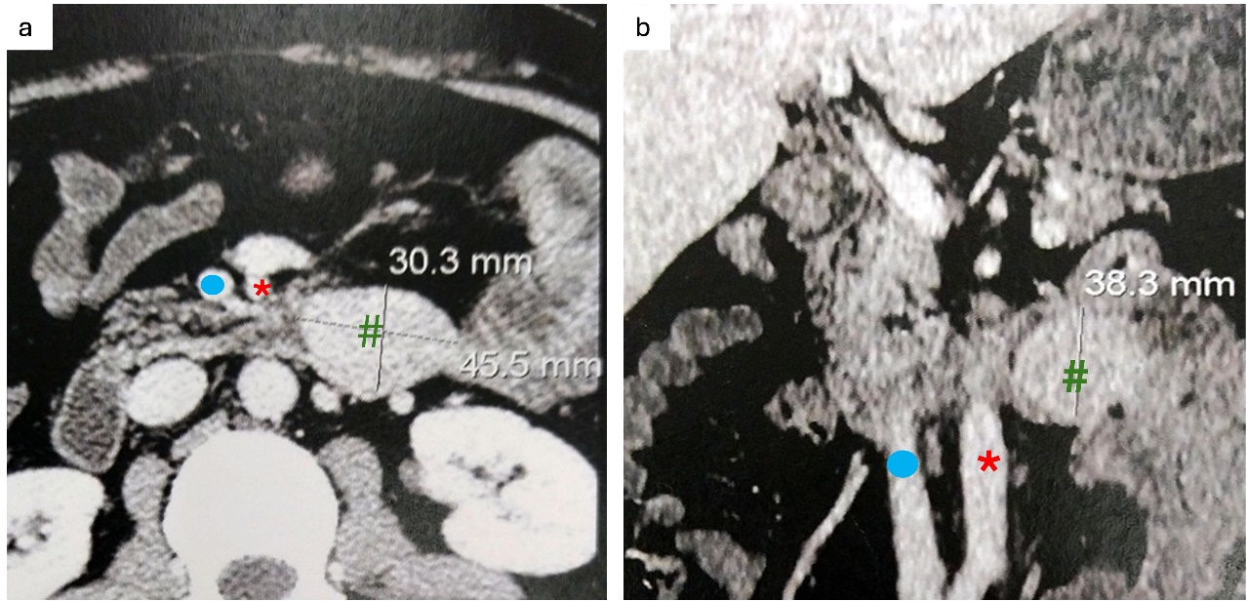

Fig 1. CT-SCAN imaging of GIST-SMA/SMV relationships (GIST of D3**#**, SMA *, SMV). **a** Transversal view. **b** Coronal view.

* + 1. **Preoperative Workup:**
* **Endoscopy + biopsy**: Localization, distance between tumor and major papilla, histological type.
* **Endoscopic ultrasound**: Parietal extension, pancreatic infiltration, and deep biopsies were performed only for submucosal tumors.
* Contrast-enhanced CT: Distant metastasis [3], tumor relationship with mesenteric vessels as shown in figures 1,2.

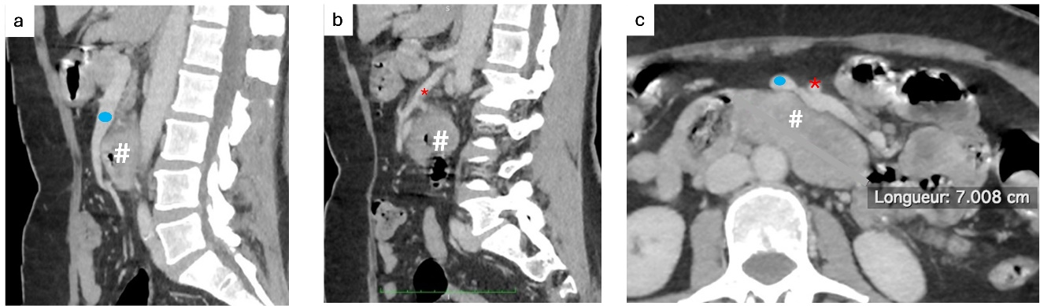

Fig 2. CT imaging of adenocarcinoma-SMA/SMV relationships. **A sagittal view of relationships (adenocarcinoma of D3#, VMS**). **b** Sagittal view of relationships (adenocarcinoma of D3**#**, SMA*), **c** Transversal view relationships (adenocarcinoma of D3**#**, FJV **\***)

* + 1. **Inclusion criteria:**

Histologically confirmed malignancy, resectability on imaging, and no distant metastases. Exclusion criteria: pancreatic head invasion, unresectable mesenteric vessel involvement, distant metastases, or ASA IV status.

* + 1. **Exclusion criteria:**

Small superficial intramucosal neoplasms (≤2 cm) were treated with endoscopic resection, whereas invasive tumors with pancreatic infiltration were treated with PD.

* + 1. **Surgical Technique:**
* Laparotomy and exposure via Treitz ligament division, Cattell-Braasch, and Kocher maneuvers.
* Tumor-Specific Resection:

Adenocarcinoma: Systematic lymphadenectomy (stations 14) with a superior mesenteric artery (SMA) first approach [4]. The inferior pancreaticoduodenal artery (IPDA), first jejunal artery (FJA), and first jejunal vein (FJV) were carefully divided with circumferential dissection of the SMA, as shown in Figure 3.

**GISTs**: The IPDA was divided at the left side of SMA with preservation of FJA, FJV, and SMA nerve plexus.

* Transection of the first jejunal loop with en bloc resection of the mesojejunum, as shown in Figure 3.
* The third duodenum and inferior part of mesopancreas (PL ph II) were en bloc resected with the specimen, with devascularization of the uncinate process [4,5].
* Duodenal transection at the level of the inferior duodenal flexure with prior identification and preservation of the major duodenal papilla.
* Side-to-side transmesocolic duodenojejunal anastomosis [6]

A supplementary surgical video (Supplemental Video 1) demonstrating the surgical technique has been submitted separately.

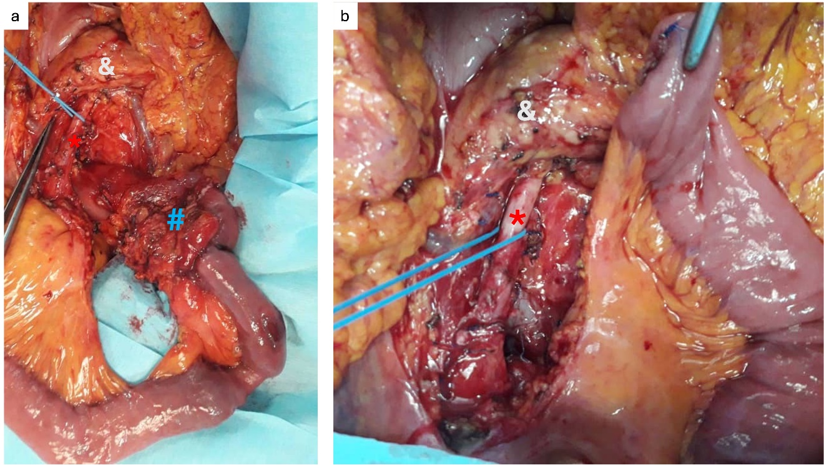

Fig 3. Lymphadenectomy for adenocarcinoma (Adenocarcinoma of D3#, SMA*, pancreas &), **a** en bloc resection of mesojejunum. **b** circumferential dissection of SMA*.

Figure 4. Resection margins (duodenal margin D, jejunal margin J, mesenteric margin M). 
 a Adenocarcinoma of D3 #, b GIST of D3/D4 #.


Fig 4. Resection margins (duodenal margin **D**, jejunal margin **J**, mesenteric margin **M**). **a** Adenocarcinoma of D3 **#, b** GIST of D3/D4 **#.**

1. **Results:**

All patients achieved R0 resection, with negative margins confirmed in all cases (Fig. 4). Postoperative morbidity included delayed gastric emptying (DGE) in four patients (66.6%), classified as ISGPS grade A or B [7], and postoperative diarrhea in three patients (50%), both managed conservatively [8]. No operative mortality occurred. The median hospital stay was 12 days (range 8–20), with a median lymph node yield of 12.3. The median follow-up duration was 36 months (range, 12–84 months). One patient with pT3N1M0 adenocarcinoma developed metastatic recurrence and died 48 months postoperatively.

Tab 1. The clinicopathological characteristics and outcomes of all patients.

|  |  |  |  |  |  |  |  |  |  |  |
| --- | --- | --- | --- | --- | --- | --- | --- | --- | --- | --- |
| Patient | Sex | Age | BMI | Morbidity (Clavien-Dindo) | Pathology | N+/N | Tumor location | Margin | Hospital stay (days) | Survival (months) |
| 1 | M | 54 | 22.9 | 1 | Adenocarcinoma (pT3N0M0) | 0/12 | D3 | R0 | 10 | 48 (Alive) |
| 2 | M | 72 | 25.2 | 2 | Adenocarcinoma (pT3N1M0) | 1/16 | D3 | R0 | 13 | 40 (Deceased) |
| 3 | M | 28 | 21.6 | 2 | GIST | 0/8 | D4 | R0 | 10 | 60 (Alive) |
| 4 | F | 48 | 26.5 | 2 | GIST | 0/10 | D3/D4 | R0 | 8 | 36 (Alive) |
| 5 | F | 60 | 27.8 | 3a | Adenocarcinoma (pT3N0M0) | 0/22 | D3/D4 | R0 | 20 | 20 (Alive) |
| 6 | M | 55 | 24 | 1 | Adenocarcinoma (pT3N1M0) | 1/9 | D3 | R0 | 11 | 18 (Alive) |

1. **Discussion :**

The contrasting surgical techniques for GISTs and adenocarcinomas emphasize the necessity of tailoring treatment to tumor histology. For GISTs (n=2), our technique emphasized minimal dissection to avoid iatrogenic injury to the pancreatic parenchyma and autonomic nerves. The video demonstrates en bloc resection with wide macroscopic margins, deliberately preserving the mesenteric lymph nodes (stations 14) and avoiding circumferential SMA dissection to reduce postoperative morbidity, consistent with guidelines for GIST management [9,10]. This approach contrasts sharply with adenocarcinomas (n=4), where systematic lymphadenectomy (stations 14) and circumferential SMA dissection, as shown in figures 3, were prioritized to address the high risk of nodal metastasis (20–40%) [11,12]. Notably, our median lymph node yield (12) approximates the thresholds proposed by Sakamoto et al. [13] (≥15 nodes) and Cloyd et al. [14] (≥12 nodes), suggesting adequate oncologic clearance as shown in Figure 4. However, the single late death from metastatic recurrence (pT3N1 adenocarcinoma) highlights the aggressive biology of advanced tumors, reinforcing the need for adjuvant therapy in high-risk cases [15]. In our series, postoperative DGE was the main postoperative complication, occurring in 66.6% of patients (n=4). According to the ISGPS definition [7], it was classified as grade A in two patients and grade B in the other two. These rates were higher than those reported in prior PSDD studies (e.g., Maher et al., 8% [16]). DGE is attributed to disrupted motilin secretion from resected duodenal enterochromaffin cells [18]. Prokinetics (e.g., erythromycin) alleviated symptoms, per ISGPS guidelines [7]. The second most common complication occurring in our series was postoperative diarrhea, occurring in 50% of patients (n=3), observed only in adenocarcinoma patients, probably due to autonomic nerve injury during circumferential SMA dissection [18-21]. This disparity may reflect differences in operative technique between GISTs and adenocarcinoma. Our morbidity profile mirrors Kato et al. [3] (DGE in 42%) and Ito et al. [4] (diarrhea in 85%). The absence of pancreatic fistulas contrasts with PD series (16–30%) [1,5,20,21], highlighting the safety of pancreatic preservation. Our small cohort (n = 6) and single-center design limit the generalizability of our findings. Future studies should standardize lymphadenectomy and the definition of surgical margins to ensure consistency and accuracy. Explore minimally invasive PSDD [22]. Investigate biomarkers (e.g., motilin levels) to predict DGE [23]

1. **Conclusion :**

PSDD offers a reliable and oncologically sound alternative to PD for selected malignancies of the third and fourth portions of the duodenum. By adapting the extent of resection and lymphadenectomy to the histologic nature of the tumor, PSDD enables adequate tumor clearance while preserving pancreatic parenchyma and its functions. Our experience supports the feasibility, safety, and functional benefits of this approach, particularly for patients at higher surgical risk. Further studies with larger cohorts are needed to validate its long-term oncologic outcomes and functional superiority.

**Footnotes.**

Sara Salem (lecturer of internal medicine, gastroenterology, and hepatology unit), Emad Hamed (Professor of internal medicine, gastroenterology, and hepatology unit), and Amany Mohamed (Professor of family medicine and biostatistician) were peer reviewers.

**E- Editor:** Salem Youssef Mohamed, Osama Ahmed Khalil, Amany Mohammed.

**Copyright ©.** This open-access article is distributed under the Creative Commons Attribution License (CC BY). It may be used, distributed, or reproduced in other forums, provided the original author(s) and the copyright owner(s) are credited. The original publication in this journal must be cited according to accepted academic practice.

**Disclaimer:** The authors' claims in this article are solely their own and do not necessarily represent their affiliated organizations or those of the publisher, the editors, or the reviewers. Any product evaluated in this article or its manufacturer's claim is not guaranteed or endorsed by the publisher.

**Ethics approval**

Ethical clearance was obtained for the conduct of this study.

All participants provided informed consent to be enrolled in the study.

**Data and materials availability:** The datasets used and/or analyzed during the current study are available from the corresponding author on reasonable request.

**Competing interests**: The authors declare that they have no competing interests.

**Funding**: This study had no funding from any source.

This work was conducted in accordance with the CARE guidelines.

**Authors' contributions:**

All authors contributed to data collection, analysis, and manuscript preparation. All authors read, revised, and approved the final manuscript.

**Acknowledgments**: Not applicable.

1. **References:**
2. Callery MP, Pratt WB, Kent TS, et al. A prospectively validated clinical risk score accurately predicts pancreatic fistula after pancreatoduodenectomy. J Am Coll Surg. 2013 ;216(1) :1-14.
3. Maher MM, Yeo CJ, Lillemoe KD, Roberts JR, et al. Pancreas-sparing duodenectomy for infra-ampullary duodenal pathology. Am J Surg. 1996;171(1):62-7.
4. Kato T, Ono Y, Oba A, et al. Treatment strategy of pancreas-sparing distal duodenectomy for distal duodenal malignancies with adjustable dissection levels (with Video). World J Surg. 2023;47(6):705-11.
5. Ito R, Mises-Y, Takahashi Y, et al. Segmental resection with partial mesopancreatic excision for duodenal carcinoma. Langenbeck's Arch Surg. 2021;406(5):1234-1240.
6. Nagakawa Y, Yi SQ, Takishita C, et al. Precise anatomical resection for mesopancreas dissection. J Hepatobiliary Pancreat Sci. 2020;27(6):342-351.
7. Chung RS, Church JM, vanStolk R. Pancreas-sparing duodenectomy: Indications, surgical technique, and results. Surgery. 1995;117(3):254-9.
8. Wente MN, Bassi C, Dervenis C, et al. Delayed gastric emptying (DGE) after pancreatic surgery: an ISGPS definition. Surgery. 2007;142(5):761-8.
9. Dindo D, Demartines N, Clavien PA. Classification of surgical complications. Ann Surg. 2004;240(2):205-13.
10. Nishida T, Blay JY, Hirota S, et al. Clinical practice guidelines for gastrointestinal stromal tumor (GIST) in Japan. Int J Clin Oncol. 2016;21(4):738-48.
11. von Mehren M, Randall RL, Benjamin RS, et al. Gastrointestinal stromal tumors, version 2.2014. J Natl Compr Canc Netw. 2014;12(6):853-62.
12. Cloyd JM, George E, Visser BC. Duodenal adenocarcinoma: advances in diagnosis and surgical management. World J Gastrointest Surg. 2016;8(3):212-21.
13. Nakagawa K, Sho M, Fujishiro M, et al. Clinical practice guidelines for duodenal cancer 2021. J Gastroenterol. 2022;57(12):927-41.
14. Sakamoto T, Saiura A, Ono Y, et al. Optimal lymphadenectomy for duodenal adenocarcinoma: does the number alone matter? Ann Surg Oncol. 2017;24(11):3368-75.
15. Cloyd JM, Norton JA, Visser BC. Does the extent of resection impact survival for duodenal adenocarcinoma? Ann Surg Oncol. 2015;22(2):573-80.
16. Golhar A, Mangla V, Mehrotra S, et al. Limited distal duodenal resection: outcomes. Ann Med Surg. 2018;30:36-41.
17. Maher MM, Yeo CJ, Lillemoe KD, et al. Pancreas-sparing duodenectomy for infra-ampullary duodenal pathology. Am J Surg. 1996;171(1):62-7.
18. Brown JC, Cook MA, Dryburgh JR. Motilin is a gastric motor activity-stimulating polypeptide. Gastroenterology. 1972;62(3):401-4.
19. Reinehr MD, Vuille-dit-Bille RN, Soll C, et al. Anatomy of the neural fibers at the SMA. Langenbeck's Arch Surg. 2022;407(6):2347-54.
20. Golhar A, Mangla V, Mehrotra S, et al. Limited distal duodenal resection: outcomes. Ann Med Surg. 2018;30:36-41.
21. Inoue Y, Saiura A, Yoshioka R, et al. Pancreaticoduodenectomy with systematic mesopancreas dissection using a supracolic anterior artery-first approach. Ann Surg. 2015;262(6):1092-101.
22. Nagakawa Y, Nakagawa N, Takishita C, et al. Reconsideration of the appropriate dissection range based on Japanese anatomical classification for resectable pancreatic head cancer. Cancers. 2021;13(14):3605.
23. Bracale U, Pontocorvi E, Silvestri V, et al. Laparoscopic segmental resection for tumors of the Angle of Treitz. Updates Surg. 2021;73(1):179-86.
24. Tanaka M, Sarr MG. Role of the duodenum in the control of canine gastrointestinal motility. Gastroenterology. 1988;94(2):622-9.