Muhimbili National Hospital
Department of Surgery
Case report
Laparoscopic Heller’s cardio-myotomy and fundoplication.; A successful approach for Achalasia Management at Muhimbili National Hospital, Tanzania: A cases series
Kitembo Salum Kibwana^{1*}, Jenikalo Kaguo¹, Mohammed Sultan Salim¹, Godfrey Mchele¹, William Lutege¹, Yona E Ringo¹
¹Department of Surgery- Gastroenterology Unit, Muhimbili National Hospital, Dar-es-salaam, Tanzania.

*Corresponding author: Kitembo Salum Kibwana, Muhimbili National Hospital, Dar-es-salaam, P.O. Box 65000, Dar-es-salaam, Tanzania. Telephone +255784607682; Email kkitembo@yahoo.com.
______________________________________________________________________

Abstract:
Aims: To describe the surgical management and outcomes of pediatric achalasia in two patients with rare comorbidities, focusing on the challenges and limitations in a resource-limited setting.
Patients & Methods: This case series includes a 9-year-old male with Triple-A syndrome and a 7-year-old male with Addison’s disease, both presenting with long-standing dysphagia. Both patients underwent laparoscopic Heller’s myotomy and Dor fundoplication. Diagnosis was primarily based on clinical presentation and barium swallow due to the unavailability of esophageal manometry.
Results: Both patients demonstrated significant improvements in dysphagia postoperatively. No intraoperative complications occurred, and at follow-up, neither patient experienced recurrence or complications. However, the lack of manometric studies may have affected diagnostic precision.
Conclusions: This case series highlights the effective use of laparoscopic Heller’s myotomy in pediatric achalasia patients with complex comorbidities. The absence of manometric studies and Per-Oral Endoscopic Myotomy options underscores the need for advanced diagnostic tools and surgical techniques in resource-limited settings.
keywords: Achalasia, Pediatric Surgery, Laparoscopic Heller's Myotomy, Dor Fundoplication, Triple-A Syndrome, Addison’s Disease, Esophageal Motility Disorders, Barium Swallow, Resource-Limited Settings, Surgical Outcomes.

Introduction
Esophageal Achalasia (EA) is an uncommon esophageal motility disorder characterized by neurodegeneration, particularly in the pediatric demographic [1]. This condition is exceptionally rare among children under the age of five [2,3]. The epidemiological incidence of achalasia in the pediatric population is estimated at 0.11 per 100,000 children per year [4]. While rare, EA can be associated with complex syndromes such as Allgrove syndrome (also known as triple A syndrome-characterized by Alacrimia, Achalasia, and Adrenocorticotropic hormone deficiency), Down’s syndrome, or familial visceral neuropathy [5,6]. Diagnosis of achalasia typically involves imaging or endoscopic evaluations, with confirmatory testing performed using esophageal manometry [6–8].
The management of EA focuses on alleviating lower esophageal sphincter (LES) pressure to enhance swallowing and improve quality of life. Pharmacological interventions are largely ineffective, and endoscopic treatments like botulinum toxin injections and pneumatic dilation have notable limitations. Surgical Heller myotomy (HM) is regarded as the gold standard due to its proven efficacy and safety [5,9]. Recently, peroral endoscopic myotomy (POEM) emerged as a minimally invasive alternative, demonstrating comparable success rates with fewer complications [10]. However, access to POEM is limited in pediatric patients, necessitating further evaluation of its long-term efficacy [11]. This study presents two cases of pediatric achalasia who underwent HM and Fundoplication. Note; Laparoscopic Dorr fundoplication involves wrapping a portion of the stomach the fundus around the lower esophagus to prevent gastric contents reflux to the esophagus

Case series

Case 1: Triple-A syndrome
A 9 years old male presented with a long history of dysphagia to liquid since the age of 3 years, He currently manages solid food with water assistance. His symptoms are accompanied by recurrent episodes of diarrhea and vomiting, hypoglycemia and poor growth since age 2. He has a history of two admissions for diarrhea, during which low cortisol levels were detected. Notably, his mother reported an absence of tears when cries. He had been diagnosed with Triple-A syndrome (Allgrove syndrome) based on his dysphagia, alacrimia, and adrenal insufficiency. Barium swallow confirmed esophageal dilatation, see Figure 1. Presently, he is on a regimen of hydrocortisone 10mg in the morning and 5mg in the evening, along with Fludrocortisone 50mcg.
Management
The patient underwent laparoscopic Heller’s oesophagocardiomyotomy (see Figure 3) and Dor fundoplication that involves wrapping the stomach 180-270 degrees around the esophagus to prevent reflux. Intraoperative findings included hypertrophic muscles at the lower intraabdominal esophagus. The procedure lasted 85 minutes, and the patient was discharged after 24 hours.
Follow up
At the one-week follow-up, the patient showed significant improvement in dysphagia symptoms and tolerated oral intake well. No recurrence was reported during the two-month follow-up.
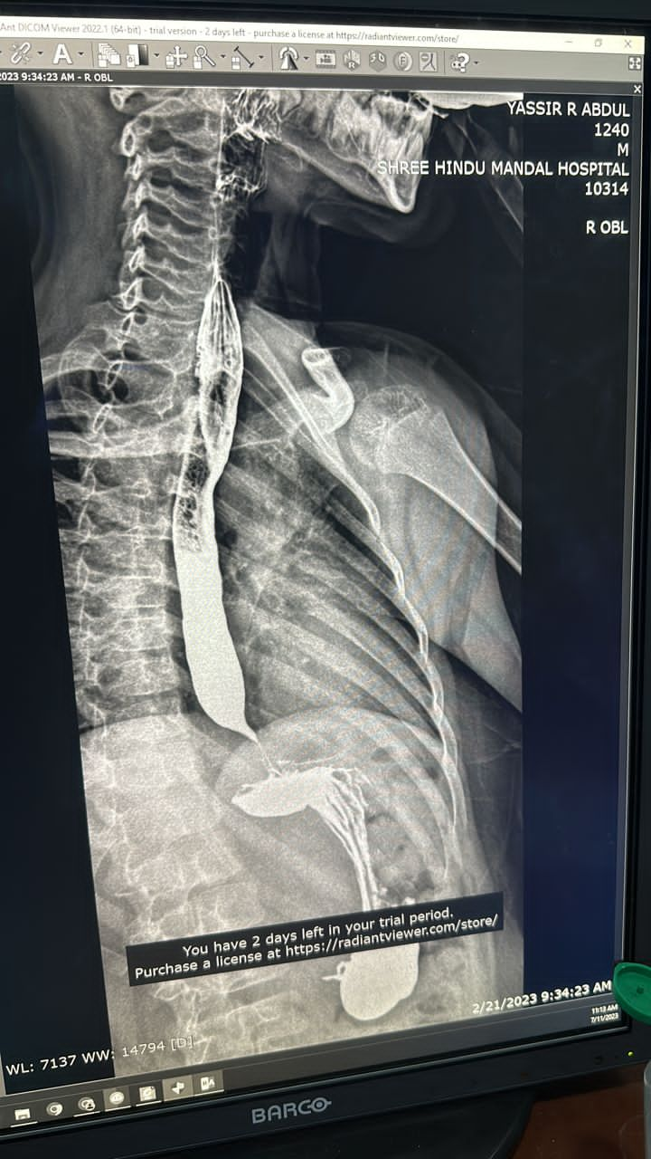  Figure. 1: Barium swallow showing dilatation of the distal esophagus | 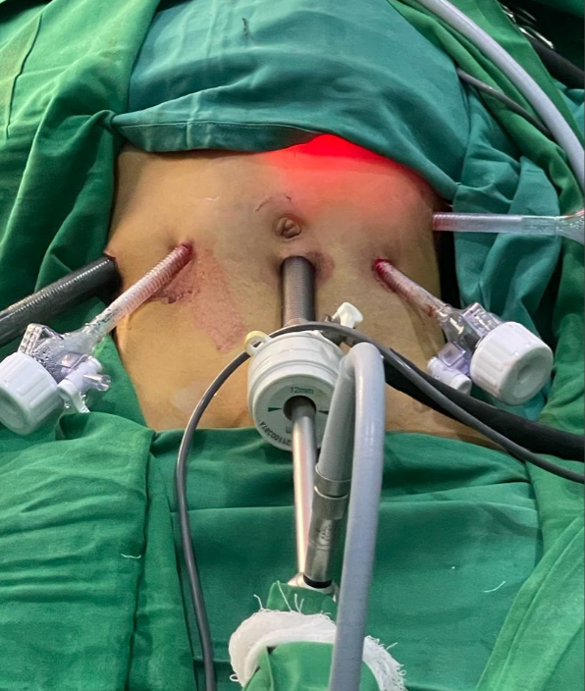  Figure 2: Pots setting during procedure | 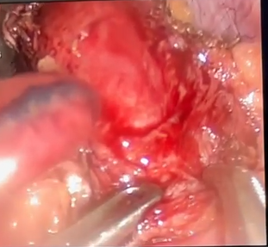  Figure. 3: Laparoscopic Heller’s cardio myotomy
Case 2: Achalasia in a 7year old male with Addison’s disease
Presentation:
A 7-year-old male with Addison’s disease presented with a long history of dysphagia, especially to liquids. There was no history of corrosive substance ingestion or neck surgery. On examination he was irritable, wasted, but exhibited normal vital signs for his age. Abdominal examination revealed a scaphoid abdomen, moving with respiration, soft non tender, with normal bowel sounds. A Barium swallow showed proximal esophageal dilatation with a bird-beak narrowing at the gastroesophageal junction, consistent with achalasia as seen in Figure 4.
Management:
The patient underwent laparoscopic Heller’s oesophagocardiomyotomy. Intraoperatively, hepatomegaly was noted along with hypertrophic circular and longitudinal muscles in the distal esophagus extending to the cardia. A long oesophagocardiomyotomy of approximately 9cm was performed, followed by Dor fundoplication. See Figure 5. The procedure lasted 90 minutes, and the patient was discharged within 24 hours.
Follow up plan:
At two months’ post-op, he remained asymptomatic, with no recurrence of dysphagia or significant complications.
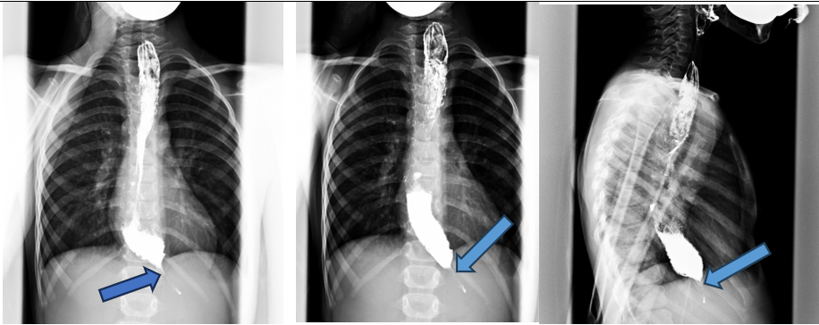
Figure 4: Barium swallow showing esophageal dilatation with bird beak appearance

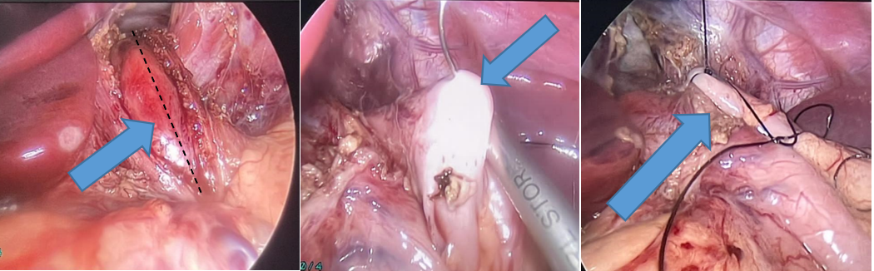
Figure 5: Heller’s Myotomy and Dor fundoplication procedure

Discussion
This case series, contribute valuable insights into pediatric EA, emphasizing the unique clinical manifestations and management challenges in this demographic. EA often presents with a range of symptoms, including dysphagia, vomiting, and chest pain, which can lead to malnutrition and a prolonged time to diagnosis, averaging around two years.
Despite the well-documented effectiveness of HM in adults, our findings align with Jarzębicka et al. in highlighting the need for tailored approaches in pediatric patients [5]. Our patients exhibited significant improvement post-surgery, reflecting the safety and efficacy of HM as a definitive treatment option. These benefits are particularly significant in resource-limited setting like Tanzania, where minimizing healthcare costs and optimizing resource utilization are paramount [6,12].
Importantly, our study did not report any complications such as esophageal perforations, demonstrating the effectiveness of our surgical techniques. Although complications like emphysema have been noted in the literature, our focus remains on the favorable outcomes associated with laparoscopic approaches [11]. Moreover, while the POEM technique shows promise, its limited availability in pediatric cases necessitates further investment in training and resources to expand treatment options in Tanzania [9,10]. This study supports the notion that individualized care is critical for achieving optimal outcomes in pediatric EA management.

Limitation
A significant limitation of this case series is the absence of esophageal manometry data, crucial for accurately diagnosing achalasia and classifying esophageal motility disorders per the Chicago Classification. Due to the lack of manometry studies at our center, we relied on barium swallow studies and clinical presentations, potentially affecting diagnostic precision. Additionally, this study did not include POEM, a minimally invasive alternative to laparoscopic Heller’s myotomy, due to unavailability of expertise and equipment. This emphasizes the need for capacity building at our institution to incorporate advanced techniques like POEM for managing achalasia in resource-limited settings.
Recommendation:
As we move forward, it is essential to standardize perioperative protocol and outcomes measures to facilitate meaningful comparisons and enhance the quality of care. Moreover, ongoing training and capacity –building initiatives are needed to ensure that healthcare providers remain proficient in laparoscopic techniques and can deliver optimal care to patients with achalasia. By embracing a multidisciplinary approach and leveraging advancements in surgical technology, we can further enhance the quality of EA management and improve patients’ outcomes in Tanzania and beyond.
Conclusion
These cases highlight the rarity of EA, particularly in pediatric patients with complex comorbidities like AAA-syndrome and Addison’s disease. The successful outcomes achieved through laparoscopic HM and Dor fundoplication in such rare and challenging cases emphasize the importance of skilled surgical intervention. Despite limited diagnostic resources, including the lack of esophageal manometry, careful clinical assessment and management led to favorable results.
Disclosure
This report adheres to the SCARE criteria for case reports.
Acknowledgments
We extend our gratitude to the administration and surgical team at Muhimbili National Hospital for their invaluable support in successful conducting these laparoscopic operations.
Funding
No external funding was received for this work.
Ethical approval
This case report study was exempted from ethical approval at our institution
Informed consent for publication
Written consent was obtained from patients’ parents for the publication of their children’s cases.
REFERENCES
1. Franklin AL, Petrosyan M, Kane TD. Childhood achalasia: A comprehensive review of disease, diagnosis and therapeutic management. World J Gastrointest Endosc. 2014 Apr;6(4):105–11.
2. Lee CW, Kays DW, Chen MK, Islam S. Outcomes of treatment of childhood achalasia. J Pediatr Surg. 2010 Jun;45(6):1173–7.
3. Walzer N, Hirano I. Achalasia. Gastroenterol Clin North Am. 2008 Dec;37(4):807–25, viii.
4. Hallal C, Kieling CO, Nunes DL, Ferreira CT, Peterson G, Barros SGS, et al. Diagnosis, misdiagnosis, and associated diseases of achalasia in children and adolescents: a twelve-year single center experience. Pediatr Surg Int. 2012 Dec;28(12):1211–7.
5. Jarzębicka D, Czubkowski P, Sieczkowska-Gołub J, Kierkuś J, Kowalski A, Stefanowicz M, et al. Achalasia in Children-Clinical Presentation, Diagnosis, Long-Term Treatment Outcomes, and Quality of Life. J Clin Med. 2021 Aug;10(17).
6. Santiana L, Kusuma FF. A rare case of mega-esophagus due to achalasia causing tracheal compression ✩. Radiol Case Reports. 2024;19(1):39–43.
7. No Title.
8. Boeckxstaens GE, Zaninotto G, Richter JE. Achalasia. 2013;6736(13):1–11.
9. Caldaro T, Familiari P, Romeo EF, Gigante G, Marchese M, Contini ACI, et al. Treatment of esophageal achalasia in children: Today and tomorrow. J Pediatr Surg. 2015 May;50(5):726–30.
10. Inoue H, Minami H, Kobayashi Y, Sato Y, Kaga M, Suzuki M, et al. Peroral endoscopic myotomy (POEM) for esophageal achalasia. Endoscopy. 2010 Apr;42(4):265–71.
11. Goneidy A, Cory-Wright J, Zhu L, Malakounides G. Surgical Management of Esophageal Achalasia in Pediatrics: A Systematic Review. Eur J Pediatr Surg Off J Austrian Assoc Pediatr Surg . [et al] = Zeitschrift fur Kinderchirurgie. 2020 Feb;30(1):13–20.
12. Riccio F, Costantini M, Salvador R, Salvador R. Esophageal Achalasia : Diagnostic Evaluation. 2022;1516–21.

