**A case report of double pylorus: a rare endoscopic finding**

Zelalem Mulu¹, Wudassie Melak², Abdulsemed Nur³, Mengistu Erke⁴

¹Department of Internal Medicine, Debre Markos University, Debre Markos, Ethiopia

²Department of Gastroenterology and Hepatology, School of Medicine, Bahirdar University, Bahirdar, Ethiopia

³Department of Gastroenterology and Hepatology, School of Medicine, Addis Ababa University, Addis Ababa, Ethiopia

⁴Department of Gastroenterology and Hepatology, School of Medicine, Addis Ababa University, Addis Ababa, Ethiopia

Correspondence: Zelalem Mulu. Email: [zmlaew@gmail.com](mailto:zmlaew@gmail.com).

DOI:[**10.21608/ajgh.2025.331053.1067.**](mailto:salemyousefmohamed@gmail.com)

Submission date: 24 October 2024.

Revision date (End of revision):31 December 2024.

Acceptance date:02 January 2025.

**Abstract**

**Introduction**

Double pylorus or duplication of the pylorus is a rare condition characterized by a gastrointestinal fistula between the gastric antrum and the duodenal bulb. It may be present at birth or developed later. There are few case reports of this condition worldwide. Patients having acquired double pylorus have symptoms related to the underlying cause, such as peptic ulcer disease or other conditions like gastric cancer. In congenital cases, most are asymptomatic.

**Case presentation**

We report a case of a 41-year-old female with a history of epigastric burning-type pain for the past 1 week, which was associated with a single episode of hematemesis. She received treatment with intravenous omeprazole for the same period before being referred to our hospital. The physical findings were unremarkable. She was evaluated with endoscopy, during which a double pylorus was incidentally found. She was later treated with 40mg of pantoprazole orally once daily, with subsequent improvement in symptoms.

**Conclusion**

Double pylorus is a rare and unexpected endoscopic finding. A typical, two-orifice pylorus is observed during diagnostic endoscopy. Medical management of such patients rests on proton pump inhibitors or histamine receptor blockers. Patients refractory to medical management and those with symptoms of gastric outlet obstruction benefit from interventional endoscopic procedures and surgical management for optimal outcomes. Our patient responded for medical management and is currently under follow-up.

***Keywords****: peptic ulcer disease, gastric polyps, esophagogastroduodenoscopy, double pylorus, penetration, H.pylori.*

**Introduction**

Duplication of the pylorus, more frequently termed double pylorus (DP), is a rare condition characterized by two communicating channels between the gastric antrum and the first part of the duodenum. Both pyloric openings lead to the first part of the duodenum [1]. It is found in 0.001% to 0.4% of esophagogastroduodenoscopies (EGD) [2]. This condition may arise (occur) due to a congenital abnormality or an acquired complication of a penetrating ulcer [3].

Here, we describe a 41-year-old female Ethiopian patient who initially presented with hematemesis and epigastric pain with an unexpected endoscopic finding of double pylorus. Her symptoms resolved after medical management with proton pump inhibitors.

**Case description**

This is a 41-year-old female patient who presented with epigastric burning type of pain for the past 7 days before admission to Felege Hiwot Comprehensive Specialized Hospital. She also had a single episode of hematemesis at the onset of the illness. She was treated with intravenous omeprazole at a local health center for 1 week before coming to our hospital. The physical examination was unremarkable, with stable vital signs and no signs of anemia or jaundice. Laboratory investigations showed normal serial determination of complete blood count and renal and liver function. Serology for hepatitis B, hepatitis C, and HIV were negative. The H. pylori stool antigen test was negative. The abdominopelvic ultrasound was normal. Later, an upper gastrointestinal endoscopy was done to reveal double pylorus and multiple antral polyps (Figure 1), from which a biopsy was taken. The endoscope was able to pass through each of the double pyloric openings to enter the first part of the duodenum. Histology was suggestive of hyperplastic polyps. Our patient was treated with pantoprazole 40mg orally daily with improvement of the symptoms and was asymptomatic with continued treatment during follow-up.

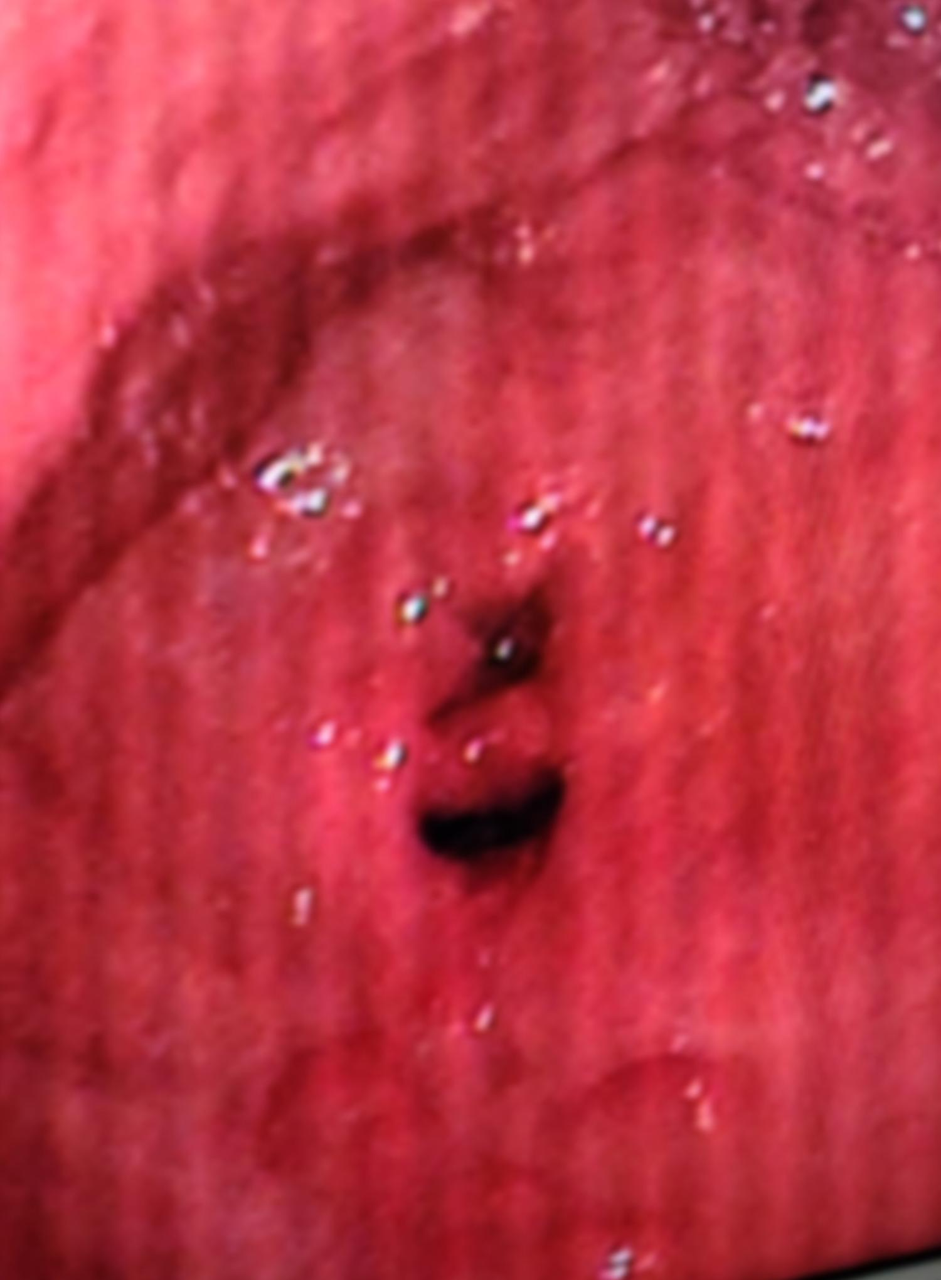

Fig.Double pyloric orifices with small polyps are seen at the antrum. The scope could traverse both openings to enter the duodenal bulb.

**Discussion**

Double pylorus, or acquired double pylorus, is a rare condition defined as a gastrointestinal fistula connecting the stomach antrum and duodenal bulb. The prevalence of double pylorus ranges from 0.001 to 0.4% by esophagogastroduodenoscopy (EGD) [4].

Acquired cases can occur in gastric cancer or as a complication of chronic peptic ulcer disease, leading to penetration of the peptic ulcer and the formation of a fistula between the duodenal bulb and the prepyloric antrum [5]. Most cases result from gastric ulcers, and only a few cases are caused by duodenal ulcers [6]. The use of various medications and the presence of Helicobacter pylori might play a role in the development of double pylorus. Long-term treatment with drugs, including corticosteroids and NSAIDs, may also prevent healing, leading to fistula formation [7]. In our patient, we think that the double pylorus is due to a gastric ulcer that was initially managed at a health center with intravenous omeprazole, leading to the healing of the ulcer; however, the gastric polyps, later identified as hyperplastic polyps, were likely associated with the surrounding inflammatory response in the antrum.

Double pylorus may occur as an exceedingly rare congenital anomaly. The cause of congenital double pylorus has been attributed to a tubular duplication of the pylorus. In a comprehensive literature review of all gastrointestinal tract duplications available in English literature, pyloric duplication was identified in only 1 out of 281 documented cases. It is generally recognized that the congenital double pylorus is primarily asymptomatic and does not necessitate intervention in most instances [8].

An acquired double pylorus typically exhibits symptoms, and individuals may experience chronic upper abdominal pain, vomiting, dyspepsia, or may present with upper gastrointestinal bleeding [9]. There are no specific clinical symptoms of double pylorus [10]. In our situation, the patient’s vital signs and the subsequent hematocrit determinations were normal, indicating non-massive upper GI bleeding.

Acquired double pylorus is most frequently an incidental finding during investigations of other conditions. The diagnosis is typically based on endoscopic findings, but it is occasionally based on radiologic findings. Endoscopy is generally the preferred method of visualization [11].

Treatment includes acid suppression via proton pump inhibitors or H2-receptor antagonists. Refractory and complicated cases require advanced endoscopic or surgical interventions [12]. For patients experiencing the symptoms of gastric outlet obstruction, the initial option to consider should be an endoscopic division of the tissue bridge using a sphincterotome, as restoring a normal pyloric aperture will relieve symptoms [13]. In patients with persistent ulcers despite anti-ulcer therapy, surgical treatment such as distal gastrectomy should be considered [14].

The clinical presentation was comparable to other reported cases but diagnosed earlier with no recognized risk factors. Like most cases, the patient responded positively to PPI treatment. The table below summarizes four other selected instances for comparison (Tab 1).

Tab .Clinical features and outcomes of selected cases of acquired double pylorus.

|  |  |  |  |  |  |  |  |
| --- | --- | --- | --- | --- | --- | --- | --- |
|  | Age  (yr) | Sex | Clinical features | Risk factor(s) | Underlying cause | Treatment | Outcome |
| Thapa et.al⁴ | 69 | M | Epigastric pain, recurrent hematemesis | NSAID and steroid use | DU | PPI and Surgery | Improved |
| Laabidi et.al¹⁵ | 65 | M | Hematemesis and indigestion | Tobacco use, H. Pylori infection | GU and gastritis | H. pylori eradication, PPI | Improved |
| Akbulut et.al⁷ | 74 | F | Epigastric pain | NSAID use | GU | PPI | Improved |
| Koh et.al¹⁶ | 62 | M | Dizziness, nausea, and melena | History of gastric ulcer | GU | PPI | Improved |

**DU: Duodenal ulcer, GU: Gastric ulcer, NSAID: Non-steroidal anti-inflammatory drug, PPI: Proton pump inhibitor.**

**Conclusion**

Double pylorus is a rare condition caused primarily by peptic ulcer disease. It may be congenital or acquired. Acquired cases are more prevalent and typically more symptomatic. Endoscopy is a reliable diagnostic modality. Proton pump inhibitors are the recommended medical treatment. Endoscopic and surgical management options are set aside for refractory cases.

**Footnotes.**

Mohamed Emara (professor of gastroenterology, hepatology, and infectious diseases) and Sara Salem (lecturer of internal medicine, gastroenterology, and hepatology unit) were the peer reviewers.

**E- Editor:** Salem Youssef Mohamed, Osama Ahmed Khalil, Amany Mohammed.

**Copyright ©.** This open-access article is distributed under the Creative Commons Attribution License (CC BY). It may be used, distributed, or reproduced in other forums, provided the original author(s) and the copyright owner(s) are credited. The original publication in this journal must be cited according to accepted academic practice.

**Disclaimer:** The authors' claims in this article are solely their own and do not necessarily represent their affiliated organizations or those of the publisher, the editors, and the reviewers. Any product evaluated in this article or its manufacturer's claim is not guaranteed or endorsed by the publisher.

**Ethical approval:**

Written informed consent was obtained from the patient after the studies were well explained before data collection. The hospital's Research Ethics Review Committee approved the case report.

**Study protocol:**

In adherence to the principles outlined in the Helsinki Declaration, the study protocol was implemented with approval from the institutional review board. Before commencing the research, written consent was obtained from the patient to utilize their clinical information.

**Data and materials availability:** The datasets used or analyzed during the current study are available from the corresponding author upon reasonable request.

**Competing interests**: The authors declare that they have no competing interests.

**Funding**: This study had no funding from any resource.

This work was done according to the **CARE** guidelines.

**Authors' contributions**

Zelalem Mulu and Wudassie Melak collected and followed up on the patients, carrying out the requested investigations. Abdulsemed Nur and Mengistu Erke also followed up on the patients and analyzed the collected data. All authors authorized the manuscript.

**Acknowledgment**: none.

**References**

1. Fattahi MR, Katayoon Homayoon, Laleh Hamidpour. Double Pylorus in a Cirrhotic Patient: A Case Report and Review of the Literature. Middle East Journal of Digestive Diseases. 2012 Apr;4(2):130. Available from: <https://pmc.ncbi.nlm.nih.gov/articles/PMC4017689/>
2. Ofosu A, Brana C, Culliford A, Gaduputi V. A Case Report of Double Pylorus: An Unusual Complication of Peptic Ulcer Disease. American Journal of Gastroenterology. 2018 Oct;113(Supplement): S1069.
3. Oktaricha H, Miftahussurur M. Double Pylorus in Upper Gastrointestinal Bleeding. Case Rep Gastroenterol. 2021 Mar 11;15(1):332-7.
4. Thapa SS, Scott J. Double pylorus. BMJ Case Reports. 2018 Sep 4: bcr-2018-225850.
5. Yong E, Yong E, Wong J, Ho T. Acquired double pylorus. smedj. 2018 Jun;59(6):335-6.
6. Safatle-Ribeiro AV, Ribeiro Júnior U, Habr-Gama A, Gama-Rodrigues JJ. Double pylorus: case report and review of the literature. Rev Hosp Clin. 1999 Aug;54(4):131-4.
7. Akbulut S, Erten A, Ozaslan E, Altiparmak E. Double Pylorus. Balkan Med J. 2014 Jun 10;31(2):187-8.
8. Naidoo R, Singh B. Congenital Double Pylorus. Case Reports in Gastrointestinal Medicine. 2012; 2012:1-2.
9. Fousekis F, Aggeli P, Kotsaftis P, Pappas-Gogos G. Double Pylorus: Report of a Case with Endoscopic Follow-Up and Review of Literature. Gastroenterol Res. 2018;11(2):154-6.
10. Oktaricha H, Miftahussurur M. Double Pylorus in Upper Gastrointestinal Bleeding. Case Rep Gastroenterol. 2021 Mar 11;15(1):332-7.
11. Lei J. Acquired double pylorus: Clinical and endoscopic characteristics and four-year follow-up observations. WJG. 2016;22(6):2153.
12. Sandoval V, Chittajallu V, Haddad FG. An Endoscopic Illusion. ACG Case Rep J. 2024 Mar;11(3): e01278.
13. Graham SM, Lin F, Flowers JL. Symptomatic double-channel pylorus. Surg Endosc. 1994 Jul;8(7):792-3.
14. Goh BK, Tan H. Double pylorus. The American Journal of Surgery. 2006 Apr;191(4):515-6.
15. Laabidi S, Ben Mohamed A, Khsiba A, et al. Acquired double pylorus presenting as gastrointestinal bleeding. Clinical Case Reports. 2022;10(3)
16. Koh M, Jang JS. Gastric Ectopic Pyloric Opening with Gastric Ulcer: A Rare Case. Korean J Gastroenterol. 2022 Mar 25;79(3):126-9.