Laparoscopic Heller’s cardiomyotomy and fundoplication; A successful approach for Achalasia Management at Muhimbili National Hospital, Tanzania: A cases series
Kitembo Salum Kibwana *, Jenikalo Kaguo, Mohammed Sultan Salim, Godfrey Mchele, William Lutege, Yona E Ringo.
Department of Surgery- Gastroenterology Unit, Muhimbili National Hospital, Dar-es-salaam, Tanzania.

*Corresponding author: Kitembo Salum Kibwana, Muhimbili National Hospital, Dar-es-salaam, P.O. Box 65000, Dar-es-salaam, Tanzania. Tel: +255784607682; Email kkitembo@yahoo.com.
DOI: 10.21608/ajgh.2024.387016
Submission date:18 August 2024.
Revision date: 25 August 2024.
Acceptance date: 18 October 2024.
First online: 20 October 2024.

Abstract:
Aims: To describe the surgical management and outcomes of pediatric achalasia in two patients with rare comorbidities, focusing on the challenges and limitations in a resource-limited setting.
Patients & Methods: This case series includes a 9-year-old male with Triple-A syndrome and a 7-year-old male with Addison’s disease, both presenting with long-standing dysphagia. Both patients underwent laparoscopic Heller’s myotomy and Dor fundoplication. The diagnosis was primarily based on clinical presentation and barium swallow due to the unavailability of esophageal manometry.
Results: Both patients demonstrated significant improvements in dysphagia postoperatively. No intraoperative complications occurred, and neither patient experienced recurrence or complications at follow-up. However, the lack of manometric studies may have affected diagnostic precision.
Conclusions: This case series highlights the effective use of laparoscopic Heller’s myotomy in pediatric achalasia patients with complex comorbidities. The absence of manometric studies and Per-Oral Endoscopic Myotomy options underscores the need for advanced diagnostic tools and surgical techniques in resource-limited settings.
Keywords: Achalasia, Pediatric Surgery, Laparoscopic Heller's Myotomy, Dor Fundoplication, Triple-A Syndrome, Addison’s Disease, Esophageal Motility Disorders, Barium Swallow, Resource-Limited Settings, Surgical Outcomes.

Introduction
Esophageal Achalasia (EA) is an uncommon esophageal motility disorder characterized by neurodegeneration, particularly in the pediatric demographic. [1]. This condition is rare among children under the age of five. [2,3]. The epidemiological incidence of achalasia in the pediatric population is estimated at 0.11 per 100,000 children per year [4]. While rare, EA can be associated with complex syndromes such as Allgrove syndrome (also known as triple A, characterized by Alacrimia, Achalasia, and Adrenocorticotropic hormone deficiency), Down’s syndrome, or familial visceral neuropathy [5,6]. Diagnosis of achalasia typically involves imaging or endoscopic evaluations, with confirmatory testing performed using esophageal manometry [6–8].
The management of EA focuses on alleviating lower esophageal sphincter (LES) pressure to enhance swallowing and improve quality of life. Pharmacological interventions are largely ineffective, and endoscopic treatments like botulinum toxin injections and pneumatic dilation have notable limitations. Surgical Heller myotomy (HM) is the gold standard due to its proven efficacy and safety [5,9]. Recently, peroral endoscopic myotomy (POEM) emerged as a minimally invasive alternative, demonstrating comparable success rates with fewer complications [10]. However, access to POEM is limited in pediatric patients, necessitating further evaluation of its long-term efficacy [11]. This study presents two cases of pediatric achalasia who underwent HM and Fundoplication. Note: Laparoscopic Dorr fundoplication involves wrapping a portion of the stomach, the fundus, around the lower esophagus to prevent gastric contents from refluxing to the esophagus.

Case series

Case 1: Triple-A syndrome
A 9-year-old child presented with a long history of dysphagia to liquid since the age of 3 years; he currently manages solid food with water assistance. His symptoms are accompanied by recurrent episodes of diarrhea and vomiting, hypoglycemia, and poor growth since age 2. He has a history of two admissions for diarrhea, during which low cortisol levels were detected. Notably, his mother reported an absence of tears when he cries. He had been diagnosed with Triple-A syndrome (Allgrove syndrome) based on his dysphagia, alacrimia, and adrenal insufficiency. Barium swallow confirmed esophageal dilatation, Fig 1. Presently, he is on a regimen of hydrocortisone 10mg in the morning and 5mg in the evening, along with Fludrocortisone 50mcg.
Management
The patient underwent laparoscopic Heller’s esophagocardiomyotomy (Fig 3) and Dor fundoplication, which involves wrapping the stomach 180-270 degrees around the esophagus to prevent reflux. Intraoperative findings included hypertrophic muscles at the lower intraabdominal esophagus. The procedure lasted 85 minutes, and the patient was discharged after 24 hours.
Follow up
At the one-week follow-up, the patient showed significant improvement in dysphagia symptoms and tolerated oral intake well. No recurrence was reported during the two-month follow-up.
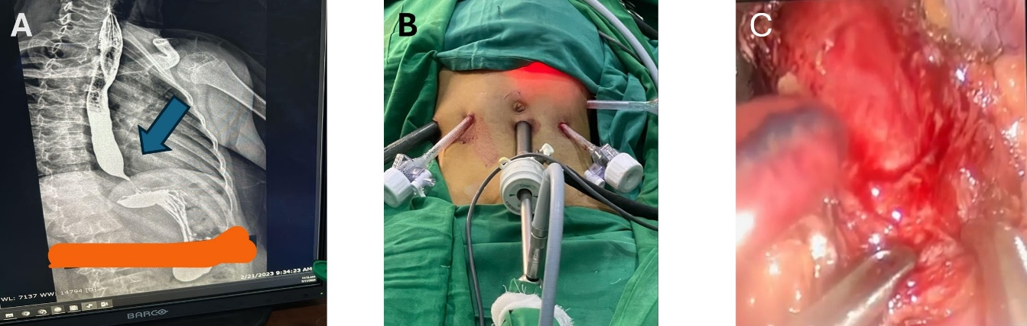
Fig1. Management of achalasia in a patient with triple A syndrome. (A. Barium swallow showing dilatation of the distal esophagus with tapering gastroesophageal junction (Arrow). B. Pots setting during the procedure. C. Laparoscopic Heller’s cardiomyotomy

Case 2: Achalasia in a 7year old male with Addison’s disease
Presentation:
A 7-year-old male with Addison’s disease presented with a long history of dysphagia, especially in liquids. There was no history of corrosive substance ingestion or neck surgery. On examination, he was irritable and wasted but exhibited typical vital signs for his age. Abdominal examination revealed a scaphoid abdomen, moving with respiration, soft, non-tender, and with normal bowel sounds. A Barium swallow showed proximal esophageal dilatation with a bird-beak narrowing at the gastroesophageal junction, consistent with achalasia (Fig 2).
Management:
The patient underwent laparoscopic Heller’s esophagocardiomyotomy. Intraoperatively, hepatomegaly and hypertrophic circular and longitudinal muscles in the distal esophagus extending to the cardia were noted. A long esophagocardiomyotomy of approximately 9cm was performed, followed by Dor fundoplication (Fig 3). The procedure lasted 90 minutes, and the patient was discharged within 24 hours.
Follow-up plan:
At two months post-op, he remained asymptomatic, with no recurrence of dysphagia or significant complications.
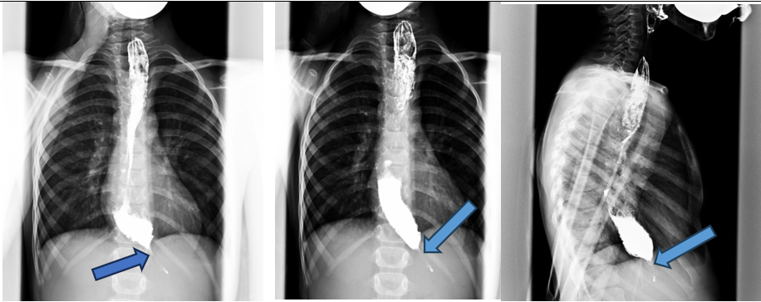
Fig 2. Barium swallow showing esophageal dilatation with bird beak appearance

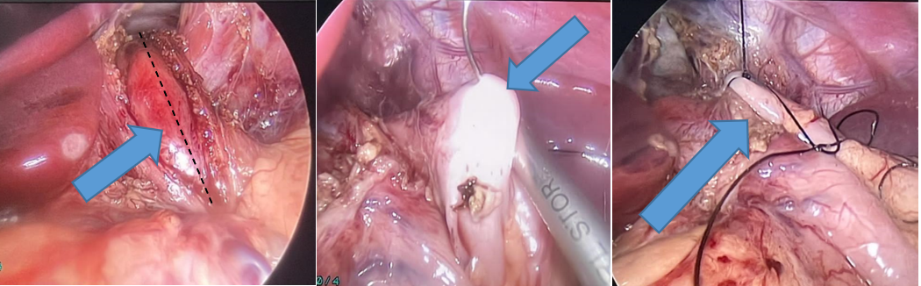

Fig 3. Heller’s Myotomy and Dor fundoplication procedure (Arrows).
Discussion
This case series contributes valuable insights into pediatric EA, emphasizing this demographic's unique clinical manifestations and management challenges. EA often presents with a range of symptoms, including dysphagia, vomiting, and chest pain, which can lead to malnutrition and a prolonged time to diagnosis, averaging around two years.
Despite the well-documented effectiveness of HM in adults, our findings align with Jarzębicka et al. in highlighting the need for tailored approaches in pediatric patients [5]. Our patients exhibited significant improvement post-surgery, reflecting the safety and efficacy of HM as a definitive treatment option. These benefits are particularly substantial in resource-limited settings like Tanzania, where minimizing healthcare costs and optimizing resource utilization are paramount [6,12].
Importantly, our study did not report any complications, such as esophageal perforations, demonstrating the effectiveness of our surgical techniques. Although complications like emphysema have been noted in the literature, our focus remains on the favorable outcomes associated with laparoscopic approaches [11]. Moreover, while the POEM technique shows promise, its limited availability in pediatric cases necessitates further training and resources to expand treatment options in Tanzania [9,10]. This study supports the notion that individualized care is critical for achieving optimal outcomes in pediatric EA management.
Limitation
A significant limitation of this case series is the absence of esophageal manometry data, which is crucial for accurately diagnosing achalasia and classifying esophageal motility disorders per the Chicago Classification. Due to our center's lack of manometry studies, we relied on barium swallow studies and clinical presentations, potentially affecting diagnostic precision. Additionally, this study did not include POEM, a minimally invasive alternative to laparoscopic Heller’s myotomy, due to the unavailability of expertise and equipment. This emphasizes the need for capacity building at our institution to incorporate advanced techniques like POEM for managing achalasia in resource-limited settings. Also, we did not do upper digestive endoscopy before the procedure.
Recommendation:
As we move forward, it is essential to standardize perioperative protocols and outcome measures to facilitate meaningful comparisons and enhance the quality of care. Moreover, ongoing training and capacity–building initiatives are needed to ensure that healthcare providers remain proficient in laparoscopic techniques and can deliver optimal care to patients with achalasia. By embracing a multidisciplinary approach and leveraging advancements in surgical technology, we can further enhance the quality of EA management and improve patients’ outcomes in Tanzania and beyond.
Conclusion
These cases highlight the rarity of EA, particularly in pediatric patients with complex comorbidities like AAA syndrome and Addison’s disease. The successful outcomes achieved through laparoscopic HM and Dor fundoplication in rare and challenging cases emphasize the importance of skilled surgical intervention. Careful clinical assessment and management led to favorable results despite limited diagnostic resources, including the lack of esophageal manometry.
Footnotes.
Editor’s note: We encourage publication from the African community despite the procedure being not entirely new but innovative for the authors and their patients.
Sara Salem (lecturer of internal medicine) and Ahmed Gomaa (professor of internal medicine) were the peer reviewers.
E- Editor: Salem Youssef Mohamed, Osama Ahmed Khalil, Amany Mohammed.
Copyright ©. This open-access article is distributed under the Creative Commons Attribution License (CC BY). It may be used, distributed, or reproduced in other forums, provided the original author(s) and the copyright owner(s) are credited. The original publication in this journal must be cited according to accepted academic practice.
Disclaimer: The authors' claims in this article are solely their own and do not necessarily represent their affiliated organizations or those of the publisher, the editors, and the reviewers. Any product evaluated in this article or its manufacturer's claim is not guaranteed or endorsed by the publisher.
Ethical approval: All procedures involving human participants followed the institutional and national research committee's moral standards, the 1964 Helsinki Declaration, and its later amendments or comparable ethical standards. All authors declare that consent was obtained from the patient (or other approved parties) to publish this study.
Data and materials availability: The datasets used or analyzed during the current study are available from the corresponding author upon reasonable request.
Competing interests: The authors declare that they have no competing interests.
Ethical approval
This case report study was approved by ethical approval at our institution.
Informed consent for publication
Written consent was obtained from patients’ parents to publish their children’s cases.
Funding: This study had no funding from any resource.
This work was done according to the CARE guidelines.
Authors’ contributions
All authors thoroughly reviewed and approved the final version of the manuscript.
Acknowledgment: We are grateful to the administration and surgical team at Muhimbili National Hospital for their invaluable support in successfully conducting these laparoscopic operations.
.

References
1. Franklin AL, Petrosyan M, Kane TD. Childhood achalasia: A comprehensive review of the disease, diagnosis, and therapeutic management. World J Gastrointest Endosc. 2014 Apr;6(4):105–11.
2. Lee CW, Kays DW, Chen MK, Islam S. Outcomes of treatment of childhood achalasia. J Pediatr Surg. 2010 Jun;45(6):1173–7.
3. Walzer N, Hirano I. Achalasia. Gastroenterol Clin North Am. 2008 Dec;37(4):807–25, viii.
4. Hallal C, Kieling CO, Nunes DL, Ferreira CT, Peterson G, Barros SGS, et al. Diagnosis, misdiagnosis, and associated diseases of achalasia in children and adolescents: a twelve-year single center experience. Pediatr Surg Int. 2012 Dec;28(12):1211–7.
5. Jarzębicka D, Czubkowski P, Sieczkowska-Gołub J, Kierkuś J, Kowalski A, Stefanowicz M, et al. Achalasia in Children-Clinical Presentation, Diagnosis, Long-Term Treatment Outcomes, and Quality of Life. J Clin Med. 2021 Aug;10(17).
6. Santiana L, Kusuma FF. A rare case of mega-esophagus due to achalasia causing tracheal compression ✩. Radiol Case Reports. 2024;19(1):39–43.
7. No Title.
8. Boeckxstaens GE, Zaninotto G, Richter JE. Achalasia. 2013;6736(13):1–11.
9. Caldaro T, Familiari P, Romeo EF, Gigante G, Marchese M, Contini ACI, et al. Treatment of esophageal achalasia in children: Today and tomorrow. J Pediatr Surg. 2015 May;50(5):726–30.
10. Inoue H, Minami H, Kobayashi Y, Sato Y, Kaga M, Suzuki M, et al. Peroral endoscopic myotomy (POEM) for esophageal achalasia. Endoscopy. 2010 Apr;42(4):265–71.
11. Goneidy A, Cory-Wright J, Zhu L, Malakounides G. Surgical Management of Esophageal Achalasia in Pediatrics: A Systematic Review. Eur J Pediatr Surg Off J Austrian Assoc Pediatr Surg. [et al] = Zeitschrift fur Kinderchirurgie. 2020 Feb;30(1):13–20.
12. Riccio F, Costantini M, Salvador R, Salvador R. Esophageal Achalasia : Diagnostic Evaluation. 2022;1516–21.

