Constipation among women healthcare professionals working at the University Clinics of Kinshasa: prevalence, habitus, and risk factors

Andy-Muller Luzolo Nzinga1,3, Madeleine Ntumba1, Boniface Kamanga1, François Njimbu1, Jeanne Bertuit 2,4, Véronique Feipel3,4.

1Department of Physical Medicine and Rehabilitation, University Clinics of Kinshasa, Faculty of Medicine, University of Kinshasa, Democratic Republic of Congo.

*2School of Health Sciences (HESAV), University of Applied Sciences and Arts Western Switzerland (HES-SO)- Lausanne, Switzerland*

*3Laboratory of Functional Anatomy - Faculty of Motor Sciences – Université Libre de Bruxelles - Brussels, Belgium*

*4Laboratory of Anatomy, Biomechanics and Organogenesis - Faculty of Medicine – Université Libre de Bruxelles - Brussels, Belgium*

Andy-Muller Luzolo NZINGA1,3*, PhD candidate, PM&R nzinga.luzolo@unikin.ac.cd*

Madeleine NTUMBA1, PM&R ntumbamadeleine5@gmail.com

Boniface KAMANGA1, PhD, PM&R boniface.kamnga@unikin.ac.cd

François NJIMBU1, PhD, PM&R njimbu.kapend@unikin.ac.cd

Jeanne BERTUIT 2,4, PhD, PT jeanne.bertuit@hesav.ch

Véronique FEIPEL3,4, PhD, PT veronique.feipel@ulb.be.

**Corresponding Author**

Andy-Muller Luzolo Nzinga

Pelvic floor Rehabilitation Unit, Department of Physical Medicine and Rehabilitation, University Clinics of Kinshasa, Faculty of Medicine, University of Kinshasa, Democratic Republic of Congo

Mail: nzinga.luzolo@unikin.ac.cd.

DOI: [**10.21608/ajgh. 2025.370974.1079**](mailto:salemyousefmohamed@gmail.com).

Submission date: 24 March 2025.

Revision date (End of revision): 05 July 2025.

Acceptance(final): 16 July 2025.

**ABSTRACT**

**Objective:** The aim is to assess the prevalence and clinical characteristics of constipation, as well as the lifestyle habits of women in healthcare professions, to improve the management of this health condition.

**Patients and Methods:** This cross-sectional study was conducted from January 3 to April 3, 2024, among 100 women healthcare professionals working at the University Clinics of Kinshasa. They were women aged 18 years and older, either employed or in training, in apparently good health, and who had given their consent to participate. The questionnaire contained data on sociodemographic and clinical characteristics, lifestyle habits, and two validated scales: the Bristol Scale and the Knowles, Eckersley, and Scott Symptom Scale (KESS). Mann-Whitney U and Chi-squared tests were used for comparisons. Binary logistic regression was used to identify factors influencing constipation. The significance level was set at 5%.

**Results**: The prevalence of constipation was 44% according to the KESS and 43% according to the Bristol scale. Constipated women were more likely to adopt an improper defecation position (p=0.005) and were less likely to have a bowel movement when they felt the urge or at set times (p<0.001). They used institutional toilets less frequently (p<0.001). They drank less water (p < 0.001) and did not engage in physical activity (p = 0.037). In the multivariate analysis, delaying bowel movements when the urge was felt (aOR: 209.6) and an increased daily water intake (aOR: 0.42) were identified as predictive factors of constipation.

**Conclusion**: Constipation was common among these women. They had poor defecatory and dietary habits, which influenced constipation.

# ***Keywords***: *Constipation; Women; Prevalence; Risk factors.*

# **Introduction**

Constipation is generally described as a condition characterized by persistent difficulty with defecation or a sensation of incomplete evacuation and/or infrequent defecation (once every 3-4 days or less) in the absence of alarm symptoms or secondary causes [1].

In terms of geographical distribution, a very high prevalence of constipation has been reported in Finland (average 79%), South Africa (29%) and South America (26.8-28%), followed by Oceania and Europe, each with an average prevalence of constipation of 19%, North America (16%), and Asia (10%). The lowest prevalence was reported in Italy (0.7%). However, due to the varying definitions of constipation used across studies, statistical comparisons between countries and continents are not feasible [2].

Constipation is a significant health issue that significantly reduces quality of life, leading to physical and psychological complications that impact an individual’s overall well-being. Physical complications related to the repeated straining during constipation include hemorrhoidal disease, pudendal nerve stretch neuropathy, prolapse, and anal incontinence [3-5].

In the Democratic Republic of Congo (DRC), many women suffer from these conditions but often do not seek medical help, and no data are currently available on the prevalence of constipation in the country. It is only in severe cases with physical complications that this diagnosis can be made in a clinical setting.

This study aims to assess the prevalence and clinical characteristics of constipation, as well as the lifestyle habits of women healthcare professionals working at the University Clinics of Kinshasa, to improve the management of this health condition.

**patients and methods**

**Study methodology**

A cross-sectional study, based on a questionnaire, was conducted among 100 women healthcare professionals at the University Clinics of Kinshasa from January 3 to April 3, 2024. Non-probability sampling was performed for convenience. Adult women aged 18 years and older, who were employed or in training, in apparent good health, and who provided informed consent, were included in the study. Women who were pregnant or within six months postpartum, hospitalized, or diagnosed with hypothyroidism or colon cancer, as well as those who declined to participate, were excluded.

The questionnaire contained data on socio-demographic and clinical characteristics, as well as lifestyle habits of the women over the previous two weeks. It also included two validated scales: the Bristol Stool Form Scale, which assessed stool quality, and the Knowles-Eccersley-Scott-Symptom Scale (KESS), which was used to diagnose constipation (supplementary file).

The KESS is an 11-question tool for diagnosing constipation with excellent validity (r = 0.90). All questions use four and 5-point Likert-type responses. The score is calculated by summing the answers selected by the patient. It ranges from 0 to 39, with a score above 11 indicating constipation [6]. The Bristol Stool Form Scale is a validated scale (r=0.71) for stool quality (consistency and water content). Types 1 and 2 indicate constipation, while types 3 and 4 are ideal stools, being easy to defecate and without excess liquid. Types 6 and 7 indicate diarrhea. (Fig. 1) [7].

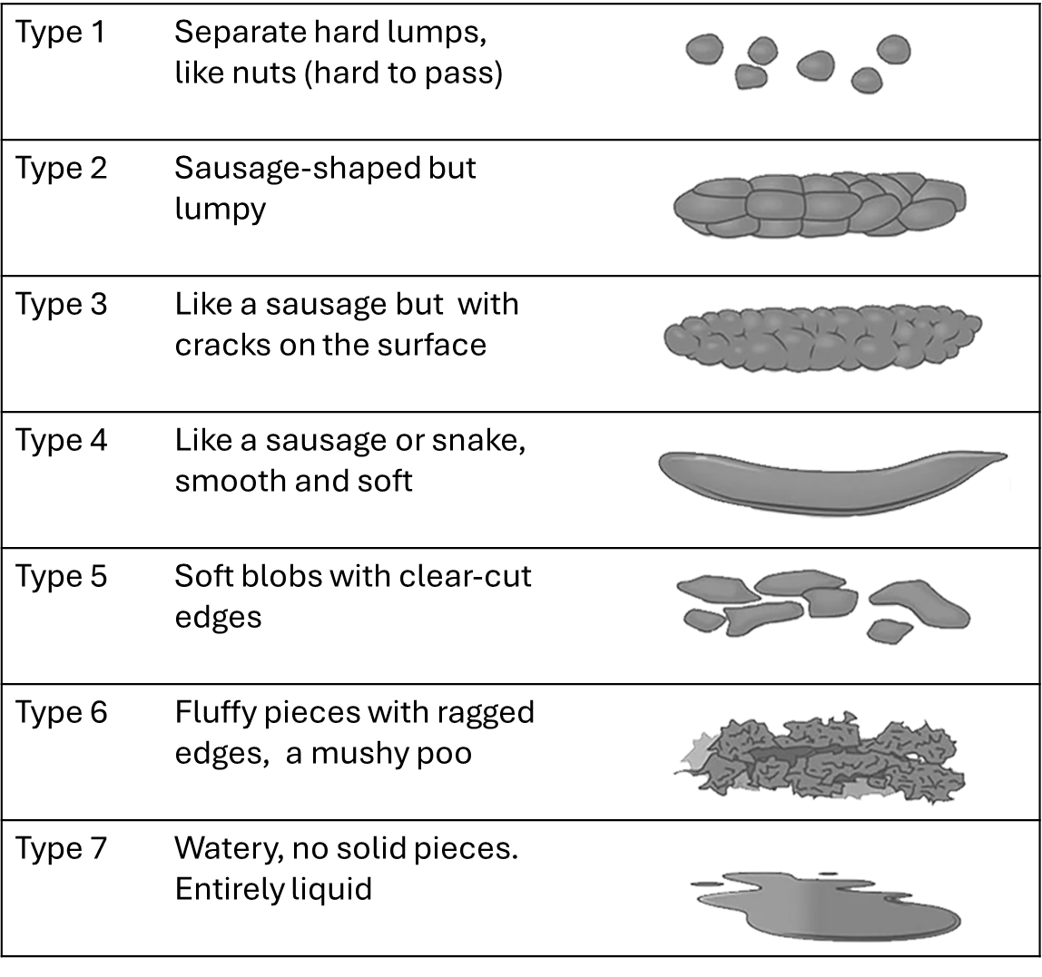

Fig 1. **The Bristol Stool Form Scale (adapted from [7])**

**Specific operational definitions were adopted:**

* Correct defecation position: squatting on a ‘Turkish toilet’, or if using a toilet bowl, putting the feet on a toilet stool (Figure 2) [8] when defecating.

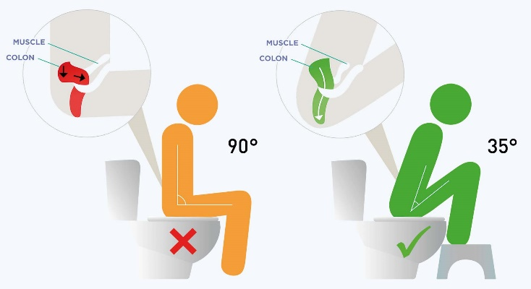

Fig 2. Sit on the toilet bowl with feet on a toilet stool [8].

## Constipating medication: drugs likely to induce constipation, such as antidepressants, antiepileptics, antihistamines, antiparkinsonian drugs, antipsychotics, antispasmodics, antidiarrheals, non-steroidal anti-inflammatory drugs, etc.

## Low-fiber diet: red and white meat, white rice, unripe bananas, potatoes, fish, etc.

## Fiber-rich foods: vegetables (amaranth, manioc leaves, sorrel, cabbage, beans, spinach, etc.), fruit (orange, passion fruit, avocado, apple, sultanas, etc.);

## Constipating drinks: fizzy and sugary drinks.

## **Ethical considerations**

## A written informed consent was submitted to each woman, allowing her to give her agreement to participate in the study. Ethical clearance, under number ESP/CE/236/2019, dated September 17, 2019, was obtained in the Democratic Republic of Congo for the conduct of this study.

## **Statistical analysis**

Qualitative variables were expressed as frequencies and percentages, along with their 95% confidence intervals (CI). Discrete quantitative variables were presented as medians with interquartile ranges (IQR: Q25–Q75). To compare groups with and without constipation, the Mann-Whitney U test was used for quantitative variables, and the Chi-square test (or Fisher's exact test if applicable) was used for qualitative variables. When the p-value was less than 0.05, the strength of the effect observed between the variables in the two groups was measured by the effect size coefficients (r for the Mann-Whitney U test and Cramer's V for the Chi-squared test). The effect was either small (r < 0.3 or v ≤ 0.2), medium (0.3 < r ≤ 0.5 or 0.2 < v ≤ 0.6), or large (r >0.5 or v > 0.6). Binary logistic regression was used to identify the determinants and factors influencing constipation.

**Results**

**Prevalence of constipation**

The prevalence of constipation was 44% (95% CI: 34.1-54.3) according to the KESS scale and 43% (95% CI: 33.1-53.3) according to the Bristol scale.

**Socio-demographic and clinical characteristics between constipated and non-constipated women**

In the group of constipated women, there were more adults (56.8% vs 33.9%; p=0.022), menopausal women (45.5% vs 23.2%; p=0.019), multiparous women (p=0.044), women with a history of hemorrhoidal disease (29.5% vs 0%; p<0.001), history of functional colopathy (20.5% vs 3.6%; p=0.007) and the notion of taking constipating medication (38.6% vs 14.3%; p=0.005). They adopted an improper defecation position (79.5% vs 62.5%; p=0.005) and reported delaying bowel movement when the urge was felt (88.6% vs 3.6%; p<0.001) or not at set times (90.9% vs 26.8%; p<0.001). They did not use institutional toilets (84.1% vs. 46.4%; p < 0.001). They drank less water (2 glasses vs. five glasses; p < 0.001) and did not engage in physical activity (75% vs. 53.6%; p = 0.037). (Tab 1)

Tab 1. Comparison of socio-demographic and clinical characteristics between constipated and non-constipated women

|  |  |  |  |  |  |
| --- | --- | --- | --- | --- | --- |
| **Variables** | **Constipation (N=44)** | **No constipation (N=56)** | **p value* (Effect size)** | | |
|  | | |
| **Age (years),** *n(%)* |  |  |  | | |  | | |
| Adults (>31) | 25(56.8) | 19(33.9) | 0.022(v=0.229) | | |  | | |
| Young adults (18-30) | 19(43.2) | 37(66.1) |  | | |
| **Profession**, *n(%)* |  |  |  | | |  | | |
| Doctors and trainees | 19(43.2) | 34(60.7) | 0.10 | | |  | | |
| Nurses and trainees | 25(56.8) | 22(39.3) |  | | |  | | |
| **History** |  |  |  | | |  | | |
| Menopause, *n(%)* | 20(45.5) | 13(23.2) | 0.019(v=0.235) | | |  | | |
| Parity, *median (IQR)* | 3(0-5) | 1(0-3) | 0.044(r=0.201) | | |  | | |
| Hemorrhoidal disease, *n(%)* | 13(29.5) | 0(0) | <0.001(v=0.436) | | |  | | |
| Functional colonopathies, *n(%)* | 9(20.5) | 2(3.6) | 0.007(v=0.268) | | |  | | |
| Constipating medication, *n(%)* | 17(38.6) | 8(14.3) | 0.005(v=0.279) | | |  | | |
| Hygienic and dietary habits |  |  |  | | |  | | |
| Improper defecatory position, *n(%)* | 35(79.5) | 35(62.5) | 0.005(v=0.305) | | |  | | |
| Delaying bowel movement when the urge was felt, *n(%)* | 39(88.6) | 2(3.6) | <0.001(v=0.859) | | |  | | |
| No set times for bowel movements, *n(%)* | 40(90.9) | 15(26.8) | <0.001(v=0.640) | | |  | | |
| Not using institutional toilets, *n(%)* | 37(84.1) | 26(46.4) | <0.001(v=0.387) | | |  | | |
| Low fiber diet, *n(%)* | 42(95.5) | 53(94.6) | 0.85 | | |  | | |
| High fiber diet, *n(%)* | 42(95.5) | 54(96.4) | 0.80 | | |  | | |
| Constipating drinks, *n(%)* | 27(61.4) | 30(53.6) | 0.43 | | |  | | |
| Frequency of water intake per day, *median (IQR)* | 2(1-2.75) | 4(3-4) | <0.001(r=0.323) | |  | | |
| Number of glasses of water per day, *median (IQR)* | 2(1-3) | 5(4-7) | <0.001(r=0.419) |  | | |
| Lack of physical activity, *n(%)* | 33(75) | 30(53.6) | 0.037(v=0.220) | | |  | | |

*\* Mann-Whitney U test for quantitative variables and Chi-square test (or Fisher's exact test, where appropriate) for qualitative variables; the significance level was 0.05*

Determinants and risk factors of constipation

In univariate analysis, adult age, menopause, parity, use of constipating medication, improper defecatory position, delaying bowel movement when the urge was felt, no set times for bowel movements, not using institutional toilets, lack of physical activity, and the number of glasses of water taken per day were all factors favoring constipation. In multivariate analysis, delaying bowel movement when the urge was felt (AOR: 209.6; CI95%: 20.27 - 2167.6; p<0.001) and the number of glasses of water taken per day (AOR: 0.42; CI95%: 0.23-0.78; p=0.007) were independent predictive factors of constipation (Table 2)

Tab 2. Determinants and factors favoring constipation

|  |  |  |  |  |
| --- | --- | --- | --- | --- |
| **Variables** | **COR(CI95%)** | **p value** | **AOR(CI95%)** | **p value**\* |
| **Age (year)** |  |  |  |  |
| Young adults (18-30) | 1 |  | 1 |  |
| Adults (>31) | 2.5(1.13-5.78) | 0.023 | 16.7(0.17-1570) | 0.22 |
| Menopause | 2.7(1.16-6.50) | 0.021 | 3.41(0-3216) | 0.72 |
| Parity | 1.2(1.001-1.403) | 0.049 | 0.71(0.34-1.510) | 0.38 |
| Constipating medication | 3,7(1.44-9.90) | 0.007 | 7.5(0.96-59.28) | 0.054 |
| Improper defecatory position | 6(1.62-22.21) | 0.007 | 122(0.57-26359) | 0.07 |
| Delaying bowel movement when the urge was felt | 210.6(38.8-1142.2) | <0.001 | 209.6(20,27-2167.61) | <0.001 |
| No set times for bowel movements | 27.3(8.3-89.4) | <0.001 | 9.84(0.76-126.6) | 0.07 |
| Not using institutional toilets | 6.1(2.32-15.98) | <0.001 | 2.61(0.05-119.7) | 0.62 |
| Frequency of water intake per day | 0.27(0.16-0.45) | <0.001 | 6.93(0.16-284.7) | 0.30 |
| Number of glasses of water per day | 0.35(0.23-0.53) | <0.001 | 0.42(0.23-0.78) | 0.007 |
| Lack of physical activity | 2.6(1.9-6.15) | 0.03 | 1.28(0.04-33.76) | 0.87 |

* P value of the binary logistic regression; significance level was 0.05

# **DISCUSSION**

In this sample of healthcare professionals from the University Clinics of Kinshasa, a high prevalence of constipation was observed, regardless of the tool used to assess it (44%; 95% CI: 34.1 - 54.3) according to the KESS scale and 43% (95% CI: 33.1 - 53.3) according to the Bristol scale. This trend is consistent with the findings of Séhonou et al. (2019) in Benin, where the prevalence of constipation among women was reported to be 45.7% [9]. This value also falls within the range of 16.7-67.9% reported in the literature [10-12], including 16.7% in Canada and 67.9% in India. Other authors have reported prevalence between 20.4% and 27.5% considering stool consistency according to the Bristol scale [9, 13]. This variability in constipation prevalence may be attributed not only to differences in diagnostic criteria but also to the methods used for data collection and analysis. However, regardless of the techniques used, the prevalence of constipation remains high in the present study.

## 

According to the present study, women who experienced constipation exhibited several characteristics that were statistically different from those of women who did not experience constipation. They were more adult, multiparous, and menopausal women with a history of hemorrhoidal disease, functional colopathy, and on medication likely to cause constipation. They had improper defecatory behavior (improper defecatory position, not having a bowel movement when desire was felt, not exonerating at set times), did not use the institutional toilet, drank less water a day, and had a lack of physical activity.

It should be recognized that constipation can have several determinants and factors that may favor its occurrence, such as lifestyle (lack of physical activity, defecation habits, etc.), eating habits (low dietary fiber intake, water insufficiency, etc.), physiological and medical factors (constipating medication, underlying medical conditions such as hemorrhoidal diseases, functional colopathies, etc.), hormonal, anatomical (prolapse, etc.) and psychological factors [14-15].

The study by Berger et al. highlighted risk factors identified by a consensus conference, including physical activity, drug treatments (opioids, neuroleptics), difficulty accessing the toilet, lifestyle changes, poor hydration, and colorectal obstruction, among others [16]. According to other authors, female gender, age, socio-economic level, and level of education appear to be the main determinants of the prevalence of constipation [2, 17]. These factors correspond closely to the characteristics observed in the women with constipation in the present study. After multivariate analysis, only two variables emerged as significant predictors of constipation. Women who delayed defecation when the urge was felt had a significantly higher risk of constipation, whereas those who consumed sufficient water were less likely to be constipated.

According to expert opinion, it is essential to avoid adopting the positions during defecation that were used by the constipated women in the present study. The correct defecation position, which aids in excretion, involves keeping the back straight on the toilet, bending the legs over the abdomen, and raising the feet onto a step. This position would encourage the propulsive action of the abdominal and pelvic floor muscles [18].

It is worth noting that bowel movements are often the result of a conditioned reflex. According to Heaton's study, most people with regular bowel movements have a bowel movement at almost the same time every day. Voluntary repression of the urge to have a bowel movement encourages prolonged contact between the stool and the rectal mucosa, helping to dry out the stool and give it a stiff consistency, which is why it is advisable to promote regularity in the gastrointestinal reflex [19-20]. In other words, people should be encouraged to have a bowel movement at set times and when the urge is felt.

Additionally, a certain amount of privacy, combined with minimal hygiene conditions, would likely encourage the desire to use the restroom. This recommendation seems particularly relevant in schools and workplaces, where these conditions are rarely respected, often resulting in voluntary withholding, which can lead to a progressive reduction in rectal sensitivity and a drying out of the stools, contributing to constipation [10].

Although there is a lack of scientific evidence regarding the link between daily water intake and constipation, expert opinion recommends sufficient water intake of 8 glasses of water, 6 times a day, equivalent to 2 liters a day [10, 20-21]. This daily water consumption is thought to have a protective role against the symptoms of constipation [22]. This is also confirmed by the study by Séhonou et al., who found a significant link between hydration and constipation [9].

According to the literature, it is possible that waters rich in minerals, especially magnesium, may have an additional laxative effect [23-25]. The study by Dupont et al., conducted in France, demonstrated the superiority of drinking 1 L of Hépar mineral water, which contains sulphates, calcium, and magnesium, compared with natural water low in minerals, in a double-blind, randomized, controlled trial involving 244 women with functional constipation [26]. It is advisable to avoid drinking too many sugary, fizzy, or alcoholic drinks, which appear to promote constipation [25].

The present study was unable to statistically establish a link between the consumption of any dietary fiber and the occurrence of constipation. In the Democratic Republic of Congo, the basic staples in the diet are manioc derivatives (such as fufu and chikwangue), maize (in the form of flour), and rice. As these are low in fiber, they are often combined with foods rich in dietary fiber (such as vegetables like amaranth, spinach, and manioc leaves, and fruits) during the main meal. For this reason, it is difficult to confirm that constipated women consume more foods low in dietary fiber than those who are not, as fiber-rich foods counterbalance their effects on the digestive system.

However, the French National Nutrition and Health Program (PNNS) recommends habitual consumption of fiber-rich foods, including five portions of fruit and vegetables a day [16, 27].

Although a lack of physical activity has been cited as a risk factor for constipation by some authors, the recommendation is primarily based on the potential positive effect of physical activity on overall well-being [28].

## 

This work is the outcome of an initial study conducted in the Democratic Republic of Congo, aimed at assessing the prevalence and clinical characteristics of constipation, as well as the practices of female healthcare professionals at the University Clinics of Kinshasa, because coloproctology is a relatively new discipline in the country, with a limited number of specialists in the field. Despite these limitations, the study has several notable drawbacks, including the specificity of the population studied and the sampling method used, which render it impossible to generalize the results. Additionally, the difficulty in specifying the nature of the foods consumed over a specific period hinders the identification of these foods as risk factors for constipation.

**Conclusion**

Constipation is a common issue among female healthcare professionals at the University Clinics of Kinshasa. The characteristics of constipated women generally corresponded to the risk factors cited in the literature. These included defecation habits, lack of physical activity, water insufficiency, biological factors (such as age), physiological factors (including parity), and medical factors (including constipating medication and underlying medical conditions). Consumption of low-fiber foods was not included, as all the women in the study balanced their meals with high-fiber foods. Among these characteristics, only two were identified as predictive factors for constipation after statistical analysis: delaying bowel movements when the urge was felt and insufficient water intake.

**Footnotes.**

Sara Salem (Professor of internal medicine, gastroenterology, and hepatology unit), Mohamed Emara (Professor of gastroenterology, hepatology, and infectious diseases department), and Amany Mohamed (Professor of family medicine and biostatistician) were peer reviewers.

**E- Editor:** Salem Youssef Mohamed, Osama Ahmed Khalil, Amany Mohammed.

**Copyright ©.** This open-access article is distributed under the Creative Commons Attribution License (CC BY). It may be used, distributed, or reproduced in other forums, provided the original author(s) and the copyright owner(s) are credited. The original publication in this journal must be cited according to accepted academic practice.

**Disclaimer:** The authors' claims in this article are solely their own and do not necessarily represent their affiliated organizations or those of the publisher, the editors, and the reviewers. Any product evaluated in this article or its manufacturer's claim is not guaranteed or endorsed by the publisher.

**Ethics approval**

A written informed consent was submitted to each woman, allowing her to give her agreement to participate in the study. Ethical clearance, under number ESP/CE/236/2019, dated September 17, 2019, was obtained in the Democratic Republic of Congo for the conduct of this study.

All participants provided informed consent to be enrolled in the study.

**Data and materials availability:** The datasets used and/or analyzed during the current study are available from the corresponding author on reasonable request.

**Competing interests**: The authors declare that they have no competing interests.

**Funding**: This study had no funding from any source.

This work was conducted following the STROBE guidelines.

**Authors' contributions:**

Andy-Muller Luzolo Nzinga, Madeleine Ntumba, and Boniface Kamanga revised the results and shared them during the manuscript writing and editing process. François Njimbu, Jeanne Bertuit, and Véronique Feipel conceived the study and analyzed the data. Andy-Muller Luzolo Nzinga, Madeleine Ntumba, and Boniface Kamanga conceived the idea, contributed to interpreting the results, and revised the manuscript. Andy-Muller Luzolo Nzinga designed the study and conducted the data analysis. François Njimbu, Jeanne Bertuit, and Véronique Feipel conducted clinical studies, collected data, and wrote the manuscript in collaboration with others. Madeleine Ntumba, Boniface Kamanga collected data, analyzed results, and prepared the manuscript. All authors read, revised, and approved the final manuscript.

**Acknowledgments**: Not applicable.

# **References**

1. Lindberg G, Hamid S, Malfertheiner P, et al. Constipation: une approche globale.World World Gastroenterol Organ Glob Guidel. 2010; 1- 4. Available from: <https://www.worldgastroenterology.org/UserFiles/file/guidelines/constipation-french-2010.pdf>. Accessed May 10, 2022.
2. Peppas G, Alexiou VG, Mourtzoukou E, Falagas ME. Epidemiology of constipation in Europe and Oceania: a systematic review. BMC Gastroenterol. 2008; 8:1-7.
3. Lee AJ, Evans CJ, Hau CM, Fowkes FG. Fiber intake, constipation, and risk of varicose veins in the general population: Edinburgh Vein Study. J Clin Epidemiol. 2001;54(4):423-9.
4. Gibbons CP, Bannister JJ, Read NW. Role of constipation and anal hypertonia in the pathogenesis of haemorrhoids. Br J Surg. 1988;75: 656-60.
5. Bharucha AE. Fecal incontinence 1,2. Gastroenterol. 2003;124(6):1672-85.
6. Knowles CH, Eccersley AJ, Scott SM, Walker SM, Reeves B, Lunniss PJ. Linear discriminant analysis of symptoms in patients with chronic constipation: validation of a new scoring system (KESS). Dis Colon Rectum. 2000;43(10):1419-26. DOI: 10.1007/BF02236639.
7. Lewis SJ, Heaton KW. The stool form scale as a useful guide to intestinal transit time. Scand J Gastroenterol. 1997;32(9):920-4.
8. Wellcare. Adopt the recommended toilet position. 2024 [Internet]. Available from: <https://www.wellcarecompany.fr/position-wc-squatty-potty/>. Accessed September 22, 2024.
9. Séhonou J, Sokpon CNDM, Kpossou A, Azandjeme C, Cataria H, Vignon R K. Constipation fonctionnelle en population générale à Cotonou (Bénin): aspects cliniques et influence des facteurs nutritionnels. Pan Afr Med J*. 2019; 34*(1): 1-7.
10. Hall GR, Karstens M, Rakel B, Swanson E, Davidson A. Managing constipation using a research-based protocol. Medsurg Nurs. 1995;4(1):11-8.
11. Muller-Lissner SA, Kamm MA, Scarpignato C. Myths and misconceptions about chronic constipation. Am J Gastroenterol. 2005;100(1):232–242.
12. Robson KM, Kiely DK, Lembo T. Development of constipation in nursing home residents. Dis Colon Rectum. 2000;43(7):940-3.
13. Cottone C, Tosetti C, Disclafani G, Ubaldi E, Cogliandro R, Stanghellini V. Clinical features of constipation in general practice in Italy. United European Gastroenterol J. 2014;2(3):232-238
14. Forrotan M, Bagheri N, Darvishi M. Chronic constipation: a review of literature. Medicine Open. 2018;97(20):1-9.
15. Hosseinzadeh ST, Poorsaadati S, Radkani B, Forootan M. Psychological disorders in patients with chronic constipation. Gastroenterol Hepatol Bed Bench. 2011;4(3):159-163.
16. Berger V, Germain C, Lacomère R, Bader C, Gerbouin O, Bénard A. Consensus approach: Prior to the construction of an evaluation scale of risk for constipation patients hospitalized for nursing practice. Rev Epidemiol Sante Publique. 2018;66(5):301-309.
17. Mugie SM, Benninga MA, Di Lorenzo C. Epidemiology of constipation in children and adults: a systematic review. Best Pract Res Clin Gastroenterol. 2011;25(1):3-18.
18. Park KS, Choi SC, Park MI, Lee T, Kim SE, Jung KW. Practical treatments for constipation in Korea. Korean J Intern Med. 2012; 27: 262-70.
19. Heaton EA. The call to stool and its relationship to constipation: a community study. Eur J Gastroenterol-Hepatol. 1994; 6(2):145-9.
20. Klauser AG, Beck A, Schindlbeck NE, Müller-Lissner SA. Low fluid intake lowers stool output in healthy male volunteers. Z Gastroenterol. 1990; 28: 606-9.
21. Le Journal des Femmes Santé. How much water to I drink per day? 2022 [Internet]. Available from: <https://sante.journaldesfemmes.fr/fiches-nutrition/2105569-quelle-quantite-eau-boire-par-jour-femme-homme-poids/>. Accessed December 24, 2023.
22. Borre M, Qvist N, Raahave D, et al The effect of lifestyle modification on chronic constipation. Ugeskr Laeger. 2015; 177(15): V09140498.
23. Ratanamongkol P, Lertmaharit S, Jongpiputvanich S. Polyethylene glycol 4000 without electrolytes versus milk of magnesia for the treatment of Functional constipation in infants and young children: A randomized controlled trial. Asian Biomed. 2009;3(4):391-9.
24. Gomes PB, Duarte MA, Melo Mdo C. Comparison of the effectiveness of polyethylene glycol 4000 without electrolytes and magnesium hydroxide in the treatment of chronic functional constipation in children. J Pediatr (Rio J). 2011; 87:24-8.
25. Wang HJ, Liang XM, Yu ZL, et al A randomised, controlled comparison of low-dose polyethylene glycol 3350 plus electrolytes with Ispaghula husk in the treatment of adults with chronic functional constipation. Clin Drug Investig. 2004;24:569-76.
26. Dupont C, Campagne A, Constant F. Efficacy and safety of a magnesium sulfate-rich natural water for patients with functional constipation. Clin Gastroenyerol Hepatol. 2014; 12: 1280-7.
27. Programme National Nutrition Santé. Dietary recommendations [Internet]. Available from: http://www.mangerbouger.fr/pro/education/s-informer-2/les-recommandations-de-sante-publique/les-recommandations-en-matiere-d-alimentation.html. Accessed July 25, 2018.
28. Chung BD, Parekh U, Sellin JH. Effect of increased fluid intake on stool output in normal healthy volunteers. J Clin Gastroenterol. 1999;28(1):29-32.