**Clinical significance of** **LncRNA-MIAT as a non-invasive diagnostic marker of** **non-Hodgkin's lymphoma associated with occult hepatitis C virus infection**

Nearmeen M. Rashad1*, Sameh A. Soliman1 Ahmed Ali obaya2, Abdelmonem Mohamed Elshamy3, Amira M. El-Helaly 4, Marwa H.S. Hussien5 Ahmed F. Gomaa1

Departments of Internal medicine 1, Clinical Oncology and Nuclear Medicine 2, Tropical Medicine3, Clinical Pathology 4, andMedical Biochemistry 5 Faculty of Medicine, Zagazig, Egypt.

**\*Corresponding author:** Nearmeen M. Rashad, **Mobile:** (+20) 01224248642,

**E-mail:** nrashad78@yahoo.com & [n.rashad@zu.edu.eg](mailto:n.rashad@zu.edu.eg).

DOI: [10.21608/ajgh.2023.187817.1028](https://ajgh.journals.ekb.eg/)

Submission date:17 January 2023

Revision date: 17 January 2023

Acceptance date: 30 January 2023

First online: 31 January 2023

**Abstract**

**Aims:** the current research aimed to investigate LncRNA-MIAT in patients with non-Hodgkin lymphoma (NHL) and to assess its correlation with clinicopathological features and treatment protocols of NHLs among Egyptian patients with Occult hepatitis C virus (HCV) infection (OCI).

**Patients & Methods: This** study was conducted on 20 patients with NHL and 30 healthy subjects as the control group. All subjects were screened for HCV-RNA in both plasma and PBMCs. RT-PCR determined lncRNA-MIAT.

**Results**: lncRNA-MIAT relative expression level was upregulated in NHL groups (2.73±0.86) compared to controls (1.06±0.07), P ˂0.001*. Among NHL, patients with OCI (3.2±0.63) had significantly higher levels of lncRNA-MIAT compared to HCV (2.6±1.08) and non-HCV (2.4±0.4), P ˂0.001*. Additionally, the relative expression levels of lncRNA-MIAT were significantly positively correlated with laboratory and clinicopathological features of NHL. Interestingly, concerning the treatment of DLBCL-NHL, there were significantly higher levels of lncRNA-MIAT in no treatment subgroup (n=10, 3.31±0.95) compared to successfully treated subgroups [CHOP (n=7, 1.58±0.34) and R-CHOP (n=3, 11.16±0.21), P ˂0.001*

**Conclusions**: lncRNA-MIAT level was upregulated in NHL patients, particularly patients with OCI. Thus, circulatory lncRNA-MIAT may serve as a promising non-invasive diagnostic marker for NHL associated with OCI.

***Keywords:*** HCV; lncRNA; MIAT; NHL; DLBCL; Occult hepatitis C; CHOP; RT-PCR; PBMCs; non-invasive.

**1. Introduction**

Non-Hodgkin's lymphomas (NHLs) are the most predominant hematological cancer. Intriguingly, NHLs prevalence is about 4% of all diagnosed cancer and rank seventh in frequency among all cancers. Furthermore, many studies have shown that lymphoma is considered the fourth most common tumor in Egypt, particularly in adults [1].

There is accumulating evidence that NHL is a group of lymphoproliferative malignancies with different behaviors and prognoses. Evolving evidence estimated the histological types of NHL, and consequently, they classified NHL into different types that vary in severity, from indolent to aggressive lymphomas [2]. Diffuse large B-cell lymphoma (DLBCL) is the most common subtype of NHL worldwide, particularly in Egypt. It represents 49% of all NHL cases presented to the National Cancer Institute [3].

There is now enough evidence to establish that HCV infection is correlated to hematologic malignancies, including lymphomas. More interestingly, HCV infection has significant consequences associated with cancer and its treatment [4]. A report conducted by Castillo et al. demonstrates a new type of HCV infection termed occult HCV infection, which revealed the presence of both HCV RNA in PBMCs and the liver without any measurable HCV RNA in serum by standard assay [5].

Thus, it is paramount to discover non-invasive methods for detecting occult HCV in addition to previously confirmed techniques, as reported in a recent study [6].

There is convincing evidence that lncRNA are epigenetic marker widely found in the nucleus, cytoplasm, and exosome [7]. Evidence suggests that lncRNA Myocardial Infarction Associated Transcript (MIAT) dysregulation is associated with different cancers [8]. Early diagnosis of cancer is crucial for proper and effective treatment. Therefore, the current research to investigate LncRNA-MIAT in NHL and to evaluate its correlation with clinicopathological parameters and progression of NHLs among Egyptian patients with OCI- HCV.

**2. Subjects and methods**

**2.1. Subjects**

This research includes 20 patients of both sexes with NHL. In addition to the 30 healthy control individuals,' age and sex-matched the cases. According to the WHO, the NHL diagnosis included clinical manifestations, an adequate biopsy specimen, and immunophenotype studies. We selected patients with Diffuse large B-cell lymphoma (DLBCL)-NHL 10 patients were newly diagnosed, and ten patients we treated with 6–8 cycles of CHOP or R-CHOP protocols. All selected patients were in the remission stage.

The Ethics Committee of the Faculty of Medicine, Zagazig University, approved the study protocol with (IRB no. 10213). Each member sent an agreement to participate in the study. The flow chart of the study is demonstrated in figure 1.

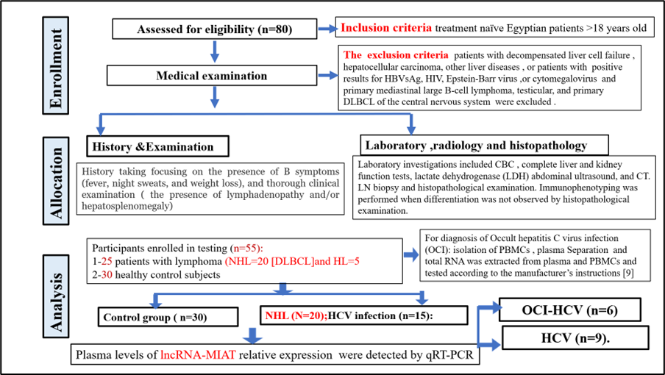

Figure . flow chart of the study.

***2.2. Laboratory tests***

Laboratory evaluation was done for the studied participants enrolled from the Departments of Internal medicine, Clinical Oncology, Nuclear Medicine, and Tropical Medicine. Testing was done according to operating techniques in Zagazig university hospital and Medical Biochemistry laboratories, as shown in figure1.

**2.3. lncRNA-MIAT expression levels by real-time PCR**

The RNA was extracted from EDTA peripheral blood samples according to the company's instructions. The mRNA expression of lncRNA-MIAT was explored by Real-time PCR and the forward primer 5’-TTTACTTTAACAGACCAGAA-3', lncRNA-MIAT reverse primer 5’-CTCCTTTGTTGAATCCAT-3'). GAPDH was used as a housekeeping gene., The expression level was determined using the 2-ΔΔCT method.

**2.4. Statistical analysis**

All analyses were conducted using SPSS version 26, and P < 0.05 was considered statistically significant. For descriptive characterization, we used t-tests and Mann-Whitney-U-tests. For descriptive characterization, frequencies were calculated using crosstabs followed by χ2-tests. Correlations between lncRNA-MIAT and studied parameters were done. All P values were two-sided.

**3. Results**

**3.1. Clinicopathological characteristics in NHL patients.**

In the current study, we adjust age and sex to avoid conflict influencing our results. As expected, there were significant differences between both groups as regards the B symptoms, BM aspirate, BM trephine, site of involvement, NHL stage, international prognostic index (IPI) NHL, and performance status. Also, we found significantly higher levels of WBC count and LDH. However, hemoglobin level and platelet count were significantly lower in the case group compared to the control group P ˂0.001*. On the contrary, we did not find any significant difference regards serum creatinine, alpha-fetoprotein, prothrombin time, albumin, AST, ALT, total bilirubin, and direct bilirubin P >0.05 (Table 1).

Table . clinicopathological characteristics in NHL patients.

|  |  |  |  |
| --- | --- | --- | --- |
| **Parameters** | **Control group, (n=30)** | **Non-Hodgkin’s (NHL) group, (n=20)** | **P value** |
| Age (years), mean ±SD | 43.56±6.43 | 43.66±6.54 | 0.450 |
| Sex [n (%)]  Male  Female | 13(43.3%)  17(56.7%) | 11(55%)  9(45%) | 0.438 |
| B symptoms [n (%)]  Present  Absent | 0(0%)  100(100%) | 12 (60%)  8 (40%) | ˂0.001* |
| BM aspirate [N (%)]  Infiltrated  Not infiltrated | 0(0%)  100(100%) | 12 (60%)  8 (40%) | ˂0.001* |
| BM trephine [N (%)]  Infiltrated  Not infiltrated | 0(0%)  100(100%) | 12 (60%)  8 (40%) | ˂0.001* |
| Site of involvement [N (%)]  Lymphadenopathy  HSM  Lymphadenopathy and HSM | 0(0%) | 2(10%)  6(30%)  12 (60%) | ˂0.001* |
| Stage [N (%)]  I  II  III  IIIS  IIIE  IV | 0(0%) | 1(5%)  1(5%)  3(15%)  2(10%)  1(5%)  12 (60%) | ˂0.001* |
| **Performance status** (WHO score)  1  2  3 | 100(100%) | 11(55%)  6 (30%)  3(15%) | ˂0.001* |
| **IPI NHL**  Low risk  Low intermediate risk  High intermediate risk  High risk | 0(0%) | 9(45%)  7(35%)  2(10%)  2(10%) | ˂0.001* |
| Prothrombin time (PT) | 11.73±0.61 | 11.4±0.5 | 0.704 |
| Albumin (g/dl) | 4.31±0.18 | 4.1±0.28 | 0.267 |
| AST (IU/L) | 18.59±4.9 | 19.4±3.2 | 0.199 |
| ALT(IU/L) | 21.93±3.5 | 22.9±5.3 | 0.499 |
| Total bilirubin (mg/dl) | 0.94±0.144 | 0.99±0.31 | 0.254 |
| Direct bilirubin (mg/dl) | 0.26±0.12 | 0.21±0.39 | 0.611 |
| WBC count (cell×103/μl) | 6.13±0.93 | 8.69±2.09 | ˂0.001* |
| Hemoglobin (g/dl) | 13.7±0.71 | 10.3±2.16 | ˂0.001* |
| Platelet(cell×103/μl) | 235.2± 58.3 | 180.4±39.5 | ˂0.001* |
| S. creatinine (mg/dl) | 0.75±0.22 | 0.71±1.69 | 0.576 |
| Alpha-fetoprotein(ng/ml) | 8.29±3.9 | 8.1 ±6.2 | 0.592 |
| LDH | 194.2± 61.3 | 491.4±99.5 | ˂0.001* |

**3.2. The relative expression level of lncRNA** **MIAT in studied groups.**

The exciting results of the existing research are that lncRNA-MIAT values were overexpressed in NHL (2.73±0.86) compared to controls (1.06±0.07), figure 2, P ˂0.001*.

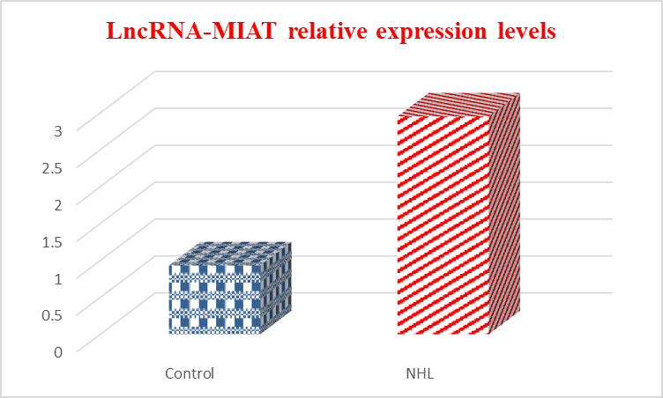

Figure . **Comparison between studied groups regards the relative expression level of LncRNA-MIAT**

Intriguingly, NHL patients with OCI (3.2±0.63) had significantly higher levels of lncRNA-MIAT compared to HCV (2.6±1.08) and non-HCV (2.4±0.4), figure 3, P ˂0.001*.

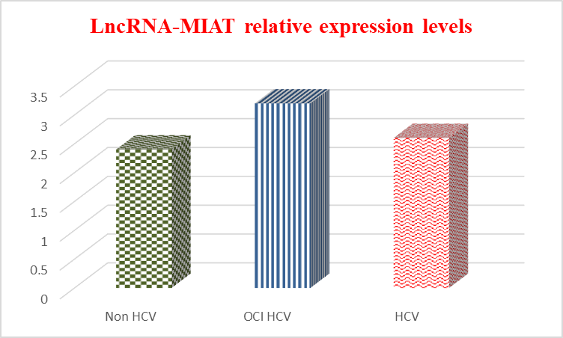

Figure . **The relative expression level of LncRNA-MIAT in NHL is classified according to HCV infection.**

**3.3. MIAT expression value in comparison to other studied parameters in NHL.**

According to the current study, there were statistically significant differences regards HCV infection percentage among NHL patients, with about 45% of NHL infected with OCI-HCV and 30 % of NHL patients infected with HCV P ˂0.001*. In addition, 55% of patients had B symptoms, and 60% of patients had infiltrated BM aspirate and trephine. Interestingly, 60% of patients had lymphadenopathy and HSM. Also, 60% of patients were in stage IV. Regards Performance status,55% of patients had 1 score, and 45% had low risk, according to IPI NHL (Table 2).

Table . The relationship between the relative expression level of LncRNA-MIAT and clinicopathological characteristics in NHL patients.

|  |  |  |
| --- | --- | --- |
| **Parameters** | **NHL, (*n* =20),*n* (%)** | **LncRNA-MIAT,** mean ±SD |
| HCV  OCI HCV  P value | 9(45%)  6(30%) | 2.6±1.11  3.2±0.93  ˂0.001* |
| **B symptoms [n (%)]**  Present  Absent  P value | 11(55%)  9(45%) | 2.6±0.8  2.8±0.93  0.777 |
| **BM aspirate [N (%)]**  Infiltrated  Not infiltrated  P value | 12 (60%)  8 (40%) | 2.6±1.08  2.9±0.63  0.154 |
| **BM trephine [N (%)]**  Infiltrated  Not infiltrated  P value | 12 (60%)  8 (40%) | 2.72±0.8  2.74±1.03  0.963 |
| **Site of involvement [N (%)]**  Lymphadenopathy  HSM  Lymphadenopathy and HSM  P value | 2(10%)  6(30%)  12 (60%) | 2.70±0.71  2.73±0.83  2.75±0.96  0.993 |
| **Stage [N (%)]**  I  II  III  IIIS  IIIE  IV  P value | 1(5%)  1(5%)  3(15%)  2(10%)  1(5%)  12 (60%) | 2.1  2.2  2.75±0.96  2.70±0.71  4.73  3.25±0.932  0.499 |
| **Performance status**  1  2  3  P value | 11(55%)  6 (30%)  3(15%) | 2.83±0.71  2.31±1.13  3.75±1.0  0.297 |
| **IPI NHL**  Low risk  Low intermediate risk  High intermediate risk  High risk  P value | 9(45%)  7(35%)  2(10%)  2(10%) | 2.23±0.71  2.51±0.82  2.75±1.11  3.75±1.31  0.340 |
| **Treatment of DLBCL-NHL**  No treatment  CHOP  R-CHOP  P value | 10(50%)  7(35%)  3(15%) | 3.31±0.95  1.58±0.34  1.16±0.21  ˂0.001* |

**3.4.** **MIAT expression value in comparison to treatment in DLBCL-NHL patients.**

DLBCL-NHL (n=20), ten patients were newly diagnosed, and ten patients we treated with 6–8 cycles of CHOP[cyclophosphamide, doxorubicin, vincristine, and prednisone], (n=7) or R-CHOP (n=3) protocols .there were significantly higher levels of lncRNA-MIAT in no treatment subgroup (n=10, 3.31±0.95) compared to successfully treated subgroups [CHOP (n=7, 1.58±0.34) and R-CHOP (n=3, 11.16±0.21), table 2, P ˂0.001*

**3.5. The associations of MIAT expression** **with other studied parameters.**

The relative expression level of lncRNA MIAT was positively correlated with WBC and LDH. On the contrary, lncRNA MIAT expression level was negatively correlated with hemoglobin and platelet, P ˂0.001* (Table 3).

Table . **Correlation of serum levels of LncRNA-MIAT with clinical and laboratory characteristics in NHL**

|  |  |  |
| --- | --- | --- |
| **parameters** | **LncRNA-MIAT** | |
| ***r*** | **p** |
| Prothrombin time | 0.023 | 0.852 |
| Albumin | -0.019 | 0.879 |
| AST | 0.231 | 0.054 |
| ALT | 0.188 | 0.119 |
| Total bilirubin | 0.068 | 0.578 |
| Direct bilirubin | 0.121 | 0.318 |
| WBC count | 0.743 | ˂0.001* |
| Hemoglobin | -0.264 | ˂0.05* |
| Platelet | -0.543 | ˂0.001* |
| LDH | 0.657 | ˂0.001* |
| Creatinine | 0.154 | 0.203 |

**3.6. linear regression analysis in NHL.**

Recent results noticed that LDH was the only predictor of MIAT among other studied parameters, P ˂0.001* (Table 4).

Table . Table 4: linear regression analyses to examine the main independent variables against the relative expression level of LncRNA-MIAT with in NHL group.

| Model | | Unstandardized  Coefficients | | Standardized Coefficients | t | P value | 95% C.I. | |
| --- | --- | --- | --- | --- | --- | --- | --- | --- |
| B | S.E. | Beta | Lower Bound | Upper Bound |
| 1 | Constant | 0.740 | 0.645 |  | 1.147 | 0.268 | -0.627 | 2.108 |
| WBC count | 0.074 | 0.052 | 0.201 | 1.428 | 0.173 | -0.036 | 0.185 |
| Hemoglobin | -0.002 | 0.001 | -0.292 | -2.045 | 0.058 | -0.003 | 0.000 |
| Platelet | -0.002 | 0.001 | -0.292 | -2.045 | 0.058 | -0.003 | 0.000 |
| LDH | 0.864 | 0.177 | 0.695 | 4.873 | ˂0.001* | 0.488 | 1.240 |

**3.7. The diagnostic performance of lncRNA MIAT in distinguishing NHL**

To further assessment of the current analytical test, we applied ROC analysis. The AUC was 0.924 (95% CI = 0.855–0.993) with sensitivity =90 %, specificity = 84%, and the cutoff values (1.6), (Fig. 4), P ˂0.001*.

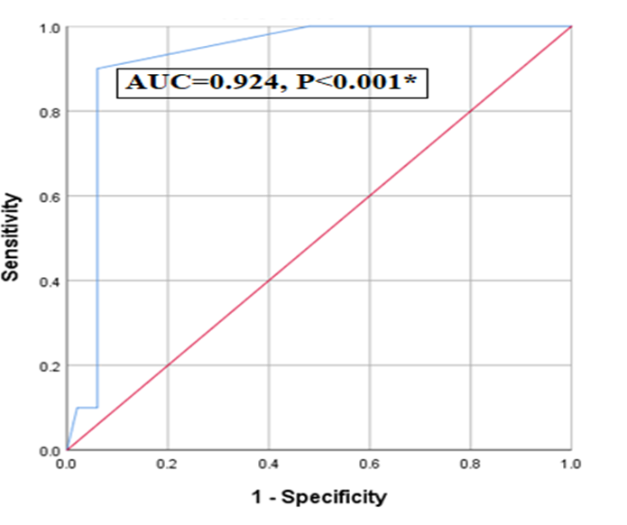

Figure . **Receiver operating characteristic curve of the relative expression levels of LncRNA-MIAT for diagnosis NHL.**

**4. Discussion**

An increasing number of studies have shown that lymphoma is considered the fourth most common tumor in Egypt; in particular, in adults, it represents 76.6% NHL and 23.4% HL [1].

The current research designed a case-control study to explore LncRNA-MIAT in patients with NHL and to assess its correlation with clinicopathological features and treatment protocols of NHLs among Egyptian patients with OCI. The current research had 30 healthy controls and 20 patients with DLBCL-NHL; 10 patients were newly diagnosed, seven patients were treated with 6–8 cycles of CHOP, and three received R-CHOP protocols. All treated patients were in the remission stage.

Concerning HCV infection, as demonstrated in the flowchart in figure 1, all participants were screened for the presence of HCV-RNA in both plasma and PBMCs, and it found that among 20 patients with NHL, about 45% of NHL infected with OCI-HCV and 30 % of NHL patients infected with HCV P ˂0.001. Moreover, 55% of patients had B symptoms, and 60% had infiltrated BM aspirate and trephine. Interestingly, 60% of patients had lymphadenopathy and HSM. Also, 60% of patients were in stage IV. Regards Performance status,55% of patients had 1 score, and 45% had low risk, according to IPI NHL

Similar results were observed in another Egyptian study by Lotfi and his colleagues. They observed that about 71.9% of lymphoproliferative disorders (LPD) had a high percentage of HCV infection: OCI-HCV (37.5%) and HCV (34.38%) [9].

Also, in another Egyptian study conducted by Youssef et al. to assess the prevalence of occult hepatitis C virus in Egyptian patients with chronic lymphoproliferative disorders, they found that about 20% of patients with chronic lymphoproliferative diseases were HCV OCI and 26% were positive HCV [10].

In contrast, a previous study has shown that the percentage of LPD patients infected with HCV was 1.9%. Such findings could be associated with differences in ethnicity and the prevalence of HCV in all Iranian populations [11].

The most common subtype of NHL is DLBCL. Conventionally, DLBCL-NHL was selected, which is the aggressive form. Our findings revealed significant differences between both groups regarding parameters of NHL and other essential markers, for example, WBC count and LDH, hemoglobin level, and platelet count. Notwithstanding advances in diagnosis, treatment, and prognosis, cancer is still one of the most widespread causes of mortality and morbidity worldwide.

There is proof that many patients are diagnosed in the late and aggressive stages of cancer. Furthermore, prominence has been given to the underlying molecular mechanisms of cancer, and many analytical types of research demonstrated that lncRNA could be used as diagnostic, prognostic, and predictive biomarkers. Hence, we decided to investigate the role of the relative expression level of MIAT in the diagnosis of NHL in correlation with clinicopathological features, HCV infection, and treatment protocol.

There is accumulating evidence that lncRNA MIAT was previously recognized as a point associated with myocardial infarction susceptibility [12]. Moreover, an exciting study confirmed that the upregulation of MIAT could lead to microvascular dysfunction [ 13]. Evolving evidence suggests that dysregulated MIAT has been detected in breast [14], hepatocellular carcinoma [15], lung cancer [16], and pancreatic [17].

The most important finding was that lncRNA-MIAT was elevated in NHL compared to controls, P ˂0.001*. Among NHL, patients with OCI had significantly higher levels of lncRNA-MIAT than HCV and non-HCV, P ˂0.001*. The sensitivity of lncRNA-MIAT in the diagnosis NHL was 90 %, and the specificity was 84% at cutoff values of 1.6. Additionally, MIAT values were positively correlated with WBC and LDH. On the opposite, circulatory MIAT was negatively associated with hemoglobin and platelet. Remarkably, LDH was the only predictor of MIAT, including another studied parameter.

Similar results observed by Wang et al. detected that MIAT is increased in AML patient specimens and acute myeloid leukemia. Notably, the upregulation of MIAT is associated with poor clinical outcomes [ 18].

Similar results were demonstrated by Sattari et al., who investigated MIAT and detected its elevation in lymphoid cell lineage, particularly the aggressive form of chronic lymphocytic leukemias carrying different mutations [12].

As stated before, MIAT/RNCR2 was exposed initially as a candidate gene for myocardial infarction [19]. An interesting study was conducted by Crea et al. to estimate MIAT in prostate cancer, and they found upregulation of lncRNA MIAT expression level in NEPC patients [20]. Similar results were observed by Lai et al., who evaluated MIAT expression in lung cancer, and they detected that MIAT was overexpressed in lung cancer.

To gain further insights, we aimed to assess the prognostic function of lncRNA-MIAT. As a result, we confirmed that there were significantly higher levels of lncRNA-MIAT in no treatment subgroup compared to successfully treated subgroups CHOP and R-CHOP, P ˂0.001*. Thus, it could be used as a prognostic and diagnostic marker of NHL, particularly DLBC-NHL.

**Conclusion**

The most important findings in the current research were overexpressed lncRNA-MIAT in NHL and with OCI. In addition, it was overexpressed in no treatment subgroup compared to successfully treated subgroups CHOP and R-CHOP. Consequently, MIAT could be a promising non-invasive diagnostic, prognostic, and predictive biomarker.

**List of abbreviations**

**LncRNA**: long non-coding RNA

**OCI**: Occult HCV infection.

**MIAT**: Myocardial Infarction Associated Transcript

**PBMCs:** Peripheral blood mononuclear cells

**RT-PCR:** A real-time polymerase chain reaction

**CHOP:** Cyclophosphamide, doxorubicin, vincristine, and prednisone

**R-CHOP:** Rituximab, cyclophosphamide, doxorubicin, vincristine, and prednisone

**HCV RNA:** Hepatitis C virus Ribonucleic acid

**BM aspirate:** Bone marrow aspiration

**BM trephine:** Bone marrow trephine biopsy

**AST:** Aspartate transaminase

**ALT:** Alanine transaminase

**WBC:** White blood cells

**LDH:** Lactase dehydrogenase

**HSM:** Hepatosplenomegaly.

**Footnotes.**

**Peer-Reviewers:** Ahmed Agrodey (assistant professor of internal medicine), Heba Taha (assistant professor of medical oncology), Bassam Mansour (lecturer of tropical medicine), and Hayam Rashed (professor of pathology).

**E- Editor:** Salem Youssef Mohamed, Osama Ahmed Khalil.

**Copyright ©.** This open-access article is distributed under the Creative Commons Attribution License (CC BY). The use, distribution, or reproduction in other forums is permitted, provided the original author(s) and the copyright owner(s) are credited. The original publication in this journal is cited by accepted academic practice. No use, distribution, or reproduction is permitted, complying with these terms.

**Disclaimer:** All claims expressed in this article are solely those of the authors and do not necessarily represent their affiliated organizations or those of the publisher, the editors, and the reviewers. Any product evaluated in this article or its manufacturer's claim is not guaranteed or endorsed by the publisher.

**Data availability**

All the data obtained and analyzed are included in this manuscript.

**Conflicts of interest**

The authors declare that they have no competing interests.

**Funding source**

The authors funded this study on their own.

**Authors’ contributions**

NMR and SAS conceived and supervised the work. AAO and AME planned and carried out the experiments. AME, MHS, and AFG analyzed the data. All authors wrote the manuscript. All authors read and approved the final manuscript.

**References**

1. Shams TM. High expression of LMO2 in Hodgkin, Burkitt, and germinal

center diffuse large B cell lymphomas. J Egypt Natl Canc Inst 2011; 23: 147–153.

2. Abd El, Shafik HE. CA 125, a New Prognostic Marker for Aggressive NHL. J Egypt Natl Canc Inst. 2009;21(3):209–17.

3. Gad A H, El Azzazi M O, El Afifi A M et al.: Treatment outcome in Egyptian lymphoma patients, 2-year results, single-center experience. The Egyptian Journal of Haematology 2014; 39(4): 209.

4. Torres HA, Shigle TL, Hammoudi N, et al.: The oncologic burden of hepatitis C virus infection: A clinical perspective. CA Cancer J Clin 2017; 67:411-431.

5. Castillo I, Pardo M, Bartolome J, et al. Occult hepatitis C virus infection in patients in whom the etiology of persistently abnormal results of liver-function tests is unknown. The Journal of Infectious Diseases ;2004;189(1): 7–14.

6. Abdel-Moneim AS. Occult hepatitis C infections: Time to change the defined groups. Microbiology and Immunology 2019; 63(11): 474–475

7.M. Dragomir, B. Chen, and G. A. Calin, "Exosomal lncRNAs as new players in cell-to-cell communication," Translational Cancer Research,2018; 7, (2), pp. S243–S252.

8. C. Sun, L. Huang, Z. Li, et al.Long non-coding RNA MIAT in development and disease: a new player in an old gameJ. Biomed. Sci.,2018; 25 (23).

9. Lotfi A A, Mohamed AE, Shalaby NA, et al. Occult hepatitis C virus infection in patients with malignant lymphoproliferative disorders. International Journal of Immunopathology and Pharmacology 2020; 34: 1–8

10. Youssef SS, Nasr AS, El Zanaty T, et al. Prevalence of occult hepatitis C virus in Egyptian patients with chronic lymphoproliferative disorders. Hepatitis Research and Treatment 2012; 1–6.

11. Farahani M, Bokharaei-Salim F, Ghane M, et al. Prevalence of occult hepatitis C virus infection in Iranian patients with lymphoproliferative disorders. Journal of Medical Virology 2013;85(2): 235–240.

12. Ishii N, Ozaki, K., Sato, H., et al. Identification of a novel non-coding RNA, MIAT, that confers risk of myocardial infarction. J. Hum. Genet. 2006;51, 1087–1099.

13. Li Y, Jiang B, Wu X, et al. Long non-coding RNA MIAT is estrogen-responsive and promotes estrogen-induced proliferation in ER-positive breast cancer cells. Biochem. Biophys. Res. Commun. 2018a;503, 45–50.

14. Huang X, Gao Y, Qin J, and Lu, S. lncRNA MIAT promotes proliferation and invasion of HCC cells via sponging miR-214. Am. J. Physiol. Gastrointest. Liver Physiol. 2018;314, G559–G565.

15. Lin D, Xu H P, Lin J, Hu, H. H., Wang, Q., and Zhang, J. Long non-coding RNA MIAT promotes non-small cell lung cancer progression by sponging miR-1246. Eur. Rev. Med. Pharmacol. Sci2020. 24:8626.

16. Li, T. F., Liu, J., and Fu, S. J. The interaction of long non-coding RNA MIAT and miR-133 play a role in the proliferation and metastasis of pancreatic carcinoma. Biomed. Pharmacother. 104, 145–150. doi: 10.1016/j.biopha.2018b.05.043

17. Wang G, Li X, Song L, Pan H, Jiang J, and Sun L. Long non-coding RNA MIAT promotes the progression of acute myeloid leukemia by negatively regulating miR-495. Leuk Res. 2019 Dec; 87:106265.

18.Sattari A, Siddiqui H, Moshiri F, et al. Upregulation of Long Noncoding RNA MIAT in Aggressive Form of Chronic Lymphocytic Leukemias. Oncotarget 2016; 7:54174–82. doi: 10.18632/oncotarget.11099.

20.Crea F, Venalainen E, Ci X, Ch et al. The role of epigenetics and long non-coding RNA MIAT in neuroendocrine prostate cancer. Epigenomics. 2016; 8:721–31.

21. Lai IL, Yang CA, Lin PC, et al. Long non-coding RNA MIAT promotes non-small cell lung cancer proliferation and metastasis through MMP9 activation. Oncotarget. 2017 Oct 3;8(58):98148-98162.