The influence of lncRNA expression dysregulation on predicting celiac diseases among patients with Hashimoto's thyroiditis
Nearmeen M. Rashad^{1*}, Mohamed Othman Wahba ^{1,} Abdelmonem Mohamed Elshamy², Manar H. Soliman³, Marwa H.S. Hussien⁴, Ahmad Sallam⁵, Amr Talaat EL Hawary ¹
¹Departments of Internal Medicine, Faculty of Medicine, Zagazig university, Zagazig, Egypt.
²Tropical Medicine, Faculty of Medicine, Zagazig University Zagazig, Egypt.
³Medical Microbiology and Immunology, Faculty of Medicine, Zagazig University Zagazig, Egypt.
⁴Medical Biochemistry, Faculty of Medicine, Zagazig University Zagazig, Egypt.
⁵Clinical Pathology Department, Faculty of Medicine, Zagazig University, Zagazig, Egypt.
*Corresponding author: Nearmeen M. Rashad, Mobile: (+20) 01224248642.
E-mail: nrashad78@yahoo.com & n.rashad@zu.edu.eg.
DOI: 10.21608/AJGH.2024.262342.1048.
Submission date:12 January 2023.
Revision date: 29 January 2024.
Acceptance date: 31 January 2024.
Published online:05 February 2024.
Abstract
Aim: the study aimed to investigate lncRNA IFNG-AS1 in Hashimoto’s thyroiditis (HT) and to evaluate its predictive and diagnostic values of Celiac disease (CD) among patients with HT.
Patients and Methods One hundred voluntary subjects: 50 healthy controls and 50 patients with HT;39 without CD and 11 with CD. Routine labs, including anti-TG, anti-TPO, and anti-TTG-IgA, investigated all subjects. lncRNA IFNG-AS1 expression was analyzed using Quantitative real-time RT-PCR.

Results
Patients with CD had significantly overexpressed lncRNA IFNG-AS1(4.17±0.618) compared to patients without CD (1.92±0.52) and control group (0.98±0.21), p ˂0.001*. It correlated considerably with intestinal and extra-intestinal manifestations and laboratory tests, including anti-TG, anti-TPO, and TTG IgA. Multivariate regression confirmed that the only variables independently associated with lncRNA IFNG-AS1 in the prediction of CD among studied parameters were anti-TG, anti-TPO, and TTG IgA. We found high sensitivity and specificity of 96% and 94% among HT, respectively. Concerning CD, the predictive power of IFNG-AS1 had sensitivity and specificity of 63.3% and 53%, respectively.
Conclusion: lncRNA IFNG-AS1 level was overexpressed in patients with HT, particularly those with CD, and correlated to clinical and laboratory parameters. Accordingly, it may be a promising predictive biomarker for HT and CD.
Keywords: anti-TPO; anti-TG; lncRNAs; CD; TTG IgA; HT; IFNG-AS1; RT-PCR; gluten intolerance; enteropathy
Introduction
Hashimoto thyroiditis (HT) is an autoimmune thyroid disease characterized by increased thyroid volume, lymphocyte infiltration of parenchyma, and antibodies specific to thyroid antigens [1]. Although the exact etiology has not been fully explained, HT is related to an interaction among genetic elements, environmental factors, and epigenetic influences [2].
Due to immune tolerance loss, HT is a pivotal disease associated with endocrine and nonendocrine autoimmune disorders [3]. From a clinical point of view, the functional and morphological alterations related to thyroid-enter-gastric autoimmunity may lead to potentially serious clinical consequences like anemia [4], micronutrient deficiencies [5], and drug malabsorption [6] as well as to increased risk for the development of gastric, intestinal, and thyroid malignancies [7]. These clinical manifestations frequently present underhand, leading to diagnostic and treatment delays [8].
Celiac disease is a complex, chronic, immune-mediated disease that affects about 1% of the population and develops in genetically susceptible individuals in response to ingested gluten proteins [9]. There is no single gold standard test for the diagnosis of CD, and the diagnosis of CD is based on a combination of clinical manifestations, the presence of the celiac-specific serological test, and the demonstration of villous abnormality on intestinal mucosal biopsies [10].
Long non-coding RNAs (lncRNAs) have been documented as a class of non-coding RNAs >200 nucleotides in size [11]. Numerous studies have reported that lncRNAs serve critical roles in the pathogenesis of various diseases and regulation of the immune system [12]. However, the expression profiles and function of lncRNAs in patients with HT are yet to be elucidated. Thus, the current research aimed to assess lncRNA IFNG-AS1 in HT and evaluate its predictive and diagnostic CD values among patients with HT.
Subjects and methods
This research conducted 50 patients with HT and 50 sex - and age-matched controls. The diagnostic criteria for HT were obtained based on clinical findings, positive serum antibodies to thyroid peroxidase (TPO Ab), and thyroglobulin (Tg Ab). Among 50 patients with HT,11 patients had CD. CD was diagnosed according to the criteria established by the European Society for Pediatric Gastroenterology, Hepatology, and Nutrition (ESPGHAN) [13]. The study design is shown in the flowchart Fig 1.
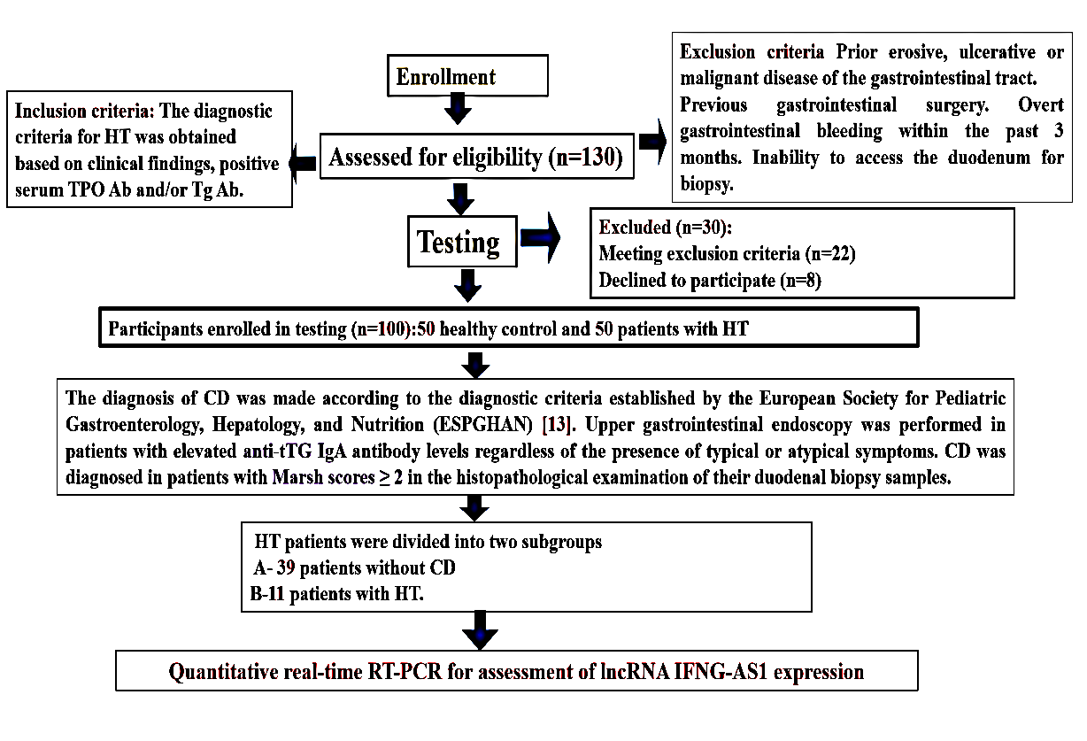
Fig1. Study flow chart.

Laboratory evaluation was done for the studied participants enrolled from the Departments of Internal Medicine and Tropical Medicine. Written informed consent was obtained from all participants, and the research ethical committee of the Faculty of Medicine, Zagazig University, authorized the study. (Ethics number. 11101), The work has been conducted by the Code of Ethics of the World Medical Association (Declaration of Helsinki) for students involving humans.
RNA Isolation and qRT-PCR
According to the manufacturer's instructions, total RNA was isolated from the PBMCs with TRIzol reagent (Invitrogen, California, USA). The cDNA was synthesized with random primers and a ReverTra Ace®qPCR RT kit (Toyobo, Osaka, Japan). qRT-PCR was performed in triplicate using Bio-Rad SYBR Green Super Mix (Bio-Rad, Hercules, USA). The primer sequences are shown in. β-Actin was used as a reference gene to analyze the genes of interest in the study quantitatively. The primers were as follows.
 | Forward primer | Reverse primer
lncRNA IFNG-AS1 | GCTGATGATGGTGGTGGCAATCT | TTAGCAGTTGGTGGGCTTCT
β-Actin | GAGTGTGGAGACCATCAAGGA | TGTATTGCTTTGCGTTGGAC

Statistical analyses
Results were reported as mean ± standard deviation for the numerical variables and as % (n) for categorical variables. The normality of variables was confirmed with the Kolmogorov-Smirnov test. The Mann-Whitney U test was used for variables that are not normally distributed. For three or more groups. One-way ANOVA or Kruskal Walles test was applied according to normality. The p-values of less than 0.05 were accepted as significant for all tests. All statistical analyses were performed using IBM Corp. Released in 2019. IBM SPSS Statistics for Windows, Version 26.0. Armonk, NY: IBM Corp.
Results
We enrolled one hundred participants;50 control and 50 patients with HT were matched regarding age and sex. Among patients with HT(N=50), there were 11 patients with CD [54.5 % were male and 45.5% were female; their mean age was 34.75±5.3]. And 39 patients without CD [64.1% were male, and 35.9% were female; their mean age was 34.89±6.2 years, as shown in Tab 1. Interestingly, studied participants had significant differences regarding the co-existence of autoimmune diseases, mainly T1DM and vitiligo, p ˂0.001*. There were meaningfully higher values of ALT, AST, HbA1c, TSH, Anti-TG, anti-TPO, and TTG IgA in patients with CD compared to other studied groups. On the other hand, there were meaningfully lower Hb, FT3, and FT4 values in patients with CD compared to other studied groups, p ˂0.001* (Tab 1).
Tab1. Clinical and laboratory characteristics of studied groups
Variable | Control group  N=50 | HT group without CD, n=39 | HT group with CD, n=11 | P value
Age | 34.86±4.8 | 34.89±6.2 | 34.75±5.3 | 0.145
Sex: Male/Female | 32/19 | 25/14 | 6/5 | X2 0.617
History of other autoimmune disease | - | 5(12.8%) | 7(63.6%) | X2˂0.001*
BMI | 23. 6±1.8 | 23.8±1.2 | 23.7±1.3 | 0.865
ALT | 25.86±2.3 | 22.89±3.5 | 50.75±5.9$, & | ˂0.001*
AST | 14.86±3.1 | 21.89±5.26# | 49.75±9.3$, & | ˂0.001*
Hb | 12.4±0.2 | 10.89±1.6# | 8.75±1.8$, & | ˂0.001*
HbA1c | 4.7±0.3 | 5.9±1.1# | 6.7 ±0.9$, & | ˂0.001*
FT3 (pg/mL) | 1.7±0.9 | 0.9±0.44# | 0.7±0.11$, & | ˂0.001*
FT4 (ng/dL) | 1.4±0.6 | 0.6±0.26# | 0.5±0.77$, & | ˂0.001*
TSH (μU/mL) | 3.4±1.1 | 5.8±1.5# | 6.7±2.6$, & | ˂0.001*
Anti TPO(IU/ml) | 28.3±8.3 | 206.5 ±11.4# | 365.1 ±18.2$, & | <0.001*
Anti TG(IU/ml) | 45.6±22.3 | 393.4±24.6# | 398.4±34.5$ | <0.001*
Anti TTG IgA (U/ml) | 1.26±0.8 | 7.89±4.5# | 20.15±9.6$, & | ˂0.001*
BMI; body mass index, ALT; alanine transaminase, AST; aspartate aminotransferase, Hb; hemoglobin, HBA1C; hemoglobin A1c, FT3; free triiodothyronine, FT4; free thyroxine, TSH, thyroid stimulating hormone; Anti-TG; anti-thyroglobulin antibodies, anti-TPO; anti-thyroid peroxidase antibodies, Anti-TTG IgA; tissue transglutaminase IgA antibodies, X2; Chi-square test, * = statistically significant * P< 0.05 =when compared with control group by ANOVA test and post hoc test:# Signiﬁcant P values (P < 0.05) when comparing the control group with patients without CD
$ Signiﬁcant P values (P < 0.05) when comparing the control group with patients with CD &Statistically signiﬁcant P values (P < 0.05) when comparing patients without CD with patients with CD.
It is well established that CD is associated with intestinal and extra-intestinal manifestations. Based on these findings, we investigated these manifestations to assess the severity and complications of CD. The differences between HT groups regard intestinal manifestations, as demonstrated in Fig 2. Among patients with CD (n=11) there was significantly higher prevalence of anorexia(n=9), heartburn(n=8), dyspepsia(n=9), nausea(n=9), abdominal distension(n=9) and abdominal pain(n=6) compared to patients without CD(n=39) as the prevalence of anorexia(n=2), heartburn(n=3), dyspepsia(n=3), nausea(n=3 ), abdominal distension(n=4) and abdominal pain(n=3), p ˂0.001*,(Fig 2).
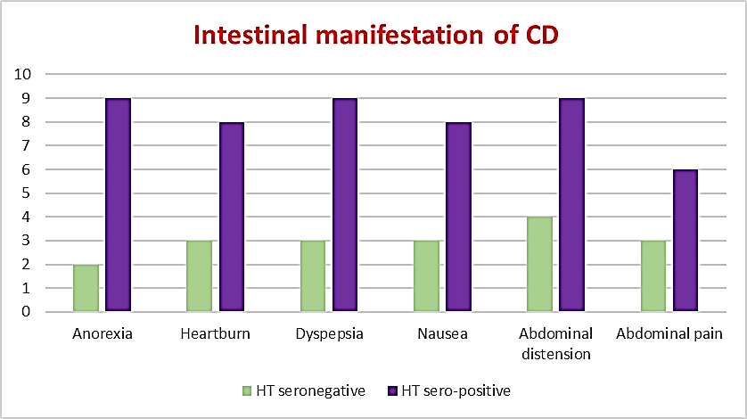
Fig2. Distribution of Intestinal manifestations in patients with HT
Regards the extra -intestinal manifestations, patients with CD(n=11) there was significantly higher prevalence of weight loss(n=5), anemia(n=8), bleeding tendency(n=4),bone aches(n=7), dental enamel hypoplasia(n=5), and oral ulcers(n=6) compared to patients without CD(n=39) as the frequency of weight loss(n=2), anemia(n=2),bleeding tendency(n=1),bone aches(n=6), dental enamel hypoplasia(n=2), and oral ulcers(n=1) , p ˂0.001*,(Fig 3).
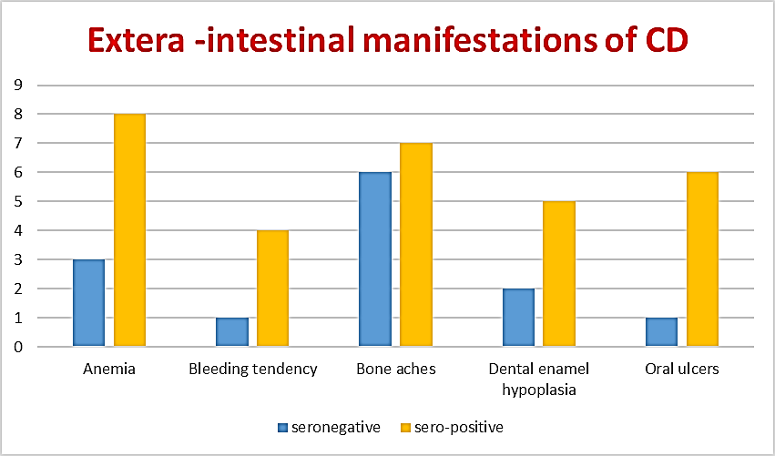
Fig3. Distribution of Extra Intestinal manifestations in patients with HT
The most important findings of the current research were the results of RT-PCR, which assesses the level of lncRNA IFNG-AS1relative expression; there were significantly higher values in patients with CD (4.17±0.618) compared to patients without CD (1.92±0.52) and control group (0.98±0.21), p ˂0.001*, (Fig4).
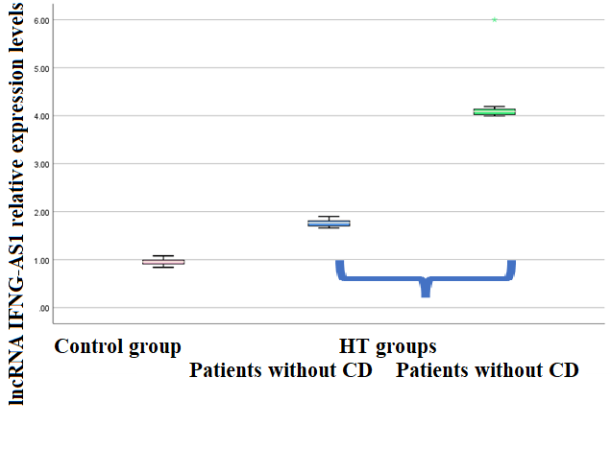
Fig4. Comparison of lncRNA IFNG-AS1 relative expression level in studied groups
This study analyzed the correlation between lncRNA IFNG-AS1relative expression and intestinal and extra-intestinal manifestations in both case groups. Among HT, patients with CD had significantly positive associations with anorexia, heartburn, dyspepsia, nausea, abdominal distension, abdominal pain, diarrhea, weight loss, anemia, bone aches, dental enamel hypoplasia, and oral ulcers, P˂0.001*. Concerning laboratory parameters, patients with CD had significantly positive associations with ALT, AST, HbA1c, TSH, anti-TG, anti-TPO, and anti-TTG IgA. On the other hand, there was a significantly negative correlation with Hb, FT3, and FT4, p ˂0.001* (Tab2).
Tab2. correlations between lncRNA IFNG-AS1 relative expression level and clinical and laboratory characteristics of HT groups.
Characteristics | HT group without CD, n=39 |  | HT group with CD,  n=11
 | r | p | r | p
Anorexia | 0.384 | ˂0.001* | 0.483 | ˂0.001*
Heartburn | 0.377 | ˂0.001* | 0.449 | ˂0.001*
Dyspepsia | 0.363 | ˂0.001* | 0.487 | ˂0.001*
Nausea | 0.569 | ˂0.001* | 0.456 | ˂0.001*
Abdominal distension | 0.164 | 0.103 | 0.538 | ˂0.001*
Abdominal pain | 0.500. | ˂0.001* | 0.454 | ˂0.001*
Diarrhea | 0.031 | 0.670 | 0.523 | ˂0.001*
Constipation | 0.568 | ˂0.001* | 0.123 | 0.224
Weight loss | 0.652 | ˂0.001* | 0.547 | ˂0.001*
Anemia | 0.069 | 0.497 | 0.456 | ˂0.001*
Bleeding tendency | 0.108 | 0.285 | 0.127 | 0.207
Bone aches | 0.500. | ˂0.001* | 0.654 | ˂0.001*
Dental enamel hypoplasia | 0.030 | 0.765 | 0.523 | ˂0.001*
Oral ulcers | 0.011 | 0.911 | 0.453 | ˂0.001*
BMI | 0.067 | 0.506 | 0.026 | 0.801
ALT | 0.670 | ˂0.001* | 0.715 | ˂0.001*
AST | 0.665 | ˂0.001* | 0.718 | ˂0.001*
Hb | -0.094 | 0.352 | -0.617 | ˂0.001*
HbA1c | 0.585 | ˂0.001* | 0.506 | ˂0.001*
FT₃ (pg/mL) | -0.769 | ˂0.001* | -0.699 | ˂0.001*
FT₄ (ng/dL) | -0.682 | ˂0.001* | -0.583 | ˂0.001*
TSH (μU/mL) | 0.491 | ˂0.001* | 0.468 | ˂0.001*
Anti-Tg (IU/mL) | 0.474 | ˂0.001* | 0.532 | ˂0.001*
Anti-TPO (IU/mL) | 0.603 | ˂0.001* | 0.734 | ˂0.001*
Anti TTG IgA (U/ml) | 0.943 | ˂0.001* | 0.837 | ˂0.001*
p<0.05
Regarding patients without CD, there were significantly positive correlations with anorexia, heartburn, dyspepsia, nausea, abdominal pain, constipation, weight loss, anemia, and bone aches, P ˂0.001*. About laboratory parameters, patients without CD had significantly positive associations with ALT, AST, HbA1c, TSH, anti-TG, anti-TPO, and TTG IgA. Conversely, there was a profoundly negative correlation with FT3 and FT4, p ˂0.001* (Tab 2).
As shown in Table 3, the Multivariate Regression test detected that the only variables independently associated with lncRNA IFNG-AS1 relative expression in the prediction of CD among studied parameters were anti-TG, anti-TPO, and TTG IgA.
Tab3. A multivariate regression test was used to evaluate the independent variable associated with lncRNA IFNG-AS1 relative expression in the prediction of CD.
Model |  | Unstandardized Coefficients |  | Standardized Coefficients | t | P value | 95% C.I.
 |  | B | Std. Error | Beta |  |  | Lower Bound | Upper Bound
 | (Constant) | 0.484 | 0.346 |  | 1.400 | 0.165 | -0.202 | 1.171
 | Anti TTG IgA | 0.041 | 0.020 | 0.239 | 2.101 | ˂0.05* | 0.002 | 0.081
 | TSH | -0.062 | 0.062 | -0.087 | -1.013 | 0.314 | -0.185 | 0.060
 | Anti-Tg | -0.003 | 0.001 | -0.472 | -4.014 | ˂0.001* | -0.004 | -0.001
 | Anti-TPO | 0.012 | 0.001 | 1.309 | 7.836 | ˂0.001* | 0.009 | 00.014
 | FT4 | 0.311 | 0.187 | 0.119 | 1.659 | 0.101 | -0.061 | .683

As shown in figure 5a and 5b, respectively. It is necessary to identify new biomarkers for HT patients. Hence, we explored the potential diagnostic value of IFNG-AS1 in HT. Our findings detected that the AUC was up to 0.974 with C.I(0.937-1.000), and the sensitivity and specificity were 96% and 94%, respectively, at a cutoff of 1.67. Although, the predictive power of IFNG-AS1 for CD. Our results perceived that the AUC was up to 0.683 with C.I(0.537-0.828), and the sensitivity and specificity were 63.3% and 53%, respectively, at a cutoff of 1.77.
Fig5a. The accuracy of lncRNA IFNG-AS1 expression for distinguishing patients with HT from the control group.

Fig6b. The accuracy of lncRNA IFNG-AS1 expression for recognizing patients with CD from others without CD among HT patients.
Discussion
It has been observed that the distribution of CD is increasing worldwide, especially in our region, as the prevalence of CD in Egypt is about 0.53%. Although the prevalence of CD is increasing, the diagnosis rate is low. In some nations, this could contribute to a need for disease recognition and restricted investigative capabilities. Therefore, early CD diagnosis is crucial, as it might prevent complications [14].
A wealth of research highlights the interaction between genetic susceptibility and environmental triggers in the pathogenesis of HT and CD [15]. This is unsurprising given the well-recognized connection between CD and HT [16]. According to the existing research, the shared genetic background is the key factor influencing the association's high incidence. lncRNAs show a significant function in the regulation of immunity. Therefore, we conducted this case-control study to investigate the lncRNA IFNG-AS1 level in HT and evaluate its predictive and diagnostic CD values among patients with HT. Among one hundred age and sex-matched participants, 50 were subjected as control and 50 patients with HT (39 patients without CD and 11 patients with CD). Notably, patients with CD had a higher thyroid autoantibody titer than HT patients without CD.
This is in keeping with the evidence that the prevalence of CD in patients with autoimmune disease is four times the prevalence of CD in general populations [17]. Similar results were observed in the Turkish study, which examined the distribution of CD among patients with thyroiditis, and they found that about 3 % of patients with thyroiditis had CD [18]. In contrast, a study conducted by Elfstrom et al. observed a lower prevalence of CD in patients with thyroiditis [19]. This discrepancy could be due to differences in the diagnostic test as they used an antigliadin antibodies test, and this test sensitivity is low, as confirmed by another study [20].
This work investigates HT and CD's potential clinical and laboratory characteristics. It is confirmed that CD is associated with intestinal and extra-intestinal manifestations. In keeping with the evidence, we examined these manifestations to assess the severity and complications of CD. We detected a high prevalence of intestinal manifestations of anorexia, heartburn, dyspepsia, nausea, and abdominal distension, and concerning the extra-intestinal manifestations, patients with CD had a higher prevalence of weight loss, anemia, bleeding tendency, bone aches, dental enamel hypoplasia, and oral ulcers.
It has been shown that lncRNAs perform essential functions in various diseases, particularly autoimmune diseases [ 21]. The most important findings of the current research were that patients with CD had significantly higher values of lncRNA relative expression and considerably higher values in patients with CD compared to other groups. This notion is supported by Peng et al., who detected meaningfully higher levels of lncRNA IFNG-AS1 in HT patients [22].
Additionally, in the CD group, lncRNA IFNG-AS1 levels were positively associated with anorexia, heartburn, dyspepsia, nausea, abdominal distension, abdominal pain, diarrhea, weight loss, anemia, bone aches, dental enamel hypoplasia, and oral ulcers. Furthermore, lncRNA IFNG-AS1 levels were positively associated with ALT, AST, HbA1c, TSH, anti-TG, anti-TPO, and TTG IgA. On the contrary, it was negatively correlated with FT3 and FT4. Interestingly, our results confirmed that the only variables independently associated with lncRNA IFNG-AS1 relative expression in the prediction of CD among studied parameters were anti-TG, anti-TPO, and TTG IgA. Some intriguing similarities have been found with Peng et al., who observed positive relationships between lncRNA IFNG-AS1 and thyroid autoantibodies [22].
For further assessment of the diagnostic value of IFNG-AS1 in HT, we found high sensitivity and specificity of 96% and 94%, respectively. Concerning CD, the predictive power of IFNG-AS1 had sensitivity and specificity of 63.3% and 53%, respectively. These data suggested that IFNG-AS1 expression could significantly predict HT and CD.
The conduction of these studies would cover the future usage of these techniques in clinical settings. Integrative assessment of omics data, including lncRNA signature, could facilitate the identification of new pathways and biomarkers and empathy of targets for prediction and treatment of HT and CD.
The strengths and limitations of the study
The current study has unique strengths. It is the first Egyptian study ever published aiming to investigate whether IFNG-AS1 expression levels could be used as a diagnostic marker of CD in HT patients. The diagnosis of CD is based on serology and endoscopy.
The limitations of our study are the small sample size of the research and patients with CD. Still, as mentioned before, we depend on both serology and endoscopy to diagnose CD. Also, in the current study, we included only Egyptian patients, and therefore, it remains unclear whether our findings apply to other ethnic groups.
Conclusions
Our results demonstrated that IFNG-AS1 is significantly enhanced in patients with HT, specifically patients with CD. The significant correlation between overexpressed IFNG-AS1 and clinical and laboratory parameters indicates that it could be used as a noninvasive predictive prognostic marker of HT and CD. The prevalence of celiac disease is increasing worldwide, and many patients with celiac disease remain undiagnosed and have many complications. Highlighting the need for Further studies with a larger sample size is very important.
Footnotes.
Peer-Reviewers: Amany Mohamed Abdallah (Assistant professor of community medicine), Marwa Shabana (Assistant professor of clinical pathology), Mohamed Emara (professor of gastroenterology, hepatology, and infectious diseases).
E- Editor: Salem Youssef Mohamed, Osama Ahmed Khalil, Mohamed Hassan Ali Emara.
Copyright ©. This open-access article is distributed under the Creative Commons Attribution License (CC BY). The use, distribution, or reproduction in other forums is permitted, provided the original author(s) and the copyright owner(s) are credited. The original publication in this journal is cited by accepted academic practice. No use, distribution, or reproduction is permitted, complying with these terms.
Disclaimer: All claims expressed in this article are solely those of the authors and do not necessarily represent their affiliated organizations or those of the publisher, the editors, and the reviewers. Any product evaluated in this article or its manufacturer's claim is not guaranteed or endorsed by the publisher.
Ethics Approval and Consent to Participate: The Internal Medicine Department and the Institutional Review Board Committee, Zagazig University approved the experimental protocol.
Consent for publication: All patients included in this research gave written informed permission to publish the data contained within this study.
Availability of data and materials: The datasets used or analyzed during the current study are available from the corresponding author upon reasonable request.
Competing interests: The authors declare that they have no competing interests.
Funding: This study had no funding from any resource.
Authors’ contributions
N M. R, M O W were responsible for conception and revision, and A M S, M H. S were accountable for the interpretation and analysis of data. M H.S. H, A S, A T H wrote the manuscript that was revised and approved by all co-authors.
References
- Fallahi P, Ferrari SM, Ruffilli I, et al. The association of other autoimmune diseases in patients with autoimmune thyroiditis: review of the literature and report of an extensive series of patients. Autoimmune Rev .2016;15:1125–8.
- A.P. Weetman: Non-thyroid autoantibodies in autoimmune thyroid disease Best Pract. Res. Clin. Endocrinol. Metab., 19 (2005), pp. 17-32.
- Betterle C, Zanchetta R. Update on autoimmune polyendocrine syndromes (APS). Acta Bio-Medica Atenei Parm. 2003; 74:9e33.
- Neumann WL, Coss E, Rugge M, et al. Autoimmune atrophic gastritis pathogenesis, pathology, and management. NatRev Gastroenterol Hepatol 2013; 10:529e41.
- Cavalcoli F, Zilli A, Conte D, et al. Micronutrient deficiencies in patients with chronic atrophic autoimmune gastritis: a review. World J Gastroenterol 2017;23(4):563e72.
- Virili C, Bassotti G, Santaguida MG, et al. Atypical celiac disease as a cause of the increased need for thyroxine: a systematic study. J Clin Endocrinol Metab 2012;97: E419e22.
- Lahner E, Capasso M, Carabotti M, et al. Incidence of cancer (other than gastric cancer) in pernicious anemia: a systematic review with meta-analysis. Dig Liver Dis 2018 Aug;50(8):780e6.
- Lenti MV, Miceli E, Cococcia S, et al. Determinants of diagnostic delay in autoimmune atrophic gastritis. AlimentPharmacol Ther 2019; 50:167e75
- Husby S, Koletzko S, Korponay-szabó IR, et al. European Society for Pediatric Gastroenterology, Hepatology, and Nutrition guidelines for the diagnosis of coeliac disease. J Pediatr Gastroenterol Nutr. 2012; 54:136–60
- Rubio-Tapia A, Hill, I D, Kelly C P et al. American College of Gastroenterology. ACG clinical guidelines: Diagnosis and management of celiac disease. Am. J. Gastroenterol. 2013, 108, 656–676.
- Xu F, Jin L, Jin Y et al. Long noncoding RNAs in autoimmune diseases. J Biomed Mater Res A. 2019; 107:468–475.
- Moradi M, Gharesouran J, Ghafouri-Fard S, et al. Role of NR3C1 and GAS5 genes polymorphisms in multiple sclerosis. Int J Neurosci. 2020; 130:407–412.
- Husby S, Koletzko S, Korponay-Szabó IR, et al., ESPGHAN Working Group on Coeliac Disease Diagnosis; ESPGHAN Gastroenterology Committee; European Society for Pediatric Gastroenterology, Hepatology, and Nutrition European Society for Pediatric Gastroenterology, Hepatology, and Nutrition guidelines for the diagnosis of coeliac disease. J Pediatr Gastroenterol Nutr. 2012; 54:136–160.
- Lionetti E., Catassi C. New clues in celiac disease epidemiology, pathogenesis, clinical manifestations, and treatment. International Reviews of Immunology. 2011;30(4):219–231.
- Antonelli A, Ferrari SM, Corrado A, et al. Autoimmune Autoimmune thyroid disorders. Rev. 2015; 14:174–180.
- Diamanti A, Capriati T, Bizzarri C, et al. Autoimmune diseases and celiac diseases: which came first: genotype or gluten? Expert Rev Clin Immunol. 2016; 12:67–77.
- Ch’ng CL, Jones MK, Kingham JGC. Celiac disease and autoimmune thyroid disease. Clin Med Res. 2007; 5:184–92.
- . Meloni A, Mandas C, Jores RD, et al. Prevalence of autoimmune thyroiditis in children with celiac disease and effect of gluten withdrawal. J Pediatr. 2009; 155:51–5.
- . Elfstrom P, Montgomery SM, Kampe O, et al. Risk of thyroid disease in individuals with celiac disease. J Clin Endocrinol Metab 2008; 93:3915–3921.
- . Rostom A, Dube C, Cranney A, et al. The diagnostic accuracy of serologic tests for celiac disease: a systematic review. Gastroenterology .2005;128: S38–46.
- Wang, J. et al. Upregulation of long noncoding RNA TMEVPG1 enhances T helper type 1 cell response in patients with Sjögren syndrome. Immunol Res .2016;64, 489–496.
- Peng H, Liu Y, Tian J. et al. The Long Noncoding RNA IFNG-AS1 Promotes T Helper Type 1 Cell Response in Patients with Hashimoto’s Thyroiditis. Sci Rep .2016 ;5, 17702.

